Algebra I

Systems of Equations

Option #1 Performance Task |   
Student Document

Authors: Initiative Team

**April 30, 2024**

Directions

Please review the task below and answer the various questions within the task to the best of your ability. If needed, you may have an adult or peer read the task out loud to aid your understanding. Additionally, feel free to use the following resources when answering each item:

* text-to-speech software
* speech-to-text software
* scratch paper

PART 1. Pricing Bracelets

Solving and Representing Systems of Linear and Quadratic Equation

Deborah is making spirit bracelets to sell to fundraise for a school club. She wants to sell as many bracelets as possible and raise as much money as possible.

Figure 1. Beads for Bracelets



Item 1 – Directions

Item 1 has no sub-items.

Deborah decides to gather some information from people in her school and community to figure out how much to charge for the bracelets. She asks different people how many bracelets they would be willing to buy at different prices and finds that the equation $f(x)=2.5{\left(x-20\right)}^{2}$ is a good model, where *x* represents the cost of a bracelet and $f(x)$ represents the number of bracelets people are likely to buy at that price. Then, she considers how many spirit bracelets she is willing to make, depending on what people will pay for them (see table 1). If people are not willing to pay very much, she does not want to invest a lot of time making a lot of bracelets, but if they are willing to pay more, Deborah is willing to invest more time to make more bracelets.

Table 1. Breakdown of Price [*x*] to Number of Bracelets [*g*(*x*)]

|  |  |
| --- | --- |
| If I charged [*x*] | I could make this many bracelets [*g*(*x*)] |
| $1.00 | 240 |
| $2.00 | 280 |
| $3.00 | 320 |
| $4.00 | 360 |
| $5.00 | 400 |
| $6.00 | 440 |
| $7.00 | 480 |
| $8.00 | 520 |
| $9.00 | 560 |
| $10.00 | 600 |
| $11.00 | 640 |
| $12.00 | 680 |
| $13.00 | 720 |
| $14.00 | 760 |
| $15.00 | 800 |
| $16.00 | 840 |
| $17.00 | 880 |
| $18.00 | 920 |
| $19.00 | 960 |
| $20.00 | 1,000 |

Item 1 Task

Show and explain **TWO** different methods that Deborah could use to determine how much she should charge for each spirit bracelet, and how many bracelets she is likely to sell if she does. One of your methods should be algebraic and give exact values. The other should make use of a graph.

You can create your graph by hand using graph paper, use a graphing calculator, or use online software such as Desmos or Geogebra.

PART 2. Two Types of Bracelets

Solving and Representing Linear Systems of Equations and Inequalities

The following year, Deborah’s club decided that they would offer two different types of spirit bracelets—Basic Spirit Bracelets and Fancy Spirit Bracelets. They decided to sell the basic bracelets for $5 each and the fancy bracelets for $8 each. Their fundraising goal is to make more than $5,000. A local craft store has donated enough materials to make up to 800 bracelets total, but the club needs to decide how many of each type to make.

Item 1

Item 1 has no sub-items. Please complete the task below.

Item 1 Task

Create a system of inequalities that represents the constraints in this situation and explain how we can see that the different elements of the system (terms, coefficients, variables, operations, inequality symbols) match the situation that is described.

Item 2

Item 2 has no sub-items. Please complete the task below.

Item 2 Task

Show and explain at least **TWO** different ways that the club could use the system of inequalities to decide how many of each type of bracelet to make, and how much money they will make if they do. One of your methods should make use of technology such as a graphing calculator or computer algebra software, one should include a graphical representation, and one should include making use of algebraic techniques.

PART 3. Type III Row Operations

Proving an Important Property of Systems

The following year, Deborah’s club created the following system of equations to determine how much to charge for their spirit bracelets:

|  |  |
| --- | --- |
| SYSTEM A: | $$\left\{\begin{aligned}5x+9y=6,000 \\ x+y=1,000 \end{aligned}\right\}$$ |

Deborah first multiplied both sides of the second equation by 2:

|  |  |  |
| --- | --- | --- |
| $$\left\{\begin{aligned}5x+9y=6,000 \\ 2∙x+2∙y=2∙1,000 \end{aligned}\right\}$$ | à | $$\left\{\begin{aligned}5x+9y=6,000 \\ 2x+2y=2,000 \end{aligned}\right\}$$ |

Then she replaced the second equation with the **sum** of the two equations:

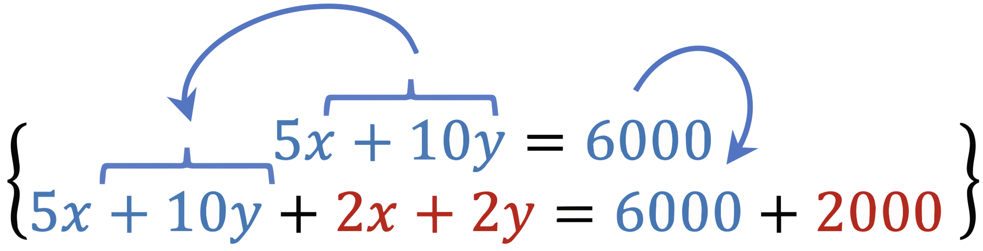

|  |  |
| --- | --- |
| SYSTEM B: | $$\left\{\begin{aligned}5x+9y=6,000 \\ 7x+11y=8,000 \end{aligned}\right\}$$ |

She says that any time you follow this process, the new system you get will have the same **solution set** as the original system.

Item 1

Item 1 has no sub-items. Complete the task below.

Item 1 Task

Use Mathematics tools and strategies to show and explain why this is.