Algebra I

Systems of Equations

Option #1 Performance Task |   
Teacher Document

Authors: Initiative Team

April 30, 2024

Table of Contents

Overview of the Performance Task 1

[Administering the Performance Task and Embedding   
Resources for Students 2](#_Toc171516455)

Key Vocabulary Associated with the Standards 2

Strategies for Supporting Students 2

Potential Alternative Means of Expression 4

PART 1. Solving and Representing Systems of Linear and Quadratic Equations: Pricing Bracelets 6

Task Alignment to Key Elements of Big Ideas and Standards 6

Part 1. Items 8

Part 1. Sample Student Responses 12

[PART 2. Solving and Representing Linear Systems of   
Equations and Inequalities: Two Types of Bracelets 17](#_Toc171516463)

Task Alignment to Key Elements of Big Ideas and Standards 17

Part 2. Items 20

Part 2. Sample Student Responses 24

[PART 3. Proving an Important Property of Systems:   
Type III Row Operations 29](#_Toc171516467)

Task Alignment to Key Elements of Big Ideas and Standards 29

Part 3. Items 30

Part 3. Sample Student Responses 32

Overview of the Performance Task

This performance task evaluates students’ understanding of key concepts within the Integrated 1 Systems of Equations Big Idea. It is divided into parts, each targeting a specific component of the Big Idea. Each part offers accessible strategies and examples of how students can demonstrate proficiency with the concepts. Various tools, mediums, and connections are provided for teachers to customize the task to the unique needs, cultures, interests, and abilities of their students, promoting an inclusive and relevant educational experience.

When preparing this performance task, distinguish between the flexible and fixed elements to ensure students have multiple ways to demonstrate their knowledge without compromising the concepts’ depth and rigor within the standards. Furthermore, educators should always consult the student’s Individualized Education Program (IEP) to ensure that all required accommodations and supplementary aids are provided during the assessment.

Additional information on providing alternative means of expression can be found in the best practice guides and content-aligned practice briefs defined as part of the Inclusive Access to a Diploma: Reimagining Proficiency for Students with Disabilities initiative.

Administering the Performance Task and  
Embedding Resources for Students

Each part of this task is broken into a series of Items for administration. This section provides guidance to the educator on how to administer all parts of the task and support the student in demonstrating their understanding of the Big Idea. As you are planning to administer this performance task, it is suggested to review these recommendations as they offer associated key vocabulary, appropriate and inappropriate resources, and potential methods and means of expression.

Key Vocabulary Associated with the Standards

The key vocabulary terms provided are essential to the concepts within the Big Ideas, therefore unless otherwise noted, the vocabulary cannot be taught during completion of the task.

* system of inequalities, constraints, terms, coefficients, variables, operations, inequality symbols, function, equation, graph, variable, point of intersection, solution, value, substitute, point, coordinate pair, terms, variables, coefficients, sum, solution set, system of equations, linear, slope, *y*-intercept, $f(x)$, $y=mx+b$

Strategies for Supporting Students

The following sections describe appropriate and inappropriate resources to provide students as they complete a task.

Appropriate Resources

Appropriate resources maintain the rigor of the standards while also accommodating any student difficulties such as confusion or anxiety or providing a resource the student could use to complete the task.

* reading the item to the student
* helping the student to make sense of the item by asking questions such as, “What is this question asking you to figure out? What important information does the question give you? Are there any words you want to ask about or look up?”
* answering clarifying questions[1]
* prompting the student to make sense of the problem by thinking out loud or by sketching
* offering drawing tools (paper/pencil, colored pencils, straight edge, or computer drawing technology)
* helping students to access technology to solve the problem, for example, supporting students in entering the function $f(x)=2.5{\left(x-20\right)}^{2}$ into Desmos
* helping the student to access resources to remind them of the meaning of mathematical terms such as “equation” and “model”
* allowing the student to complete the task across more than one class period
* allowing students to **access** technology to complete Part 2 Item 2

Inappropriate Resources

The inappropriate resources identify what assistance should be avoided as it may alter the rigor of the standards and negatively impact the student’s ability to independently demonstrate proficiency and be objectively scored on that task.

* explaining/re-teaching mathematical concepts (for example, linear or quadratic functions, modeling with functions, solving systems of equations, creating and solving systems of equations/inequalities, solving algebraic equations)
* walking students through the process of writing a linear function based on a table of values
* walking students through the process of setting up and solving a system of equations
* explaining/re-teaching mathematical concepts

Potential Alternative Means of Expression

Potential methods and means of expression show the various ways students can demonstrate their knowledge of the standards being assessed in this part of the task.

Students can work through the process of coming up with the system of equations using any method or modality that makes sense to them. However, to demonstrate proficiency with Item 1, the student **must** represent the system algebraically as shown in the rubric. This algebraic representation can be

* written down by hand using paper and pencil
* typed
* generated using speech-to-text software
* dictated to a scribe[2]
* described verbally
* explained verbally
* generated using an annotated graph or table to support or help clarify their explanation

Students can create graphs in the following ways:

* by hand, using paper and pencil
* using a graphing calculator
* using online graphing software such as Desmos or Geogebra

PART 1. Solving and Representing Systems of Linear and Quadratic Equations: Pricing Bracelets

Part 1 of the Systems of Equations performance task outlines the following:

* associated standards that will be assessed
* student task requirements
* rubrics that assess each item
* sample student responses

Teachers should familiarize themselves with the related standards, review the student task, peruse each item’s rubric, and view the sample student responses to sufficiently prepare for students to use this performance task to show proficiency with the standards assessed in this task. Additionally, teachers must be careful to incorporate any IEP-defined supplementary aids and services specific to individual students with disabilities taking this performance task.

Task Alignment to Key Elements of Big Ideas and Standards

Clusters of content standards exist within the Big Ideas allowing the Big Ideas to demonstrate the central concepts and key understandings of the course content. The indicator statements provide the teacher with the key concepts being evaluated in each Big Idea as well as the associated content standards centered within the Big Idea of this task and come from the *Mathematics Framework for California Public Schools: Kindergarten Through Grade Twelve* (*Mathematics Framework*) and are aligned to California adopted mathematics state standards.

Systems of Equations: Big Idea Indicator 1

Students investigate real situations that include data for which systems of one or two equations or inequalities are helpful, paying attention to units. Investigations include linear, quadratic, and absolute value [relationships].

Related Standards

The following are standards that align with the indicator statements above.

* **Solve systems of equations.** [Linear-linear and linear-quadratic]
  + (*Item 1*) **A-REI.7** Solve a simple system consisting of a linear equation and a quadratic equation in two variables algebraically and graphically.
* **Represent and solve equations and inequalities graphically.** [Linear and exponential; learn as general principle.]
  + *(Item 1)* **A-REI.10** Understand that the graph of an equation in two variables is the set of all its solutions plotted in the coordinate plane, often forming a curve (which could be a line).
  + *(Item 1)* **A-REI.11** Explain why the *x*-coordinates of the points where the graphs of the equations *y* = *f*(*x*) and *y* = *g*(*x*) intersect are the solutions of the equation *f*(*x*) = *g*(*x*); find the solutions approximately, (for example, using technology to graph the functions, make tables of values, or find successive approximations). Include cases where *f*(*x*) and/or *g*(*x*) are linear, polynomial, rational, absolute value, exponential, and logarithmic functions.

Part 1. Items

Deborah is making spirit bracelets to sell to fundraise for a school club. She wants to sell as many bracelets as possible and raise as much money as possible.

Figure 1. Beads for Bracelets



Item 1

Item 1 has no sub-items.

Deborah decides to gather some information from people in her school and community to figure out how much to charge for her spirit bracelets.

She asks different people how many bracelets they would be willing to buy at different prices and finds that the equation $f(x)=2.5{\left(x-20\right)}^{2}$ is a good model, where *x* represents the cost of a bracelet and $f(x)$ represents the number of bracelets people are likely to buy at that price.

Then, she considers how many spirit bracelets she is willing to make, depending on what people will pay for them (see table 1). If people are not willing to pay very much, she does not want to invest a lot of time making a lot of bracelets, but if they are willing to pay more, Deborah is willing to invest more time to make more bracelets.

Table 1. [Student Document Table 1.] Breakdown of Price [*x*] to Units [*g*(*x*)]

| **If I charged [*x*]** | **I could make this many bracelets [*g*(*x*)]** |
| --- | --- |
| $1.00 | 240 |
| $2.00 | 280 |
| $3.00 | 320 |
| $4.00 | 360 |
| $5.00 | 400 |
| $6.00 | 440 |
| $7.00 | 480 |
| $8.00 | 520 |
| $9.00 | 560 |
| $10.00 | 600 |
| $11.00 | 640 |
| $12.00 | 680 |
| $13.00 | 720 |
| $14.00 | 760 |
| $15.00 | 800 |
| $16.00 | 840 |
| $17.00 | 880 |
| $18.00 | 920 |
| $19.00 | 960 |
| $20.00 | 1,000 |

Item 1 Task

Show and explain **TWO** different methods that Deborah could use to determine how much she should charge for each spirit bracelet, and how many bracelets she is likely to sell if she does. Make one of your methods algebraic and give exact values. The other should make use of a graph (**A-REI.7**, **A-REI.10, A-REI.11**).

You can create your graph by hand using graph paper, use a graphing calculator, or use online software such as Desmos or Geogebra.

A Rubric for Assessing a Response to Item 1

**A-REI.7** Solve a simple system consisting of a linear equation and a quadratic equation in two variables algebraically and graphically.

**A-REI.10** Understand that the graph of an equation in two variables is the set of all its solutions plotted in the coordinate plane, often forming a curve (which could be a line).

**A-REI.11** Explain why the *x*-coordinates of the points where the graphs of the equations *y* = *f*(*x*) and *y* = *g*(*x*) intersect are the solutions of the equation *f*(*x*) = *g*(*x*); find the solutions approximately, (for example, using technology to graph the functions, make tables of values, or find successive approximations). Include cases where *f*(*x*) and/or *g*(*x*) are linear, polynomial, rational, absolute value, exponential, and logarithmic functions.

Rubric for Item 1

| Attempted | Approaching | Proficient |
| --- | --- | --- |
| The student attempts to present at least one strategy for finding a solution, but there are multiple major conceptual errors. —OR— The explanation is missing or so unclear and imprecise that it is not possible to determine the student’s level of conceptual understanding. | The student presents two ***generally*** correct strategies for solving the problem, one using algebraic techniques and giving exact values and one using graphical techniques which may include visual estimation.  There are no major conceptual errors, though a few small, insubstantial errors may be present (for example, transcription or calculation errors, missing axis labels or scale).  The explanation may lack clarity, specificity, or precise language regarding the connection between the solution of individual equations, the solution of the system, and the point of intersection of the two curves. | The student presents two complete and correct strategies for determining how much to charge for each bracelet and how many are likely to sell at that price.  A demonstration of a valid algebraic strategy for finding the solution of the system by giving exact values (versus an estimation or solving graphically) is this:   * identifies the exact solution of the system/coordinates of the point of the intersection: *x* = 25 – 4√29, *y* = 1,200 – 160√29 can be given as a coordinate pair or described narratively. * correctly interprets the solution to the system in context (*x*-value = number of bracelets they should make, *y*-value = number of bracelets likely to sell).   The graphical strategy uses these techniques (a solution estimate is allowed):   * a graph correctly plotting both curves; and correctly labeling the axes, curves, scale, and intersection point. * explains that the graph of an equation in two variables is the set of all its solutions plotted in the coordinate plane. * identifies the coordinate pair of the intersection point of the two curves as the solution to the system. * correctly interprets the coordinate pair of the intersection point and the solution to the system in context (the *x*-coordinate = number of bracelets she could make and the *y*-coordinate = number of bracelets likely to sell). |

Part 1. Sample Student Responses

The content below provides a sample of proficient responses from a student. The text that leads with “Student Voice” is an example of how a student might respond to each item. This section should only serve as a model—different students will arrive at solutions in different ways.

Item 1

Deborah is making spirit bracelets to sell to fundraise for a school club. She wants to sell as many bracelets as possible and raise as much money as possible.

Deborah decides to gather some information from people in her school and community to figure out how much to charge for the bracelets.

She asks different people how many bracelets they would be willing to buy at different prices and finds that the equation $f(x)=2.5{\left(x-20\right)}^{2}$ is a good model, where *x* represents the cost of a bracelet and *y* represents the number of bracelets people are likely to buy at that price.

Then she considers how many spirit bracelets she is willing to make, depending on what people will pay for them (see table 1).

Item 1 Task

Show and explain **TWO** different methods that Deborah could use to determine how much she should charge for each spirit bracelet, and how many bracelets she is likely to sell if she does. One of your methods should be algebraic and give exact values. The other should make use of a graph.

You can create your graph by hand using graph paper, use a graphing calculator, or use online software such as Desmos or Geogebra.

Student Voice: For the first function, $f(x)=2.5{\left(x-20\right)}^{2}$, every coordinate pair (*x*, *f*(*x*)) that satisfies the equation tells us that if a bracelet costs *x* dollars, then *f*(*x*) people are likely to buy one. For example, if the cost is $1, then we can find the number of people likely to buy a bracelet by substituting *x* = 1 into the equation and solving for $f(x)=2.5{\left(1-20\right)}^{2}$ 
 à $f(x)=902.5$ (so 902–903 people).

If we graph the equation, we will be able to see all the possible solutions.

Figure 2. Student-Generated Graph

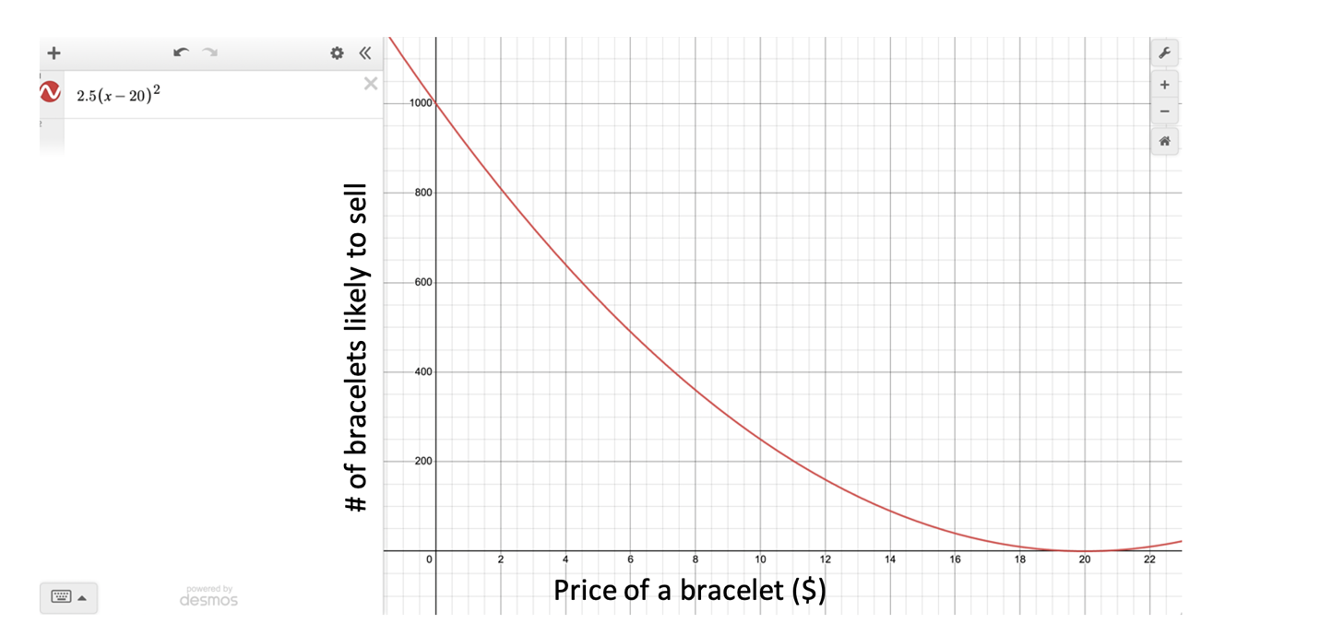

Student Voice: The second function is represented as a table, so it will be easier to graph if we write it as an equation. We can see that the unit change (slope) is constant because when *x* [the cost of a bracelet] goes up by $1, *g*(*x*) [the number of bracelets she is willing to make] goes up by 40 every time. That means the function is linear and can be written as $g(x)=mx+b$, with *m* = 40. When *x* = 0, *g*(*x*) = 200 [because when *x* = 1, *g*(*x*) = 240, so we can just subtract 40 to find the *y*-value that goes with *x* = 0]. So, *b* = 200 and we have the equation $g(x)=40x+200$. Now, we can graph that equation on the same axes as the first equation, like this:

Figure 3. Student-Generated Graph

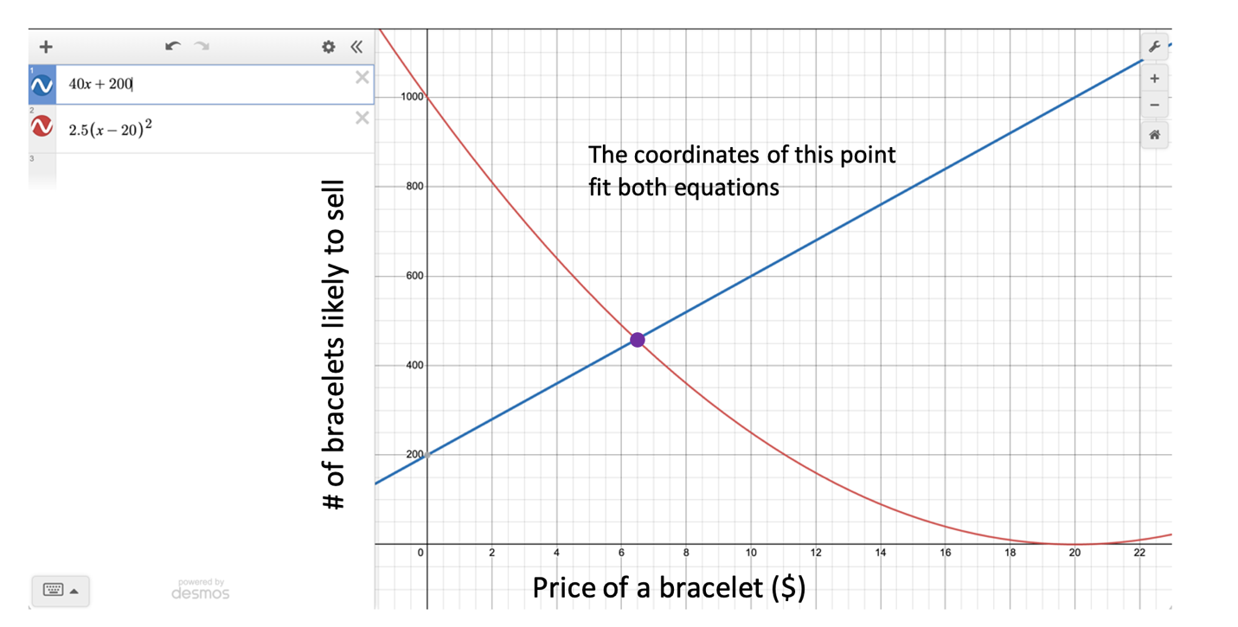

Student Voice: We need to find a solution that fits both equations—that is, we need an (*x*, *y*) point that lies on both curves. We can see that there is only one point that falls on both curves—the point where they intersect. It is hard to tell exactly what the point is by looking, but it is pretty close to (6.5, 450). If you hover over the intersection point, Desmos shows you that it’s (6.459, 458.374).

Figure 4. Student-Generated Graph

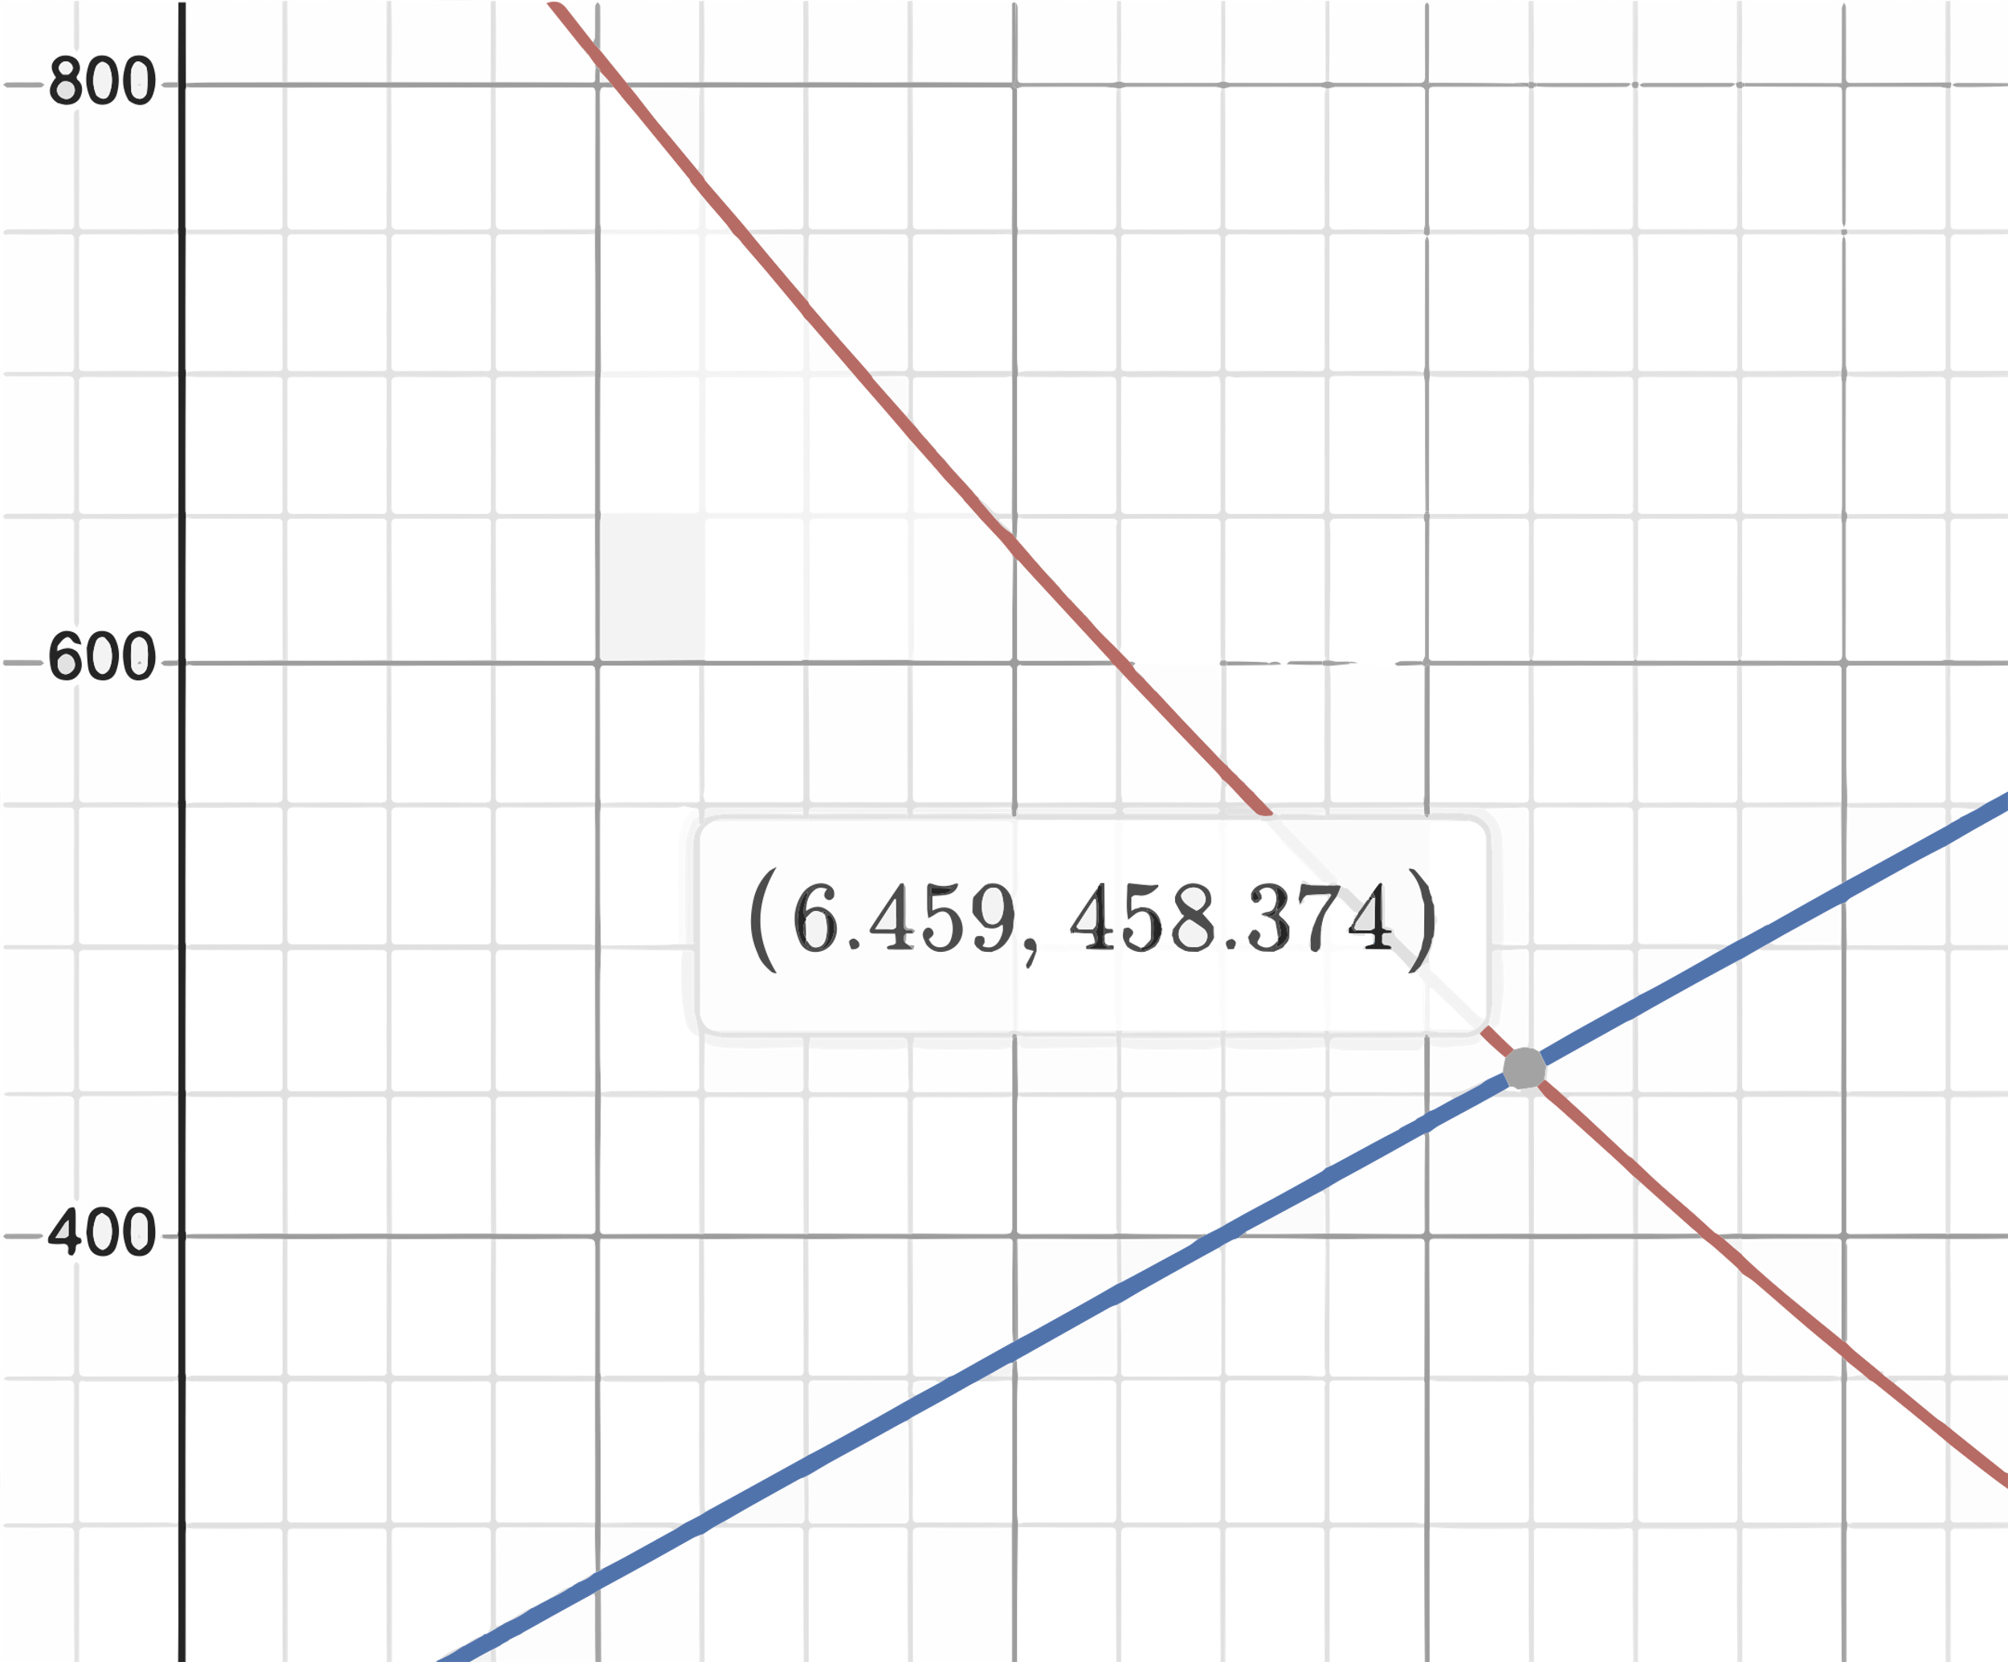

So, they should probably sell the bracelets for around $6.45 or $6.50, and around 458 people will buy them.

Method[3](Algebraic):

If you want to find the solution exactly you have to use algebra. We need to solve this system of equations:

$$\left\{\begin{aligned}y=2.5(x-{20)}^{2} \\ y=40x+200 \end{aligned}\right\}$$

Since both equations are in *y* = form, we can set them equal to form a new equation that has only one variable:

$$2.5{\left(x-20\right)}^{2}=40x+200$$

I divided both sides by 2.5 to get

$${\left(x-20\right)}^{2}=16x+80$$

Then, I multiplied out the left side:

$$x^{2}-40x+400=16x+80$$

I wanted to get zero on one side, so I subtracted 16*x* and 80 from both sides:

$$x^{2}-56x+320=0$$

The easiest way to solve quadratic equations is the quadratic formula, so I substituted *a* = 1, *b* = -56, and *c* = 320, and got

$$x=\frac{-(-56)±\sqrt{{(-56)}^{2}-4(1)(320)}}{2(1)}$$

$$x=\frac{56±\sqrt{1,856}}{2}$$

$$x=25±4\sqrt{29}$$

$$x≈6.459, 49.54$$

So, we can see that one of the solutions we found algebraically matches the one we could see in the graph.

If we substitute $x=25-4\sqrt{29}$ into $x=25-4\sqrt{29}$, we get $y=40\left(25-4\sqrt{29} \right)+200$ 
 🡪 $y=1,200-160\sqrt{29}≈458.374$, which matches what we saw in the graph.

PART 2. Solving and Representing Linear Systems of Equations and Inequalities: Two Types of Bracelets

This performance task outlines the following:

* associated standards that will be assessed
* rubrics that assess each item
* the student task requirements
* sample student responses

Teachers should familiarize themselves with the related standards, review the student task, peruse each item’s rubric, and view the sample student responses to sufficiently prepare for students to use this performance task to show proficiency in this task.

Task Alignment to Key Elements of Big Ideas and Standards

Clusters of content standards exist within the big ideas allowing the big ideas to demonstrate the central concepts and key understandings of the course content. The indicator statements provide the teacher with the key concepts being evaluated in each Big Idea as well as the associated content standards centered within the Big Idea of this task come from the Mathematics Framework and are aligned to California-adopted mathematics state standards.

Systems of Equations: Big Idea Indicator 1

Students investigate real situations that include data for which systems of one or two equations or inequalities are helpful, paying attention to units. Investigations include linear, quadratic, and absolute value [relationships].

Related Standards

* **Solve systems of equations.** [Linear-linear and linear-quadratic]
  + *(Item 2)* **A-REI.6** Solve systems of linear equations exactly and approximately (for example, with graphs), focusing on pairs of linear equations in two variables.
* **Represent and solve equations and inequalities graphically.** [Linear and exponential;* learn as general principle.]
  + *(Item 2)* **A-REI.12** Graph the solutions to a linear inequality in two variables as a half-plane (excluding the boundary in the case of a strict inequality), and graph the solution set to a system of linear inequalities in two variables as the intersection of the corresponding half-planes.
* **Interpret the structure of expressions.** [Linear expressions and exponential expressions with integer exponents]
  + *(Item 1)* **A-SSE.1** Interpret expressions that represent a quantity in terms of its context.
    - **A-SSE.1a** Interpret parts of an expression, such as terms, factors, and coefficients.
    - **A-SSE.1b** Interpret complicated expressions by viewing one or more of their parts as a single entity. For example, interpret P(1 + *r*)*n* as the product of P and a factor not depending on P.

Systems of Equations: Big Idea Indicator 2

Students use technology tools strategically to find [systems’] solutions and approximate solutions, [construct] viable arguments, [interpret] the meaning of the results, and [communicate] them in multidimensional ways.

Related Standards

* **Represent and solve equations and inequalities graphically.** [Linear and exponential*; learn as general principle.]
  + *(Item 2)* **A-REI.11** Explain why the *x*-coordinates of the points where the graphs of the equations *y* = *f*(*x*) and *y* = *g*(*x*) intersect are the solutions of the equation *f*(*x*) = *g*(*x*); find the solutions approximately, (for example, using technology to graph the functions, make tables of values, or find successive approximations). Include cases where *f*(*x*) and/or *g*(*x*) are linear, polynomial, rational, absolute value, exponential, and logarithmic functions.

Part 2. Items

The following year, Deborah’s club decided that they would offer two different types of spirit bracelets—Basic Spirit Bracelets and Ornate Spirit Bracelets. They decided to sell the basic bracelets for $5 each and the ornate bracelets for $8 each. Their fundraising goal is to make more than $5,000. A local craft store has donated enough materials to make up to 800 bracelets total, but the club needs to decide how many of each type to make.

Item 1

Item 1 has no sub-items. Please complete the task below.

Item 1 Task

Create a system of inequalities that represents the constraints in this situation and explain how we can see that the different elements of the system (terms, coefficients, variables, operations, inequality symbols) match the situation that is described   
(**A-SSE.1a, b**).

A Rubric for Assessing a Response to Item 1

**A-SSE.1** Interpret expressions that represent a quantity in terms of its context.

* **A-SSE.1a** Interpret parts of an expression, such as terms, factors, and coefficients.
* **A-SSE.1b** Interpret complicated expressions by viewing one or more of their parts as a single entity. For example, interpret P(1 + *r*)*n* as the product of P and a factor not depending on P.

Table 3. Rubric for Item 1

| Attempted | Approaching | Proficient |
| --- | --- | --- |
| The student attempts to present one of the constraints symbolically or explain how it could be done, but there are multiple major conceptual errors. —OR— The explanation is missing or so unclear and imprecise that it is not possible to determine the student’s level of conceptual understanding. | The student gives a correct system of inequalities such as $\left\{\begin{aligned}5x+8y>5,000 \\ x+y≤800\end{aligned}\right\}$, but the explanation of how and why the structure of the inequalities in the system match the constraints is either missing or too unclear or imprecise to determine the student’s level of conceptual understanding —OR— the student presents a system of inequalities with minor procedural errors.  The student correctly explains how and why the structure of each inequality in the system matches the constraints described in the problem; the explanation makes it clear that the errors in the system of inequalities are minor and not conceptual —OR— the student gives one inequality that matches a constraint given in the problem and correctly explains how and why the structure of the inequality matches the constraint. | The student presents two **complete and correct** strategies for determining how much to charge for each bracelet and how many are likely to sell at that price.  The student gives a correct system of inequalities such as $\left\{\begin{aligned}5x+8y>5,000 \\ x+y≤800\end{aligned}\right\}$.  The student correctly explains how and why the structure of each inequality in the system matches the constraints described in the problem. |

Item 2

Item 2 has no sub-items. Please complete the task below.

Item 2 Task

Show and explain at least **TWO** different ways that the club could use the system of inequalities to decide how many of each type of bracelet to make, and how much money they will make if they do. One of your methods should make use of technology such as a graphing calculator or computer algebra software, one should include a graphical representation, and one should include making use of algebraic techniques (**A-REI.6, A-REI.12, A-REI.11**).

A Rubric for Assessing a Response to Item 2

**A-REI.6** Solve systems of linear equations exactly and approximately (for example, with graphs), focusing on pairs of linear equations in two variables.

**A-REI.12** Graph the solutions to a linear inequality in two variables as a half-plane (excluding the boundary in the case of a strict inequality), and graph the solution set to a system of linear inequalities in two variables as the intersection of the corresponding half-planes.

**A-REI.11** Explain why the *x*-coordinates of the points where the graphs of the equations *y* = *f*(*x*) and *y* = *g*(*x*) intersect are the solutions of the equation *f*(*x*) = *g*(*x*); find the solutions approximately, (for example, using technology to graph the functions, make tables of values, or find successive approximations). Include cases where *f*(*x*) and/or *g*(*x*) are linear, polynomial, rational, absolute value, exponential, and logarithmic functions.

Table 4. Rubric for Item 2

| Attempted | Approaching | Proficient |
| --- | --- | --- |
| The student attempts to describe the feasible region or a strategy for determining it, but there are multiple major conceptual errors. —OR— The explanation is missing or so unclear and imprecise that it is not possible to determine the student’s level of conceptual understanding. | The student presents two *generally correct* strategies for solving the problem (one using algebraic techniques and giving exact values; one using graphical techniques; and one making use of technology).  There are *no major conceptual errors*, though a few small, insubstantial errors may be present (for example, transcription or calculation errors, missing axis labels or scale).  The explanations may lack clarity, specificity, or precise language regarding the connection between the solution sets of individual inequalities, the solution set of the system, and the overlap of the solution sets of the two inequalities. | The student presents ***two*** complete and correct strategies for determining the options for how many of each type of bracelet to make.  At least one of the strategies   * uses technology (such as a graphing calculator or online graphing software); * uses graphical techniques to approximately determine and describe the feasible region [the triangle formed roughly by the points (0, 625), (0, 800), and (475, 325)]; and * uses algebraic techniques and gives the exact boundaries of the feasible region (*y*-axis with 625 > *y* ≥ 800; the line *x* + *y*≤ 800 with 0 ≤ *x* < 466 2/3; and the line 5*x* + 8*y* > 5,000 with 0 ≤ *x* < 466 2/3.   The graphical strategy   * includes a graph that shows both inequalities correctly plotted and shaded; * axes, lines, scale, and vertices of the feasible region correctly labeled; * explains that the graph of an inequality in two variables is the set of all its solutions plotted/shaded in the coordinate plane; and * identifies the overlapping plotted points and shaded areas as the solution to the system of inequalities.   The algebraic strategy   * demonstrates and explains a valid algebraic strategy for identifying the solution set of the system of inequalities, * correctly interprets the point of intersection of the lines *x* + *y* = 800 and 5*x* + 8*y* = 5,000 (466 2/3, 333 1/3) as one of the vertices of the triangle that bounds the feasible region, and * correctly interprets the solution set of the system in context (that is, the coordinates of any point in the feasible region correspond to a combination of fancy and basic bracelets that satisfies the constraints. |

Part 2. Sample Student Responses

The content below provides a sample of proficient responses from a student. The text that leads with “Student Voice” is an example of how a student might respond to each item. This section should only serve as a model—different students will arrive at solutions in different ways.

Item 1

Create a system of inequalities that represents the constraints in this situation and explain how we can see that the different elements of the system (terms, coefficients, variables, operations, inequality symbols) match the situation that is described.

Student Voice: First, we need to assign some variables. Let’s say that *x* represents the number of basic bracelets they will make, and *y* represents the number of fancy bracelets they will make. Then the amount of money they get from basic bracelets will be 5 * *x* and the amount they get from fancy bracelets will be 8 * *y*. The total amount of money they will get is $5x+8y$. We know that this amount needs to be more than $5,000, so we can write this inequality: $5x+8y>5,000$.

We know they can make up to 800 bracelets but not more. The number of basic bracelets added to the number of fancy bracelets needs to be less than or equal to 800. So, we can write the inequality $x+y≤800$.

Now we have a system of inequalities to represent the situation:

$$\left\{5x+8y>5,000 x+y≤800 \right\}$$

Item 2

Show and explain at least **TWO** different ways that the club could use the system of inequalities to decide how many of each type of bracelet to make, and how much money they will make if they do. One of your methods should make use of technology such as a graphing calculator or computer algebra software, one should include a graphical representation, and one should include making use of algebraic techniques (**A-REI.6, A-REI.12, A-REI.11**).

Student Voice: One way to figure out how many of each type of bracelet they should make is to graph the two inequalities:

Figure 5. Student-Generated Graph

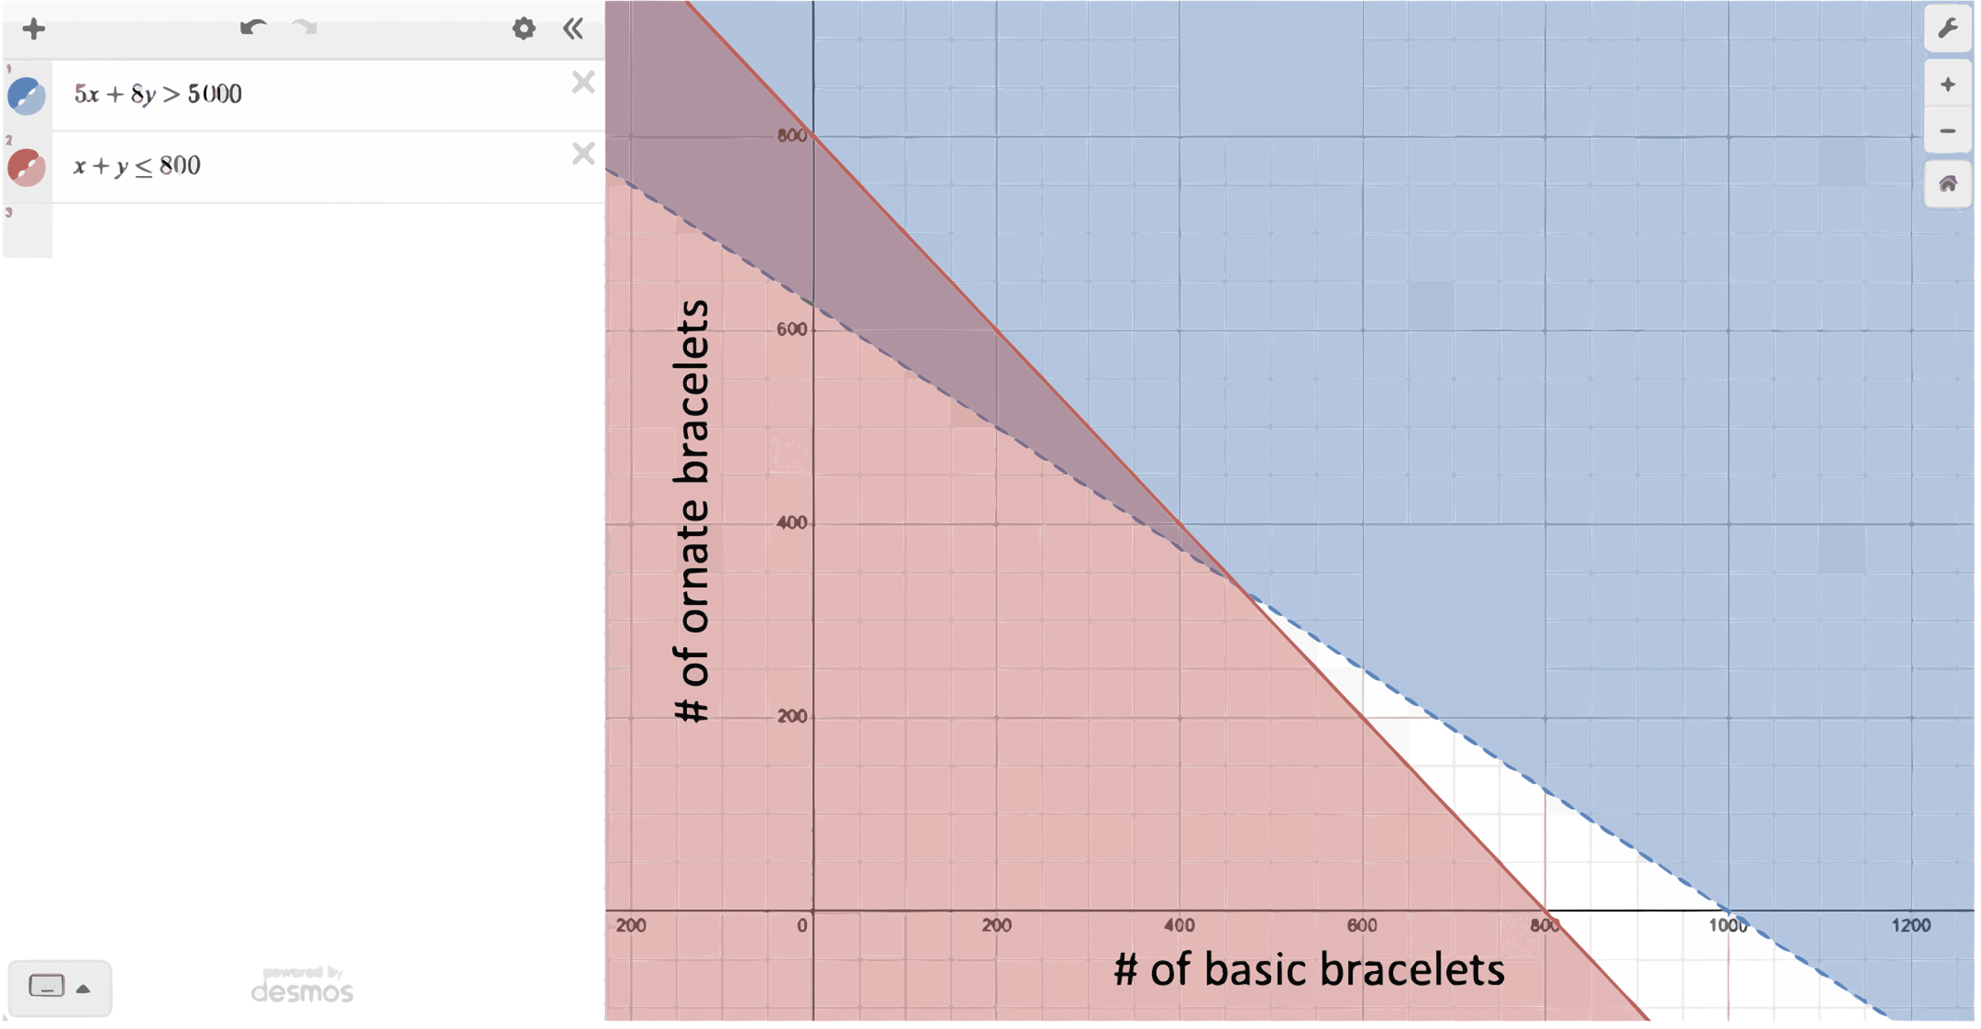

Student Voice: The shaded blue part of the graph represents all the (*x*, *y*) points that are combinations that would generate over $5,000. (The line is dotted because the points on the line would generate exactly $5,000 but not more, so they are not solutions to the blue inequality.) The shaded ret part represents all the (*x*, *y*) points that are combinations that add up to 800 bracelets or less. (This line is solid because exactly 800 bracelets are okay, so those points count.) The section where the blue and red shading overlap (purple) are solutions to the system because they are combinations of basic and fancy bracelets that add up to 800 or less and generate over $5,000.

Figure 6. Student-Generated Graph

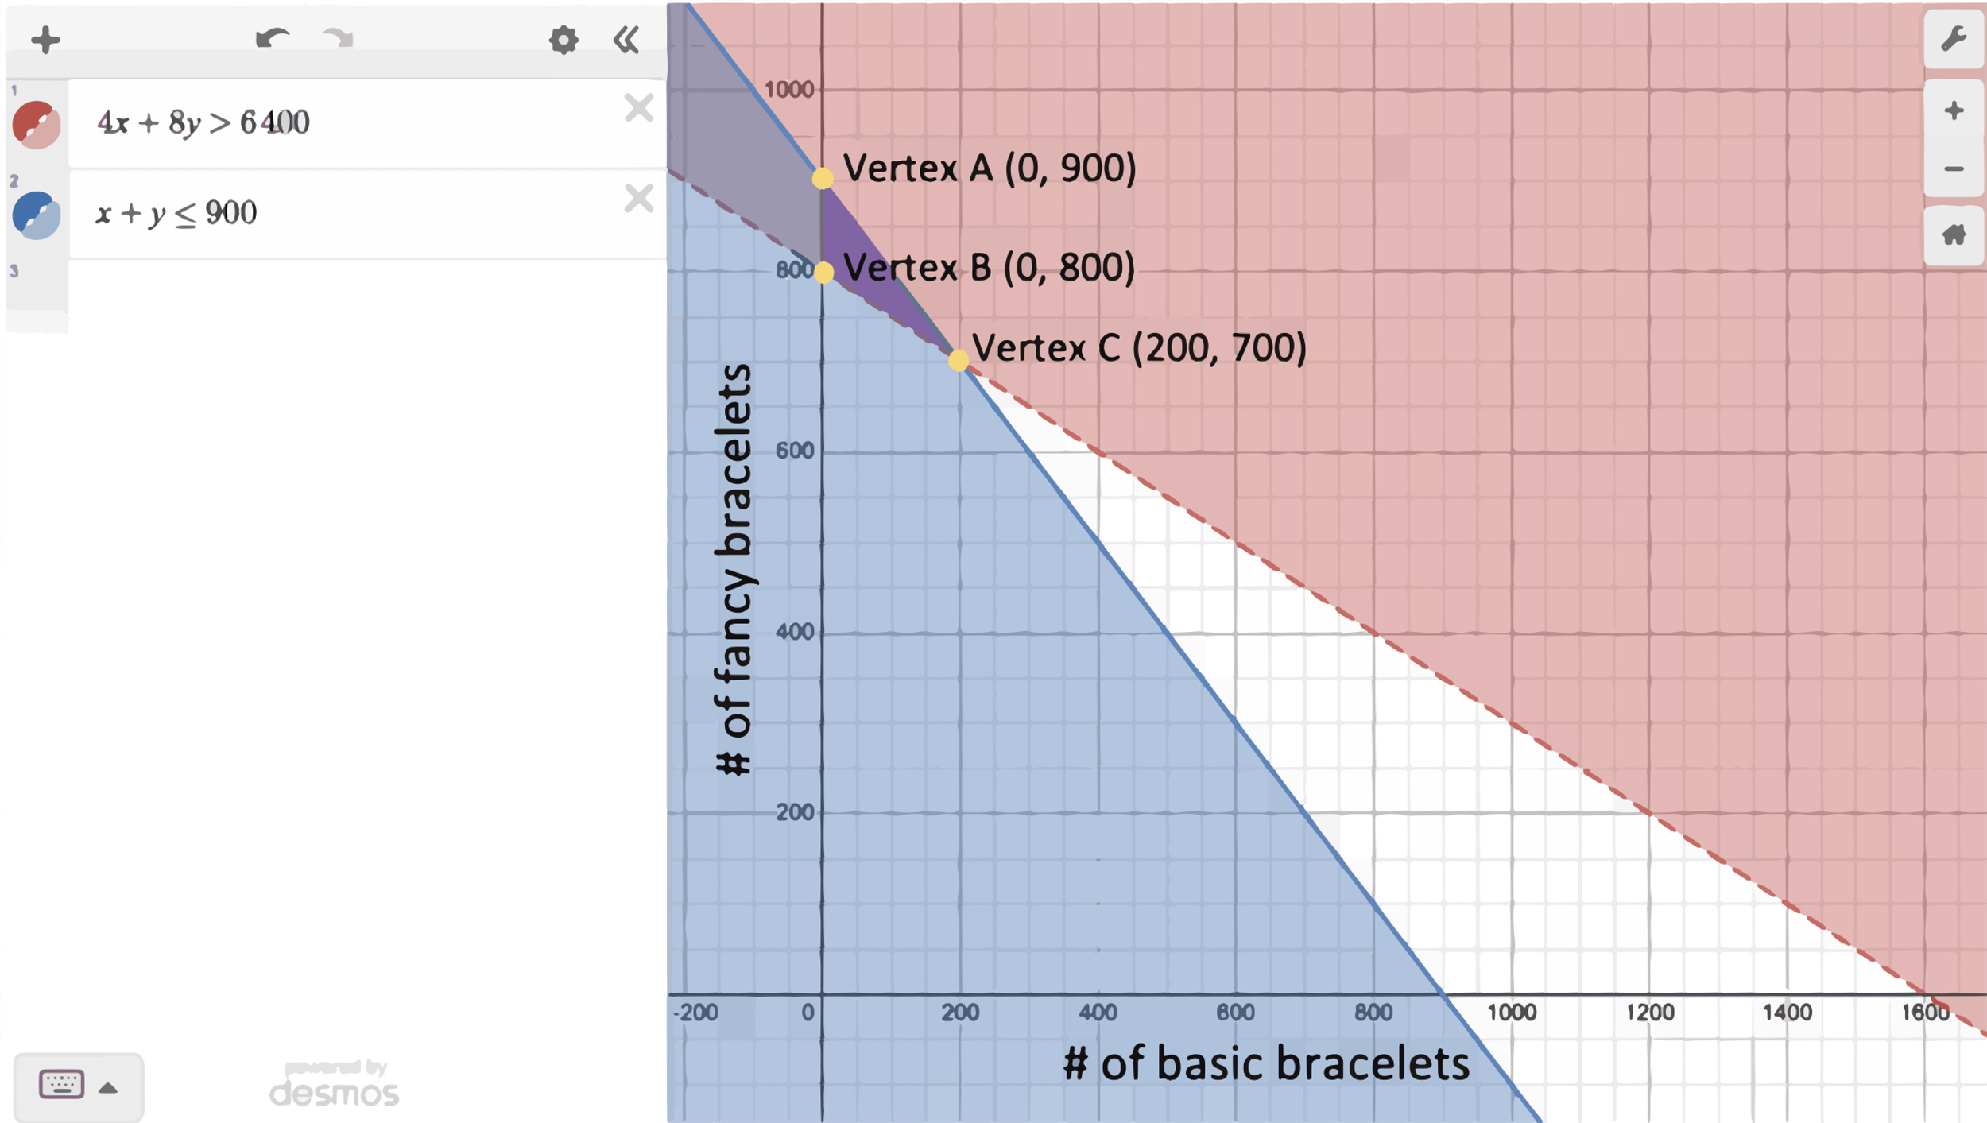

Student Voice: Those are the combinations that the club should consider. By looking at the graph, we can see that the vertices of the triangular solution set are (0, 800) meaning they make no basic bracelets, and 800 fancy bracelets, around (0, 625) meaning they make no basic bracelets and only 625 fancy bracelets, and around (475, 325) meaning they make 475 basic and 325 fancy bracelets. Any point inside this triangle (or on the part of the red line or *y*-axis that makes up the border of the triangle) represents a combination of fancy and basic bracelets that would make 800 bracelets or less and generate over $5,000.

If we want to find the vertices exactly, we have to use algebra.

It’s obvious that vertex A is (0, 800) because it is on the *y*-axis (where *x* = 0), and if we substitute *x* = 0 into *x* + *y* = 800, we get *y* = 800. To find the exact coordinates of vertex B, we can substitute *x* = 0 into 5*x* + 8*y* = 5,000 which gives us 8*y* = 5,000 🡪 *y* = 5,000/8 = 625. (So, it turns out our eyeball guess was exactly right.) To find the exact coordinates of vertex C, we have to find the point where the lines *x* + *y* = 800 and 5*x* + 8*y* = 5,000. That is, we have to find the solution of the system $\left\{5x+8y=5,000 x+y=800 \right\}$.

One way to solve the system is to multiply the second equation by -8 on both sides to get

$$\left\{\begin{aligned}5x+8y=5,000 \\ -8x+\left(-8\right)y=-8∙800 \end{aligned}\right\}$$

$$\left\{\begin{aligned}5x+8y=5,000 \\ -8x-8y=-6,400 \end{aligned}\right\}$$

Then, add the two together to get $-3x=-1,400.$ This shows us that $x=\frac{-1,400}{-3}=466\frac{2}{3}$. Since $x+y=800$, that means $y=800-466\frac{2}{3}=333\frac{1}{3}$. So, the exact coordinates of vertex C are $\left(466\frac{2}{3}, 333\frac{1}{3}\right)$, which are pretty close to our eyeball estimate of (475, 325).

If they pick any combination of bracelets inside the purple triangle (or on the part of the red line or *y*-axis that makes up the border of the triangle), they will satisfy both constraints.

PART 3. Proving an Important Property of Systems: Type III Row Operations

This performance task outlines the following:

* associated standards that will be assessed
* rubrics that assess each item
* student task requirements
* sample student responses

Teachers should familiarize themselves with the related standards, review the student task, peruse each item’s rubric, and view the sample student responses to sufficiently prepare for students to use this performance task to show proficiency in this task.

Task Alignment to Key Elements of Big Ideas and Standards

Systems of Equations: Big Idea Indicator 1

Students investigate real situations that include data for which systems of one or two equations or inequalities are helpful, paying attention to units. Investigations include linear, quadratic, and absolute value [relationships].

Related Standards

* **Solve systems of equations.** [Linear-linear and linear-quadratic]
  + *(Item 1)* **A-REI.5** Prove that, given a system of two equations in two variables, replacing one equation by the sum of that equation and a multiple of the other produces a system with the same solutions.

Part 3. Items

The following year, Deborah’s club created the following system of equations to determine how much to charge for their spirit bracelets.

|  |  |
| --- | --- |
| SYSTEM A: |  |

Deborah first multiplied both sides of the second equation by 2:

|  |  |  |
| --- | --- | --- |
|  | à |  |

Then she replaced the second equation with the sum of the two equations:

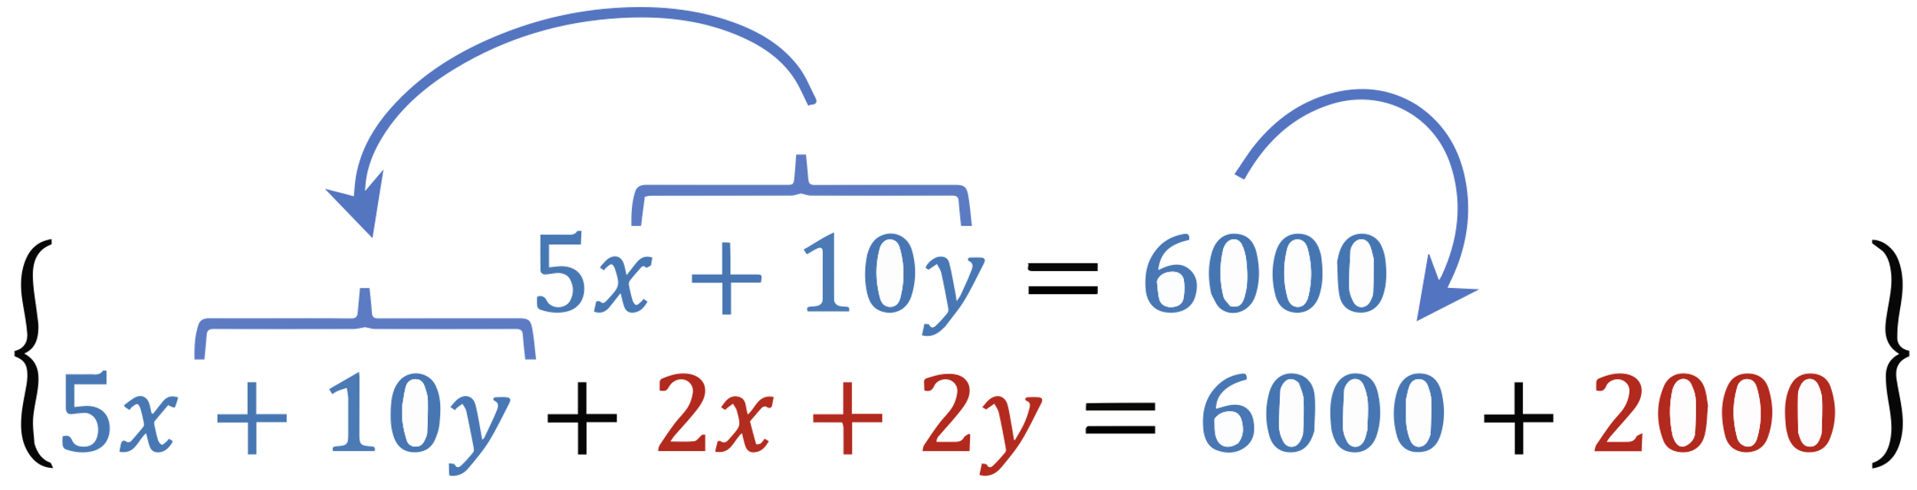

|  |  |
| --- | --- |
| SYSTEM B: |  |

She says that any time you follow this process, the new system you get will have the **same solution set** as the original system.

Item 1

Item 1 has no sub-items. Complete the task below.

Item 1 Task

Use mathematics tools and strategies to show and explain why this is (**A-REI.5**).

A Rubric for Assessing a Response to Item 1

**A-REI.5** Prove that, given a system of two equations in two variables, replacing one equation by the sum of that equation and a multiple of the other produces a system with the same solutions.

Table 5. Rubric for Item 1

| Attempted | Approaching | Proficient |
| --- | --- | --- |
| The student attempts to explain why replacing an equation in a system with a multiple of that equation or with the sum of that equation and a multiple of the other gives a system with the same solutions as the original, but there are multiple major conceptual errors. —OR— The explanation is missing or so unclear and imprecise that it is not possible to determine the student’s level of conceptual understanding. | The student correctly explains one of the statements under “proficient” with no major conceptual errors.  The student's explanation may lack clarity, specificity, or precise language, but overall is generally conceptually correct.  A few minor errors may be present. | The student correctly explains why replacing an equation in a system with a multiple of that equation creates a new system with the same solutions as the original system (for example, by noting that an equation and all its multiples are simultaneous equations or by showing and explaining algebraically that the two must have the same solutions).  The student correctly explains why adding one true equation to another true equation creates a third true equation (that is because adding the same value to both sides of a true equation keeps it in balance). |

Part 3. Sample Student Responses

The content below provides a sample of proficient responses from a student. The text that leads with “Student Voice” is an example of how a student might respond to each item. This section should only serve as a model—different students will arrive at solutions in different ways.

Item 1

The following year, Deborah’s club created the following system of equations to determine how much to charge for their spirit bracelets.

|  |  |
| --- | --- |
| SYSTEM A: |  |

Deborah first multiplied both sides of the second equation by 2:

|  |  |  |
| --- | --- | --- |
|  | à |  |

Then she replaced the second equation with the sum of the two equations:



|  |  |
| --- | --- |
| SYSTEM B: |  |

She says that any time you follow this process, the new system you get will have the **same solution set** as the original system.

Item 1

Use mathematics tools and strategies to show and explain why this is.

Student Voice: Any time we multiply both sides of an equation by the same number, the new equation will have the same solutions as the original. We can see this if we graph an equation and its “multiples.” They all have the same graph, which means that they have the same set of solutions.

Figure 7. Student-Generated Graph

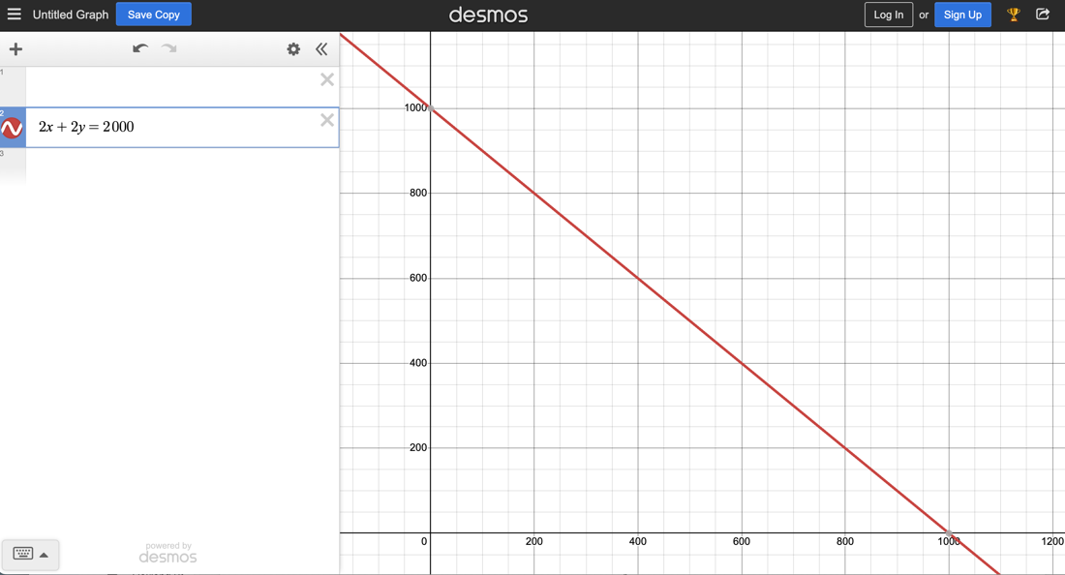

Figure 8. Student-Generated Graph

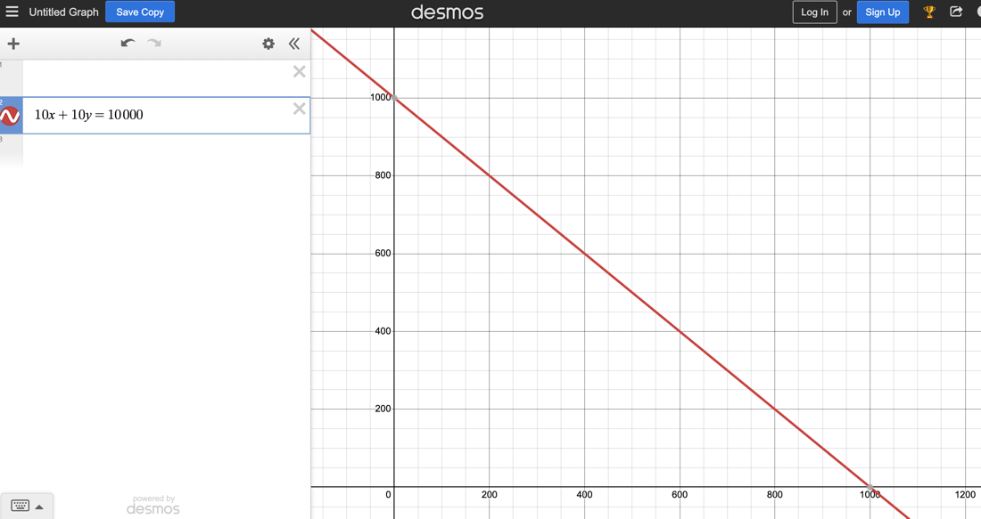

Figure 9. Student-Generated Graph

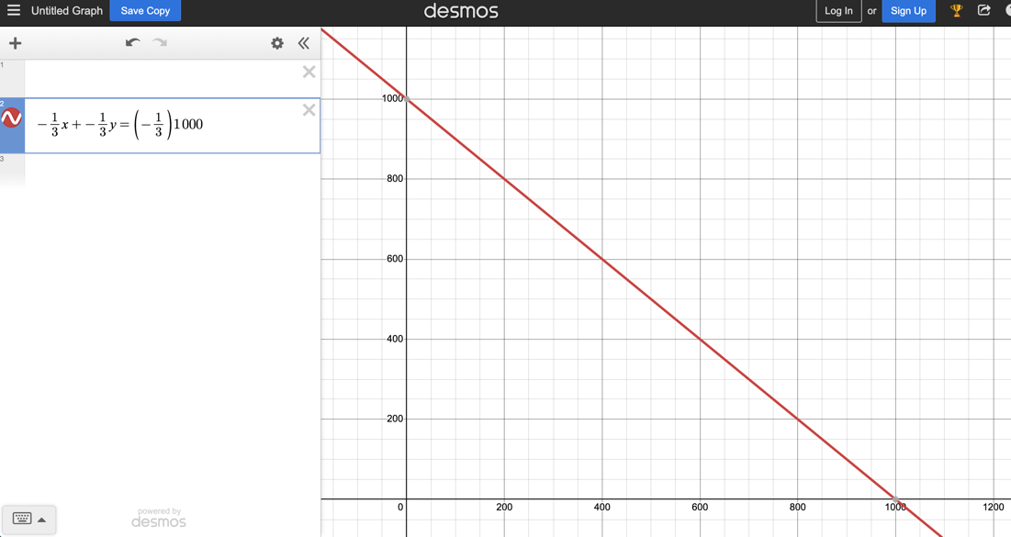

Student Voice: Another way to see this is to suppose that (*a*, *b*) is a solution to an equation like $x+y=1,000$. That is, $a+b=1,000$. If $a+b=1,000$ is a true equation, then $k∙a+k∙b=k∙1,000$ must also be a true equation. So (*a*, *b*) is also a solution to $kx+ky=1,000k$.

If you have a system of two equations and multiply both sides of one of the equations by any number, you haven’t changed the solutions of that equation. That means the solutions to the system can’t have changed, either.

We can also see by looking at graphs that an equation that is the sum of the two equations in the system (the red line) passes through the point of intersection of the two equations in the system (the green and black lines). So, we could replace either of those equations with this new equation and still have the same point of intersection (which is the solution of the system).

Another way to see this is to suppose that point (*a*, *b*) is the solution of this system. So $5a+9b=6,000$ and $a+b=1,000$. If $5a+9b$ and 6,000 are the same amount and we add that same amount to each side of $a+b=1,000$, then the new equation will still be balanced (because we are adding the same amount to both sides).

We would have $\left(5a+9b\right)+\left(a+b\right)=6,000+1,000$, or $6a+10b=7,000$. We can see that the point (*a*, *b*) is still a solution for this new equation.

So, we know that if we multiply one equation by some number to create a new system, that system will still have the same solution as the original one. If we then add the two equations together and replace one of them with the new equation, it will also still have the same solution. Therefore, replacing one equation in the system with the sum of that equation and a multiple of the other will always produce a system with the same solutions as the original system.

Figure 10. Student-Generated Graph

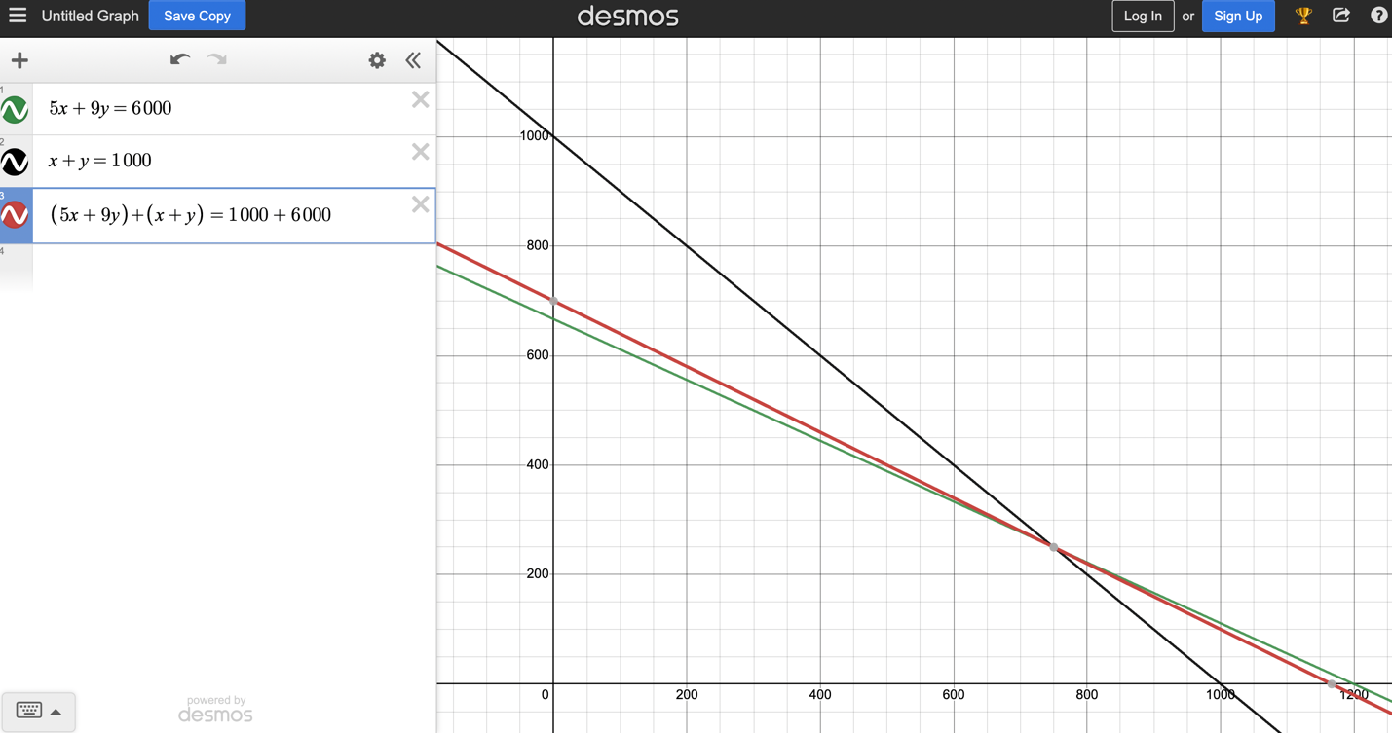

1. As an example from a sample task, clarifying the idea that Deborah might be willing to make more bracelets if she knows she can sell them for more money (this is what table 1 is showing); clarifying that the equation $f\left(x\right)=2.5{\left(x-20\right)}^{2}$ should be interpreted as meaning, “If bracelets cost *x* dollars, *y* people will buy them.” Students are not being assessed on their understanding of supply and demand curves, so it appropriate to discuss this idea more with students to ensure they understand the context well enough to make sense of how they can use mathematics to solve the problem.
2. In this situation, it is important for the scribe to be careful to record only what the student explicitly communicates, rather than making interpretations and “filling in the blanks.”
3. There are many valid ways to solve this equation; this is just one possible way.