Mathematics I – Geometry Supertask

Shapes and Structures, Building with Triangles, & Transformations and Congruence

Option #1 Performance Task |   
Teacher Document

Authors: Initiative Team

April 30, 2024

Table of Contents

Overview of the Performance Task 1

[Administering the Performance Task and Embedding   
Resources for Students 2](#_Toc171626072)

Key Vocabulary Associated with the Standards 2

Strategies for Supporting Students 2

Potential Alternative Means of Expression 5

[PART 1. Using Coordinates To Prove Theorems and   
Solve Problems 6](#_Toc171626076)

Task Alignment to Key Elements of Big Ideas and Standards 6

Part 1. Items 8

Part 1. Sample Student Responses 10

PART 2. Congruence, Rigid Motion, and Constructions 15

Task Alignment to Key Elements of Big Ideas and Standards 15

Part 2. Items 16

Part 2. Sample Student Responses 19

PART 3. Transformations in the Plane 25

Task Alignment to Key Elements of Big Ideas and Standards 25

Part 3. Items 26

Part 3. Sample Student Responses 35

Overview of the Performance Task

This performance task evaluates students’ understanding of key concepts within the Mathematics I Shapes and Structures, Building with Triangles, and Transformations and Congruence Big Ideas. It is divided into parts, with each targeting specific overlapping components of these three Big Ideas related to plane geometry. Each part offers accessible strategies and examples of how students can demonstrate proficiency with the concepts. Various tools, mediums, and connections are provided for teachers to customize the task to the unique needs, cultures, interests, and abilities of their students to promote an inclusive and relevant educational experience.

When preparing to administer this performance task, the teacher needs to distinguish between flexible and fixed elements to ensure students have multiple ways to demonstrate their knowledge without compromising the depth and rigor of the standards. As always, educators should also consult the student’s Individualized Education Program (IEP) to ensure that all required accommodations and supplementary aids are provided during the assessment.

Additional information on providing alternative means of expression can be found in the Best Practice Guide and content-aligned Practice Briefs created as part of the Inclusive Access to a Diploma: Reimagining Proficiency for Students with Disabilities Initiative.

Administering the Performance Task and  
Embedding Resources for Students

Each part of this task is broken into a series of Items for administration. This section provides guidance to the educator on how to administer the task and how to support the student in demonstrating their understanding of the Big Ideas which should be reviewed before the task is implemented with students. As you are planning to administer this performance task, it is suggested to review these recommendations as they offer associated key vocabulary, appropriate and inappropriate supports, and potential methods and means of expression.

Key Vocabulary Associated with the Standards

The key vocabulary terms provided are essential to the concepts within the Big Ideas, therefore unless otherwise noted, the vocabulary cannot be taught during completion of the task.

* coordinate points, square, parallel lines, perpendicular lines, distance formula, Pythagorean Theorem, transformation and rigid transformations, perimeter, slope, translation, reflection, line of reflection, rotation, center of rotation congruence, polygon, hypotenuse, angle of rotation, pre-image and image, corresponding points, and line segments

Strategies for Supporting Students

The following sections describe appropriate and inappropriate resources to provide students as they complete a task.

Appropriate Resources

Appropriate resources maintain the rigor of the standards while also accommodating any student difficulties such as confusion or anxiety while providing a resource the student could use to complete the task.

* reading the item to the student
* answering clarifying questions related to the key vocabulary, for example
  + Part 1 “coordinate points” mean writing a point as (*x*, *y*), “vertex” is the corner point of a square, “perimeter” is the length all around a shape
  + Part 2 “polygon” is a shape with sides as line segments and vertices connecting these line segments
  + Part 3 “What are corresponding pre-image and image points?”
* helping the student to make sense of the item by asking questions such as, “What is this question asking you to figure out? What important information does the question give you? Are there any words you want to ask about or look up?”
* offering drawing tools (graph paper, pencil, colored pencils, highlighters, straight edge, compass, protractor, computer drawing technology, multiple copies of the same provided graphs, adaptive materials, assistive technology)
* helping the student to *access resources* by reminding them of the meaning of mathematical terms
* providing multiple copies of the graphed images (on large graph paper)
* providing manipulatives to design polygon *ABCDE* in Part 2[1] and *△ABC* in Part 3[2]
* printing images on larger sheets of graph paper
* allowing students to complete different parts or items over an extended period (versus completing an entire task or part in one sitting)

Inappropriate Resources

The inappropriate resources identify what assistance should be avoided as it may alter the rigor of the standards and negatively impact the student’s ability to independently demonstrate proficiency and be objectively scored on that task.

* explaining to students how to use resources such as a compass or protractor
* reteaching mathematics concepts (such as the Pythagorean Theorem or distance formula, attributes of rigid transformation)
* demonstrating how to solve a similar problem so the student can reproduce the teacher’s strategy

Potential Alternative Means of Expression

Potential methods and means of expression show the various ways students can demonstrate their knowledge of the standards being assessed in this part of the task.

The following options provide additional ways students might demonstrate their knowledge of the standards being assessed.

Students can complete this task by

* using graph paper,[3] pen or pencil, colored pencils or highlighters, straight edge, compass, and/or protractor
* using scientific or graphing calculators
* using graphing technology such as GeoGebra or Desmos
* annotating a paper or digital copy of a geometry image
* using verbal expression or text-to-speech software to describe the results (for example, in Part 3 describing why and how they would perform a transformation)
* dictating to a scribe[4]

PART 1. Using Coordinates To Prove Theorems and Solve Problems

Part 1 of this performance task outlines the following:

* associated standards that will be assessed
* student task requirements
* rubrics that assess each item
* sample student responses

Teachers should familiarize themselves with the related standards, review the student task, explore each item’s rubric, and view the sample student responses to sufficiently prepare students to use this performance task to show proficiency in this task. Additionally, teachers must be careful to incorporate any IEP-defined supplementary aids and services specific to individual students with disabilities taking this performance task.

Task Alignment to Key Elements of Big Ideas and Standards

Clusters of content standards exist within the Big Ideas allowing the Big Ideas to demonstrate the central concepts and key understandings of the course content. The indicator statements provide the teacher with the key concepts being evaluated in each Big Idea as well as the associated content standards centered within the Big Idea of this task and come from the 2023 *Mathematics Framework for California Public Schools: Kindergarten Through Grade Twelve* (*Math Framework)* and are aligned to California adopted mathematics state standards.

Shapes in Structure: Big Idea Indicator 2

Study the changes in coordinates and express the changes algebraically.

Building with Triangles: Big Idea Indicator 1

Investigate with geometric figures, constructing figures in the plane, relating the distance formula to the Pythagorean Theorem, and noticing how areas and perimeters of polygons change as the coordinates change.

Transformations and Congruence: Big Idea Indicator 2

Investigate transformations in the plane. Use geometry software to study transformations, developing definitions of rotations, reflections, and translations in terms of angles, circles, perpendicular lines, and parallel lines.

Transformations and Congruence: Big Idea Indicator 3

Express translations algebraically.

Related Standards

* **Use coordinates to prove simple geometric theorems algebraically.** [Include distance formula; relate to Pythagorean Theorem]
  + *(Item 1a)* **G-GPE.4** Use coordinates to prove simple geometric theorems algebraically.
  + *(Item 1a)* **G-GPE.5** Prove the slope criteria for parallel and perpendicular lines and use them to solve geometric problems (for example, find the equation of a line parallel or perpendicular to a given line that passes through a given point).
  + *(Item 1b)* **G-GPE.7** Use coordinates to compute perimeters of polygons and areas of triangles and rectangles, for example, using the distance formula.

Part 1. Items

The following coordinate points are three vertices of a square: (-5, 4) (-7, -1) (0, 2). The focus of this task is for students to show their understanding of shapes using proof and algebraic knowledge.

Item 1

Item 1 is broken into two sub-items.

Use your knowledge of properties of squares, parallel and perpendicular lines, the distance formula, the Pythagorean Theorem, and/or transformations to solve the following tasks. (**G-GPE.4, G-GPE.5**).

Item 1a [Student Document (A)]

What are the coordinates (*x*, *y*) of the fourth vertex of this square? Without using a ruler or protractor, prove that this shape is a square.

A Rubric for Assessing a Response to Item 1a

**G-GPE.4** Use coordinates to prove simple geometric theorems algebraically.

**G-GPE.5** Prove the slope criteria for parallel and perpendicular lines and use them to solve geometric problems (for example, find the equation of a line parallel or perpendicular to a given line that passes through a given point).

Rubric for Item 1a

| Attempted | Approaching | Proficient |
| --- | --- | --- |
| The student attempts to graph the three given points and/or to find a fourth point.  The justification is missing or so unclear that it is not possible to determine the student’s level of understanding. | The student finds the fourth point of the square (-2, -3).  The student attempts to justify mathematically why the points form a square, but the justification is only partially correct or not fully thorough (for example, only considering slope but not connecting this to show how the lengths are congruent; or discussing how the sides are parallel but not showing they are congruent; or they created a graph that looks like a square but do not rigorously prove that the angles are right). | The student finds the fourth point of the square (-2, -3).  The student rigorously proved that the four points create a square by showing that  all four side lengths are congruent, and  all four angles are right angles. |

Item 1b

For Item 1b, use the information gathered in Item 1a [Student Document (A)] to complete the task below (**G-GPE.7**).

Item 1b [Student Document (B)]

Find the perimeter of the square. Show all calculations.

A Rubric for Assessing a Response to Item 1b

**G-GPE.7** Use coordinates to compute perimeters of polygons and areas of triangles and rectangles, for example, using the distance formula.

Rubric for Item 1b

| Attempted | Approaching | Proficient |
| --- | --- | --- |
| The student attempts to find the lengths but the answers are incomplete or incorrect. | The student response shows calculations for the distance of each length using either the distance formula or Pythagorean Theorem and then uses this to calculate the final perimeter of the square, with minor calculation errors. The student knows how to use the distance formula or Pythagorean Theorem. | The student response shows calculations for the distance of each length using either the distance formula or Pythagorean Theorem and then, uses this to calculate the final perimeter of the square. |

Part 1. Sample Student Responses

The content below provides a sample of proficient responses from a student. The text that leads with “Student Voice” is an example of how a student might respond to each item. This section should only serve as a model—different students will arrive at solutions in different ways.

Item 1

Item 1 is broken into two sub-items.

Use your knowledge of properties of squares, parallel and perpendicular lines, the distance formula, the Pythagorean Theorem, and/or transformations to answer the following question.

Item 1a [Student Document (A)]

What are the coordinates (*x*, *y*) of the fourth vertex of this square? Without using a ruler or protractor, prove that this shape is a square.

Student Voice: The fourth point is (-2, -3).

In this graph, the student graphed the 3 given points, (-5, 4), (-7, -1), and (0, 2), creating a red line segment between (-5, 4) and (-7, -1) and a blue line segment between (-5, 4) and (0, 2). They then created slope triangles for each of these line segments and noted the lengths of each of the vertical and horizontal line segments of these triangles. The student then created a slope triangle from the point (-7, -1) that mirrored the line segment’s slope triangle from (-5, 4) and (0, 2), going down 2 and 5 to the right, landing at the point (-2, -3). Similarly, they also created a slope triangle from the point (0, 2) that mirrored the line segment’s slope triangle from   
(-5, 4) and (-7, -1), going down 5 and 2 to the left, also landing at the point (-2, -3), which is their fourth point of the square.

Figure 1. Sample Student-Generated Response

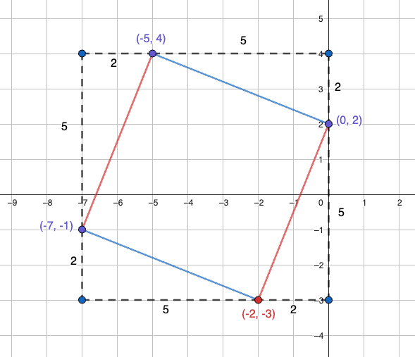

Student Voice: To prove that (-2, -3) creates a square with the given points (-5, 4), (-7, -1), and (0, 2), I wanted to show that all four sides are equal length and that all four angles are 90°.

All 4 sides are congruent:

I used the distance formula (or Pythagorean Theorem) to find the distance between the points (-5, 4) and (-7, -1):

$$\sqrt{{(-5--7)}^{2}+{(4--1)}^{2} }=d$$

$$\sqrt{{(2)}^{2}+{(5)}^{2}}=d$$

$$\sqrt{4+25}=d$$

$$\sqrt{29}=d$$

Similar calculations are shown for the distance of the other three lengths all equaling $\sqrt{29}$:

distance between (-7, -1) and (-2, -3) = $\sqrt{29}$

distance between (-2, -3) and (0, 2) = $\sqrt{29}$

All 4 angles are 90°:

I know that perpendicular lines, lines that intersect and give a 90°, have slopes that are the opposite reciprocal of each other, so if the slope of the sides between (-7, -1) and (-5, 4) and the side between (0, 2) and (-2, -3) is $\frac{5}{2}$, then the other two sides must have a slope of $-\frac{2}{5}$ to be opposite reciprocals and are then therefore right angles. Looking at the graph, I used a slope triangle to confirm that the slopes of the sides (-7, -1) and (-2, -3) is $-\frac{2}{5}$ and so is the slope between (-2, -3) and (0, 2).

Other possible correct responses

The bullet points below describe other potential response types.

* Students might also use the distance formula instead of the Pythagorean Theorem. Students may use the distance formula and Pythagorean Theorem synonymously.
* Students might also use input-output tables to find the slope.
* They might also use their knowledge of transformations to find the point, such as
  + translating the top side of the square down 5 and 2 to the right, to get the fourth point;
  + since translating the points (-5, -4) to (-7, -1) is (x–2, y–5), then the new point would be (0–2, 2–5) = (-2, -3); or
  + rotating the left side of the square clockwise 90° means that since the slope is $\frac{5}{2}$ the slope from (-7, -1) needs to be $-\frac{2}{5}$, moving down two and 5 to the right to get (-2, -3).

Item 1b [Student Document (B)]

For Item 1b, use the information gathered in Item 1a [Student Document (A)] to complete the task below.

Without using a ruler or protractor, prove that this shape is a square and find its perimeter. Use your knowledge of properties of squares, parallel and perpendicular lines, the distance formula, the Pythagorean Theorem, and/or transformations.

Student Voice: Using the Pythagorean Theorem (or distance formula), I found the length of each side.

Use the slope triangle lengths of 2 and 5, to find the hypotenuse length:

$${(2)}^{2}+{(5)}^{2}=c^{2}$$

$$4+25=c^{2}$$

$$29=c^{2}$$

$$c=\sqrt{29}$$

Since all four sides have slope triangles that are 2 and 5, the side lengths will each be $\sqrt{29}$ units.

So, the perimeter = $\sqrt{29}$ + $\sqrt{29}$ + $\sqrt{29}$ + $\sqrt{29}$ = $4\sqrt{29}$ units (students might also calculate $≈21.54$ units).

PART 2. Congruence, Rigid Motion, and Constructions

Part 2 of this performance task outlines the following:

* associated standards that will be assessed
* student task requirements
* rubrics that assess each item
* sample student responses

Teachers should familiarize themselves with the related standards, review the student task, peruse each item’s rubric, and view the sample student responses to sufficiently prepare students to use this performance task to show proficiency in this task.

Task Alignment to Key Elements of Big Ideas and Standards

Clusters of content standards exist within the Big Ideas allowing the Big Ideas to demonstrate the central concepts and key understandings of the course content. The assessment categories provide the teacher with the key concepts being evaluated in each Big Idea as well as the associated content standards centered within the Big Idea of this task and come from the 2023 California Mathematics Framework and are aligned to California adopted mathematics state standards.

Shapes in Structure: Big Idea Assessment Indicator 1

Perform investigations that involve building triangles and quadrilaterals, considering how the rigidity of triangles and non-rigidity of quadrilaterals influence the design of structures and devices.

Transformations and Congruence: Big Idea Assessment Indicator 2

Explore congruence of triangles, including quadrilaterals built from triangles, through geometric constructions.

Related Standards

The following are standards that align with the assessment category items above:

* **Understand congruence in terms of rigid motions.** [Build on rigid motions as a familiar starting point for development of the concept of geometric proof.]
  + *(Items 2a, 2b)* **G-CO.6** Use geometric descriptions of rigid motions to transform figures and to predict the effect of a given rigid motion on a given figure; given two figures, use the definition of congruence in terms of rigid motions to decide if they are congruent.
  + *(Items 2a, 2b)* **G-CO.7** Use the definition of congruence in terms of rigid motions to show that two triangles are congruent if and only if corresponding pairs of sides and corresponding pairs of angles are congruent.

Part 2. Items

The focus of this item is for students to use their understanding of rigid motions to determine or create congruence between shapes (**G-CO.6, G-CO.7**).

The diagram below shows three polygons you will use as you construct your responses.

Figure 2. [Student Document Figure 1.] Diagram of Three Polygons

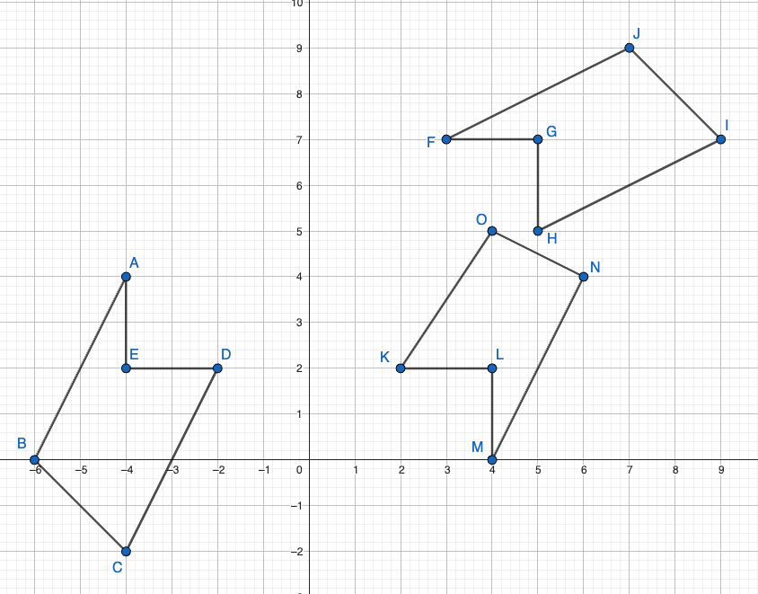

Item 1

Item 1 is broken into two sub-items.

Use your understanding of congruence and rigid transformations to answer the following questions. Be sure to name the polygons in order of corresponding vertices.

Item 1a [Student Document (A)]

Which of the three polygons are congruent? Show how you know using your understanding of congruence and rigid transformations. (Be sure to name the polygons in order of corresponding vertices.)

A Rubric for Assessing a Response to Item 1a

**G-CO.6** Use geometric descriptions of rigid motions to transform figures and to predict the effect of a given rigid motion on a given figure; given two figures, use the definition of congruence in terms of rigid motions to decide if they are congruent.

**G-CO.7** Use the definition of congruence in terms of rigid motions to show that two triangles are congruent if and only if corresponding pairs of sides and corresponding pairs of angles are congruent.

Rubric for Item 1a

| Attempted | Approaching | Proficient |
| --- | --- | --- |
| The student attempts to explain whether the polygons are congruent or not, but they do not use rigid transformations to verify congruence. | The student attempts to use transformations to describe why polygons *ABCDE* and *FGHIJ* are congruent **or** why polygon *ABCDE* uses a generally correct, mathematically rigorous strategy.  The explanation may lack clarity, specificity, or *thoroughness* (for example they only show how some of the points are transformed but not all; transformations might be described via visual estimation instead of via mathematically rigorous descriptions and drawings). | The student response proves that polygons *ABCDE* and *FGHIJ* are congruent.  The student justifies this congruence because the same series of transformations (using any combinations of translation, reflection, or rotations for every corresponding point or all corresponding sides) can be used to transform all vertices in *ABCDE* into the corresponding vertices in *FGHIJ*.  The student shows their transformations and demonstrates that the same series that works for all points and results in congruent parts. |

Item 1b [Student Document (B)]

For the polygon that is not congruent to the other two, explain how to edit that polygon so that it is now congruent to the other two polygons, including naming any new points with the new coordinates, (*x*, *y*) and state why this makes the polygon congruent to the other two.

A Rubric for Assessing a Response to Item 1b

**G-CO.6** Use geometric descriptions of rigid motions to transform figures and to predict the effect of a given rigid motion on a given figure; given two figures, use the definition of congruence in terms of rigid motions to decide if they are congruent.

**G-CO.7** Use the definition of congruence in terms of rigid motions to show that two triangles are congruent if and only if corresponding pairs of sides and corresponding pairs of angles are congruent.

Rubric for Item 1b

|  |  |  |
| --- | --- | --- |
| Attempted | Approaching | Proficient |
| The student attempts to say which polygons are not congruent, however, they do not use rigid transformations to verify why they are not congruent. | The student attempts to use transformations to describe that polygon *ABCDE* is not congruent to polygon *MNOKL* but they may not have a thorough explanation (for example they only show how some of the points are transformed but not all; or they try to transform through visual estimation instead of through mathematical descriptions of how they know if it is reflected correctly; they may not correct the out-of-place point using transformations, or the polygons are not named in the order of corresponding points). | The student identifies the correct change to polygon *MNOKL* (moving point *O* from (4, 5) to (4, 6).  The student gives a mathematically rigorous explanation for why this change will result in a polygon that is congruent to *ABCDE* and/or *FGHIJ*. |

Part 2. Sample Student Responses

The content below provides a sample of proficient responses from a student. The text that leads with “Student Voice” is an example of how a student might respond to each item. This section should only serve as a model—different students will arrive at solutions in different ways.

Item 1

Item 1 is broken into two sub-items.

The focus of this item is for students to use their understanding of rigid motions to determine or create congruence between shapes.

Item 1a [Student Document (A)]

Which of the three polygons are congruent? Show how you know using your understanding of congruence and rigid transformations. (Be sure to name the polygons in order of corresponding vertices.)

Student Voice: Polygon *ABCDE* is congruent to polygon *FJIHG*. First, I can reflect polygon *ABCDE* across the line $y=-x$  (or across the line $\overset{⃡}{AD}$  ). Because it is a reflection, the new polygon *A'B'C'D'E' $≅$* polygon *ABCDE*, where *A'*(-4, 4), *B'*(0, 6), *C'*(2, 4), *D'*(-2, 2), *E'*(-2, 4).

Figure 3. Sample Student-Generated Diagram

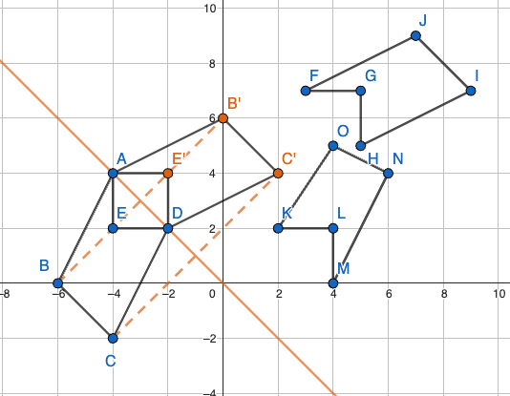

Student Voice: Next, I can translate polygon *A'B'C'D'* 3 units up and 7 units to the right. *F* becomes *A"*, *J* becomes *B"*, *I* becomes *C*", *H* becomes *D*", and *G* becomes *E*". Since I can create polygon *FJIHG* from *ABCDE* with a reflection and a translation, the new polygon *FJIHG $≅$* polygon *ABCDE*.

Figure 4. Sample Student-Generated Diagram

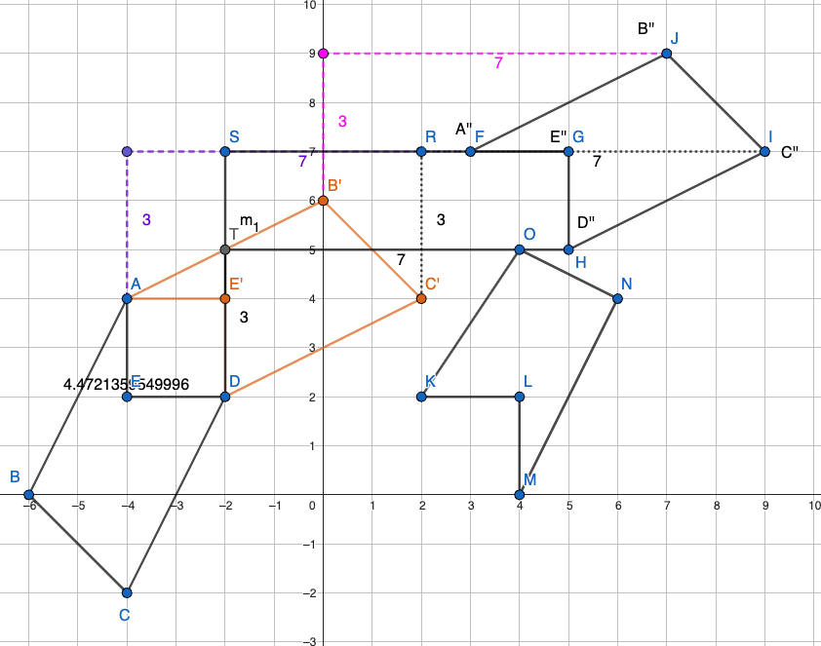

Student Voice: Polygons *ABCD* and *FJIHG* are not congruent to polygon *MNOKL*. First, I rotated the polygon *ABCD* 180° clockwise around point *D* to get my polygon. This new polygon *A'B'C'D*' (at *A'*(0, 0), *B*'(2, 4), *C'*(0, 6), *D'*(-2, 2), *E*'(0, 2)) is congruent to polygon *ABCD* because rotations hold congruence.

Next, I made line segments to connect the corresponding vertices of polygon *A'B'C'D'* to polygon *MNOKL*, which, if it was a rigid translation, then all these new line segments should be parallel and the exact same length. This worked for all points *A'*, *B*', and *D'* which translated 4 units to the right, but point *C*' went at a diagonal, so polygon *MNOKL* is not congruent to polygon *ABCD* because point *O* is out of place.

Figure 5. Sample Student-Generated Diagram

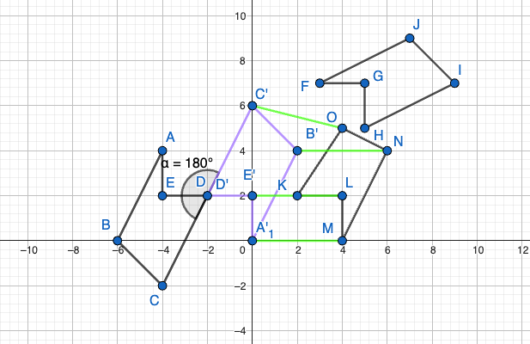

Item 1b [Student Document (B)]

Use the same diagram from Item 1 to answer the following questions.

For the polygon that is not congruent to the other two, explain how to edit that polygon so that it is now congruent to the other two polygons, including naming any new points with the new coordinates, (*x, y*) and state why this makes the polygon congruent to the other two.

Student Voice: To make polygon *ABCD $≅$* polygon *MNOKL*, I can continue my translation that worked for the other points and move *C*' four units to the right or (*x* + 4, *y*) to get a new point *O. C'* is (0, 6), so the new *O* should be at (0 + 4, 6) or (4, 6).

Figure 6. Sample Student-Generated Diagram

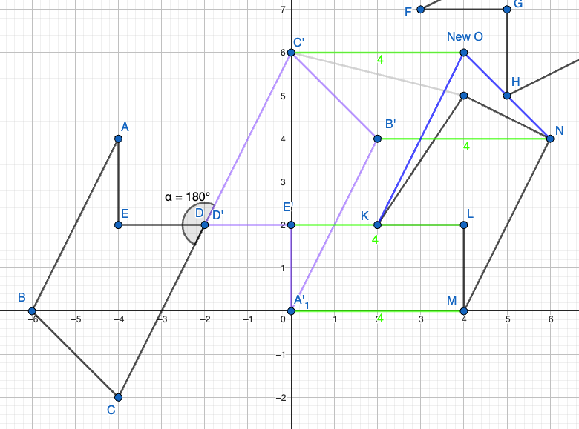

PART 3. Transformations in the Plane

Part 3 of this performance task outlines the following:

* associated standards that will be assessed
* student task requirements
* rubrics that assess each item
* sample student responses

Teachers should familiarize themselves with the related standards, review the student task, peruse each item’s rubric, and view the sample student responses to sufficiently prepare students to use this performance task to show proficiency in this task.

Task Alignment to Key Elements of Big Ideas and Standards

Clusters of content standards exist within the Big Ideas allowing the Big Ideas to demonstrate the central concepts and key understandings of the course content. The assessment categories provide the teacher with the key concepts being evaluated in each Big Idea as well as the associated content standards centered within the Big Idea of this task and come from the 2023 California Mathematics Framework and are aligned to California adopted mathematics state standards.

Building with Triangles: Big Idea Assessment Indicator 2

Build with triangles and quadrilaterals, noticing positions and movement, and creating equations that model the changing edges using technology.

Transformations and Congruence: Big Idea Assessment Indicator 2

Investigate transformations in the plane. Use geometry software to study transformations, developing definitions of rotations, reflections, and translations in terms of angles, circles, perpendicular lines, and parallel lines.

Related Standards

* **Experiment with transformations in the plane.**
  + *(Items 1a, 2a, 3a)* **G-CO.2** Represent transformations in the plane using, for example, transparencies and geometry software; describe transformations as functions that take points in the plane as inputs and give other points as outputs. Compare transformations that preserve distance and angle to those that do not (for example, translation versus horizontal stretch).
  + *(Items 2a, 3a)* **G-CO.3** Given a rectangle, parallelogram, trapezoid, or regular polygon, describe the rotations and reflections that carry it onto itself.
  + *(Items 1b, 2b, 3b)* **G-CO.4** Develop definitions of rotations, reflections, and translations in terms of angles, circles, perpendicular lines, parallel lines, and line segments.

Part 3. Items

On the coordinate plane below, the first triangle in the upper left quadrant is labeled △*ABC*. This triangle is then transformed by a translation, a reflection, and a rotation, to produce the three images in the other quadrants. These images are broken out in different ways for the various tasks in Part 3. Use the following information and read each item to complete the task.

Figure 7. [Student Document Figure 2.] Triangle Images

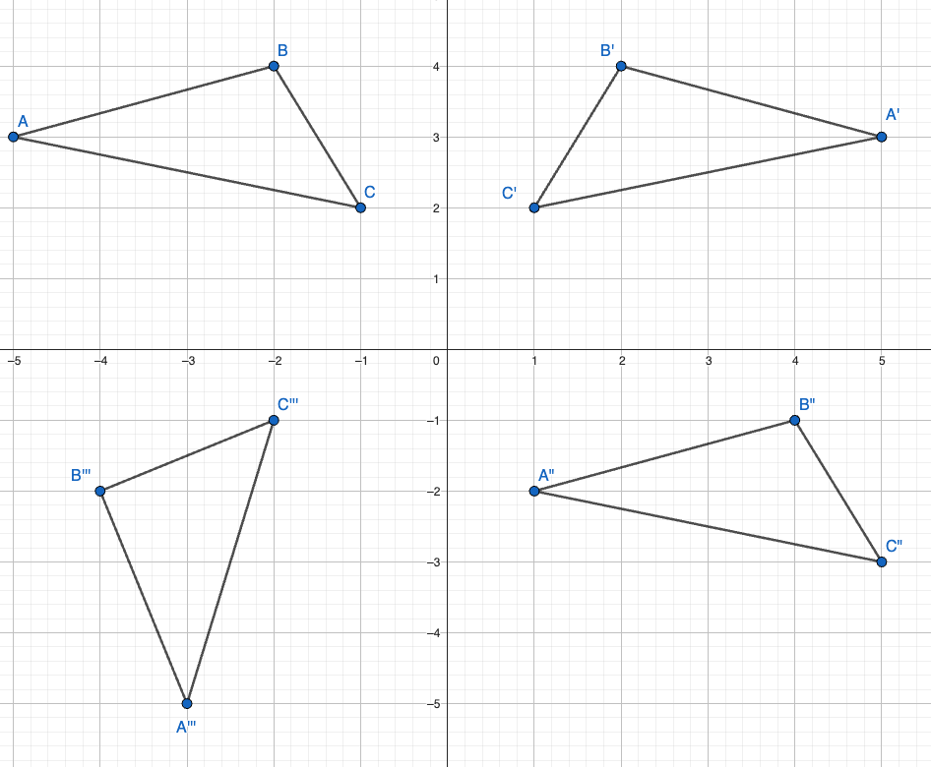

Item 1

Item 1 is broken into two sub-items.

Use the triangle diagram referenced at the start of Part 3 and below to solve Items 1a and 1b (**G-CO.2**, **G-CO.4**).

Figure 8. [Student Document Figure 3.] Triangle Images for Item 1

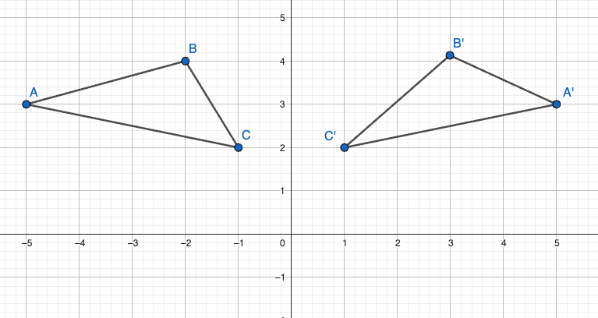

**Item 1a** [Student Document (A)]

For the upper right triangle’s transformation from △*ABC* to △*A′B′C′,* describe the transformation of △*ABC* that results in △*A′B′C′*. Be specific (include when appropriate: distance, direction, line of reflection, center of rotation, or angle of rotation.)

A Rubric for Assessing Item 1a

**G-CO.2** Represent transformations in the plane using, for example, transparencies and geometry software; describe transformations as functions that take points in the plane as inputs and give other points as outputs. Compare transformations that preserve distance and angle to those that do not (for example, translation versus horizontal stretch).

Rubric for Item 1a

| Attempted | Approaching | Proficient |
| --- | --- | --- |
| The student attempts to name a transformation. | The student correctly identifies the transformation as a **reflection** but does not specify the equation of the line of reflection (for example, “You flip it over a line so it is a mirror image”). | The student correctly states that △*A'B'C'* is a **reflection** of △ABC across the line of symmetry that is the *y*-axis (or the line *x* = 0). |

**Item 1b** [Student Document (B)]

For the upper right triangle’s transformation from △ABC to △A′B′C′, explain the properties of this transformation, using line segments between the pre-image and image points and other reference parts on the coordinate plane.

A Rubric for Assessing Item 1b

**G-CO.4** Develop definitions of rotations, reflections, and translations in terms of angles, circles, perpendicular lines, parallel lines, and line segments.

Rubric for Item 1b

| Attempted | Approaching | Proficient |
| --- | --- | --- |
| The student attempts to connect the image to pre-image points but it is not clear from the explanation that the student understands the properties that must be true for all **reflections.** | The student identifies some properties of a **reflection**, though the explanation may lack specificity and thoroughness (for example, they may connect corresponding pre-image to image points and possibly draw congruent marks on the segments but do not show that the measurement between the pre-image and image points and line of reflection are equidistant) rather than a mathematically rigorous way (for example, “the line of reflection is a perpendicular bisector for each line segment connecting the corresponding points from the pre-image and image”). | The student correctly states that in a **reflection**, the line of reflection is a perpendicular bisector for each line segment connecting the corresponding points from the pre-image and image points.  The student gives a rigorous mathematical explanation for how they know this is the case in this problem. |

Item 2

Item 2 is broken into two sub-items.

Use the triangle diagram below and the diagram used at the start of Part 3 to answer the questions below (**G-CO.2**, **G-CO.3, G-GO.4**).

Figure 9. [Student Document Figure 4.] Triangle Images for Item 2

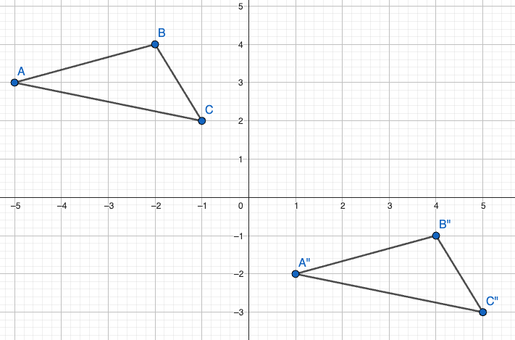

Item 2a [Student Document (A)]

For the bottom right triangle’s transformation from △*ABC* to △*A″B″C″,* describe the transformation of △*ABC* that results in △*A″B″C″.* Be specific (include when appropriate: distance, direction, line of reflection, center of rotation, or angle of rotation).

A Rubric for Assessing Item 2a

**G-CO.2** Represent transformations in the plane using, for example, transparencies and geometry software; describe transformations as functions that take points in the plane as inputs and give other points as outputs. Compare transformations that preserve distance and angle to those that do not (for example, translation versus horizontal stretch).

**G-CO.3** Given a rectangle, parallelogram, trapezoid, or regular polygon, describe the rotations and reflections that carry it onto itself.

Rubric for Item 2a

| Attempted | Approaching | Proficient |
| --- | --- | --- |
| The student attempts to name a **translation**. | The student correctly identifies the transformation as a **translation** but does not specify the number of units or the directions of the translation. | The student correctly states that *△A''B''C''* is a **translation** of *△ABC* and describes this as 6 units to the right and 5 units down. |

Item 2b [Student Document (B)]

For the bottom right triangle’s transformation from *△ABC* to *△A″B″C″,* explain the properties of this transformation, using line segments between the pre-image and image points and other reference parts on the coordinate plane.

A Rubric for Assessing Item 2b

**G-CO.4** Develop definitions of rotations, reflections, and translations in terms of angles, circles, perpendicular lines, parallel lines, and line segments.

Rubric for Item 2b

| Attempted | Approaching | Proficient |
| --- | --- | --- |
| The student attempts to connect the image to pre-image points but does not make a connection to the properties that must be true for all translations. | The student identifies some properties of a **translation**, though the explanation may lack specificity and thoroughness (for example, they might say only one of the attributes of this property, “the line segments connecting the corresponding points from the pre-image and image are congruent,” without mentioning they are also parallel, or say both attributes of the property without rational for how they know this is true, “the line segments are congruent” without a mathematically rigorous justification). | The student correctly states that in a **translation**, the line segments connecting the corresponding points from the pre-image and image will give congruent and parallel line segments.  The student gives a rigorous mathematical explanation for why this is the case in this problem. |

Item 3

Item 3 is broken into two sub-items.

Use the triangle diagram below and the diagram used at the start of the task to answer the questions below (**G-CO.2**, **G-CO.3***,* **G-CO.4**).

Figure 10. [Student Document Figure 5.] Triangle Images for Item 3

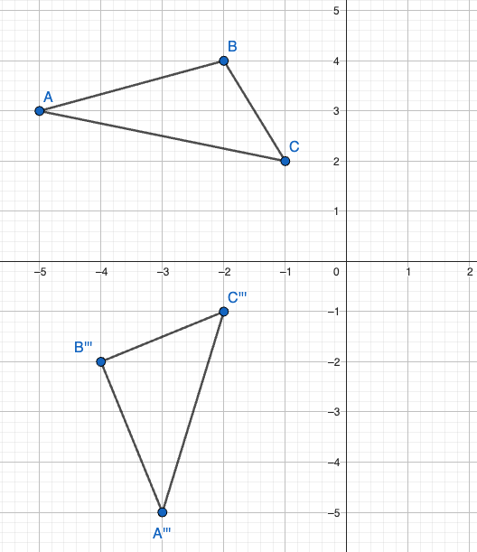

Item 3a [Student Document (A)]

For the bottom left triangle’s transformation from *△ABC* to *△A‴B‴C‴,* describe the transformation of △*ABC* that results in △*A‴B‴C‴*. Be specific (include when appropriate: distance, direction, line of reflection, center of rotation, or angle of rotation).

A Rubric for Assessing Item 3a

**G-CO.2** Represent transformations in the plane using, for example, transparencies and geometry software; describe transformations as functions that take points in the plane as inputs and give other points as outputs. Compare transformations that preserve distance and angle to those that do not (for example, translation versus horizontal stretch).

**G-CO.3** Given a rectangle, parallelogram, trapezoid, or regular polygon, describe the rotations and reflections that carry it onto itself.

Rubric for Item 3a

| Attempted | Approaching | Proficient |
| --- | --- | --- |
| The student attempts to name a transformation but is incorrect. | The student correctly identifies this diagram as a rotation but does not specify the angle, direction, or center point. | The student correctly stated that *△A‴B‴C‴* is a rotation of *△ABC* 90° counterclockwise around a center point of (0, 0). |

Item 3b [Student Document (B)]

For the bottom left triangle’s transformation from *△ABC* to *△A‴B‴C‴,* explain the properties of this transformation, using line segments between the pre-image and image points and other reference parts on the coordinate plane.

A Rubric for Assessing Item 3b

**G-CO.4** Develop definitions of rotations, reflections, and translations in terms of angles, circles, perpendicular lines, parallel lines, and line segments.

Rubric for Item 3b

| Attempted | Approaching | Proficient |
| --- | --- | --- |
| The student attempts to connect the image to pre-image points but does not make a connection to the properties that must be true for all rotations. | The student identifies some properties of a **rotation**, though the explanation may lack specificity and thoroughness (for example, they may not completely show that the line segments connecting the corresponding points from the pre-image and image each have a perpendicular bisector that intersects the center of rotation). | The student correctly states that in a **rotation**, the perpendicular bisectors of each of the line segments connecting the corresponding points from the pre-image and image will all intersect at the point of rotation (the origin in this case) AND is able to show that this is true for this problem. |

Part 3. Sample Student Responses

The content below provides a sample of proficient responses from a student. The text that leads with “Student Voice” is an example of how a student might respond to each item. This section should only serve as a model—different students will arrive at solutions in different ways.

Item 1

Item 1 is broken into two sub-items.

Use the triangle diagram referenced at the start of Part 3 and below to solve Items 1a and 1b (**G-CO.2**, **G-CO.4**).

Figure 11. [Student Document Figure 3.] Triangle Images for Item 1



Item 1a

For the upper right triangle’s transformation from *△ABC* to *△A′B′C′,* describe the transformation of △*ABC* that results in △*A′B′C′*. Be specific (include when appropriate: distance, direction, line of reflection, center of rotation, or angle of rotation.)

**Student Voice:** The transformation from *△ABC* to *△A'B'C'* is a reflection of *△ABC* across the line of reflection that is the *y-*axis to get *△A'B'C'*. See figure 12 for an example.

Figure 12. Student Annotated Diagram

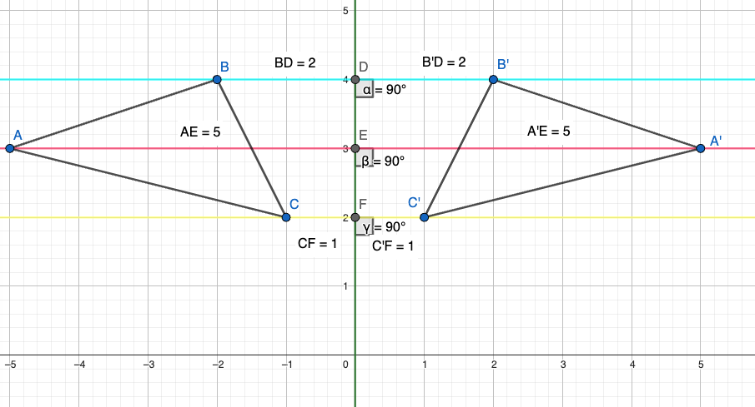

Item 1b

For the upper right triangle’s transformation from *△ABC* to *△A′B′C′,* explain the properties of this transformation, using line segments between the pre-image and image points and other reference parts on the coordinate plane.

**Student Voice:** I know that for a reflection you need to specify a line of reflection. To be a reflection, the line of reflection will be the perpendicular bisector of the line segments created by connecting the corresponding pre-image to image points.

In my picture, figure 11, I connected *A* to *A',* *B*to *B'*, and *C* to *C'*. Each of these lines crosses the *y*-axis or line of symmetry at 90°.

I also measured the distance between each pre-image/image point to the line of symmetry. You can see that these distances are congruent to the distance from the reflected point to the line of reflection. So, in my measurements, *BD = B'D'* = 2 units, *AE = A'E'*= 5 units, *CF = C'F'*= 1 unit.

Therefore, the *y*-axis is the perpendicular bisector of the segments connecting the corresponding pre-image to image points.

Other possible responses

* Students might also say that the line segments created between corresponding points in the pre-image and image are all parallel. This will be true also, but this is also a default of each being perpendicular to the line of symmetry. Thus, if students have this additional statement that is wonderful noticing and they also need the perpendicular relationship and equidistance to the line of symmetry.
* Students might also say this is a reflection because for each point (*x*, *y*) the reflection point is (*x*, -*y*). While this is true and enough to state it is a reflection, this does not satisfy explaining the properties of reflections.

Item 2

Item 2 is broken into two sub-items.

Use the triangle diagram below and the diagram used at the start of Part 3 to answer the questions below (**G-CO.2**, **G-CO.3, G-GO.4**).

Figure 13. [Student Document Figure 4.] Triangle Images for Item 2



Item 2a

For the bottom right triangle’s transformation from *△ABC* to *△A″B″C″,* describe the transformation of △*ABC* that results in △*A″B″C″.* Be specific (include when appropriate: distance, direction, line of reflection, center of rotation, or angle of rotation.)

**Student Voice:** *△ABC* to *△A″B″C″* is a translation 6 units to the right and 5 units down, which you can see in figure 14.

Figure 14. Student Annotated Diagram

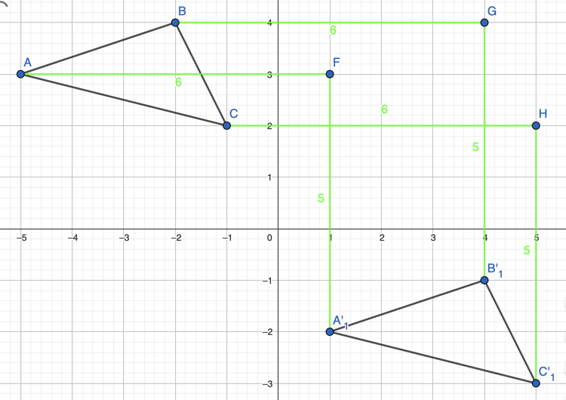

Item 2b

For the bottom right triangle’s transformation from *△ABC* to *△A″B″C″,* explain the properties of this transformation, using line segments between the pre-image and image points and other reference parts on the coordinate plane.

**Student Voice:** I know this is a translation because when I connect the corresponding pre-image and image points, you see parallel line segments that are also congruent. My second picture in figure 15 below shows the parallel lines that each have a length of about 7.81 units (students can use dynamic geometry tools or rulers to confirm this, as well as the Pythagorean Theorem or distance formula).

Figure 15. Student Annotated Diagram

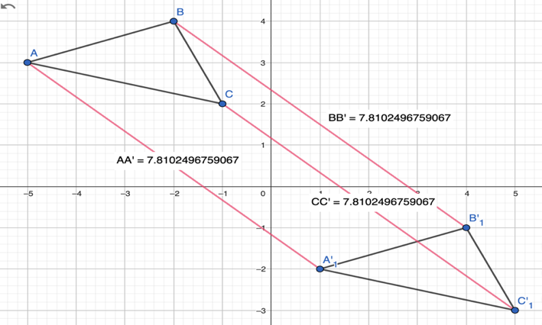

Item 3

Item 3 is broken into two sub-items.

Use the triangle diagram below and the one used at the start of the task to answer the questions below (**G-CO.2**, **G-CO.3***,* **G-CO.4**).

Figure 16. [Student Document Figure 5.] Triangle Images for Item 3



Item 3a

For the bottom left triangle’s transformation from *△ABC* to *△A‴ B‴ C‴,* describe the transformation of △*ABC* that results in △*A‴ B‴ C‴.* Be specific (include when appropriate: distance, direction, line of reflection, center of rotation, or angle of rotation).

**Student Voice:** This transformation of *△ABC* that results in *△A‴B‴C‴* is a rotation of 90° counterclockwise around a center point of (0, 0) or the origin that you can see in figure 17.

Figure 17. Student Annotated Diagram

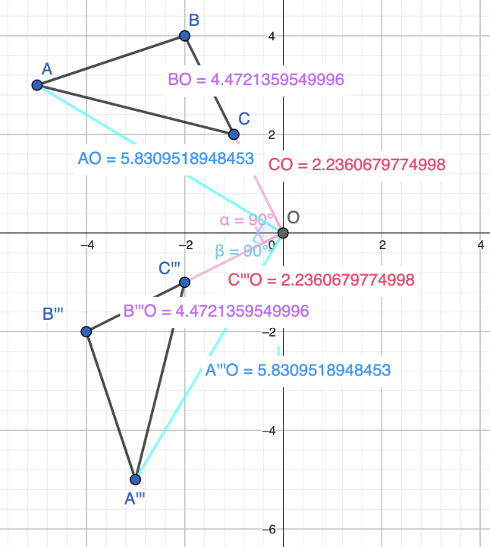

Item 3b

For the bottom left triangle’s transformation from *△ABC* to *△A‴B‴C‴,* explain the properties of this transformation, using line segments between the pre-image and image points and other reference parts on the coordinate plane.

**Student Voice:** When I created the line segments that connect each corresponding pre-image to image points, the perpendicular bisector for each of these will go through the center point of (0, 0) or the origin, which you can see in figure 18.

Figure 18. Student Annotated Diagram

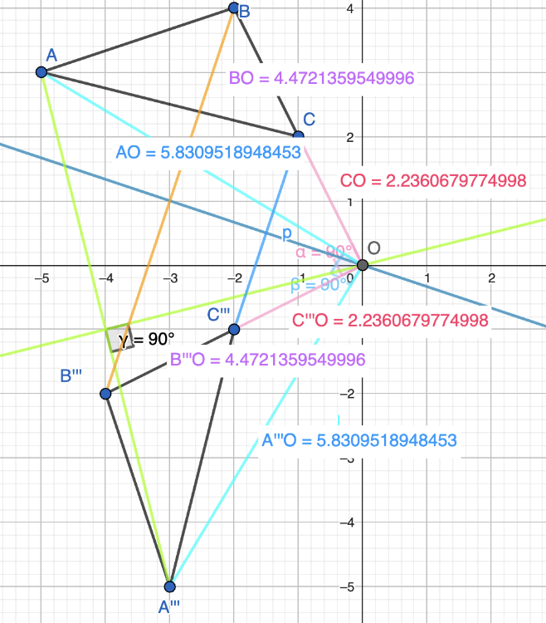

Students can use constructions (with a compass and straight edge, or geometry dynamic software) or knowledge of slope and perpendicular lines to prove the lines drawn are in fact perpendicular bisectors.

1. Using a cutout of a shape or tracing paper might support students in seeing congruence based on the same shape and size of the shapes, but that alone does not prove congruence in a mathematically rigorous way (that is, that one shape can be transformed into the other using a series of rigid transformations). Students will still need to demonstrate their understanding of how rigid transformations are connected to congruence.
2. Using a cutout of a shape or tracing paper might support students in seeing the transformation, but in order to show proficiency they must still demonstrate their understanding of how to specify each transformation and the properties of each transformation.
3. The use of graph paper and pen or pencil is demonstrated in the sample responses.
4. If a student dictates to a scribe, it is important for the scribe to be careful to record only what the student explicitly communicates, rather than making interpretations and “filling in the blanks.”