Mathematics I

Variability &   
Correlation and Causation Supertask

Option #1 Performance Task |   
Student Document

Authors: Initiative Team

April 30, 2024

Directions

Please review the task below and answer the various questions within the task to the best of your ability. If needed, you may have an adult or peer read the task out loud to aid your understanding. Additionally, feel free to use the following resources when answering each item:

* text-to-speech software
* speech-to-text software
* scratch paper

PART 1. Shifting the School Day

Understanding Variability & Correlation and Causation

Fiona and her friends recently read a policy statement from the American Academy of Pediatrics about how teenager’s “body clocks” are set to stay up later and sleep later than adults. The statement says that because school hours are aligned more with adults’ body clocks than teenagers’, many teens don’t get enough sleep.

For this reason, Fiona and her friends think that school should start and end one hour later. They want to see how many people at their school, both adults and students, agree with them.

They designed a survey, which 173 people completed:

**Are you a student or teacher?**

* Student
* Teacher

**Do you think we should shift the school day one hour later (that is, start school an hour later and also end school an hour later)?**

* Yes
* No
* Not sure/no opinion

Then, they represented the data in a two-way frequency table:

Figure 1. Respondents to Sleep Survey

|  |  |  |  |  |
| --- | --- | --- | --- | --- |
|  | **Opinion on Question:** No/Oppose | **Opinion on Question:** Yes/Support | **Opinion on Question:** No Opinion | **Totals** |
| **Population:** Students | 42 | 79 | 12 | 133 |
| **Population:** Teachers | 23 | 14 | 3 | 40 |
| **Totals** | 65 | 93 | 15 | **Grand Total:**  173 |

Item 1 – Directions

Item 1 is broken into three sub-items.

Use the details above to complete the following tasks.

Item 1 Tasks

1. Calculate three joint relative frequencies from the table and explain their significance.
2. Calculate two marginal relative frequencies from the table and explain their significance.
3. Discuss the conditional frequencies in the table and their significance. Which ones surprise you? Which ones do not? Why? What conclusions can you draw based on this data?

PART 2. Hours of Sleep

Interpreting Data Sets

Fiona and her friends decided to collect more data about how much sleep different members of the school community are getting. They designed a second survey, which 105 people completed:

**Are you a student or a teacher?**

* Student
* Teacher

**How many hours of sleep did you get last week on school nights?**

They polled 80 students and 25 teachers.

Table 1. Second Survey Results

|  | Students | Teachers |
| --- | --- | --- |
| Number of observations | 80 | 25 |
| Minimum | 20 | 10 |
| Maximum | 50 | 80 |
| First quartile | 30 | 20 |
| Median | 35 | 30 |
| Third quartile | 40 | 40 |
| Mean | 35 | 32.4 |

Item 1 – Directions

Item 1 is broken into four sub-items.

Use the details above to complete the following each sub-item.

Item 1 Tasks

1. Using the minimum, maximum, quartiles, and median, sketch side-by-side box plots to compare the amount of sleep students and teachers in this student’s school are getting.

Figure 2. Number Lines for Item 1a Sketches

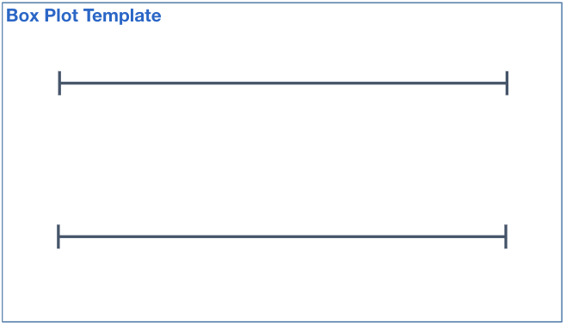

1. How would you describe the difference in the amount of sleep students and teachers get per week? Be sure you discuss differences and similarities in shape, center, and spread.
2. Explain why the mean is equal to the median for students and why the mean is greater than the median for teachers? Explain your reasoning.
3. When is the median or mean a more appropriate choice for describing the “center” of a distribution? Explain your reasoning, particularly in light of outliers.

PART 3. Sandals and Ice Treats

Representing Variables in a Scatter Plot

Beth’s club sells ice treats at lunch as a fundraiser. They notice that when more students are wearing sandals, they sell more ice treats. Beth recorded data for a month to see if there was a relationship.

Table 2. Ice Treats Sales

| Date | Number of students wearing sandals at lunch | Number of  ice treats sold |
| --- | --- | --- |
| April 3 | 9 | 22 |
| April 4 | 14 | 30 |
| April 5 | 10 | 19 |
| April 6 | 10 | 28 |
| April 7 | 16 | 30 |
| April 10 | 18 | 32 |
| April 11 | 10 | 26 |
| April 12 | 11 | 25 |
| April 13 | 8 | 18 |
| April 14 | 12 | 29 |
| April 17 | 16 | 22 |
| April 18 | 25 | 50 |
| April 19 | 27 | 60 |
| April 20 | 25 | 48 |
| April 21 | 18 | 28 |
| April 24 | 22 | 35 |
| April 25 | 30 | 66 |
| April 26 | 24 | 42 |
| April 27 | 18 | 40 |
| April 28 | 19 | 38 |
| May 1 | 10 | 22 |
| May 2 | 12 | 24 |
| May 3 | 18 | 40 |
| May 4 | 14 | 20 |
| May 5 | 18 | 38 |
| May 8 | 28 | 62 |
| May 9 | 24 | 45 |
| May 10 | 22 | 42 |
| May 11 | 17 | 28 |
| May 12 | 19 | 37 |
| May 15 | 26 | 37 |
| May 16 | 26 | 62 |
| May 17 | 21 | 46 |
| May 18 | 23 | 56 |
| May 19 | 13 | 35 |

Item 1 – Directions

This item is broken into four sub-items.

Use the details above to complete the following tasks.

Item 1 Tasks

1. Use technology to create a scatterplot where the x-axis represents the number of students Beth observed wearing sandals at lunch and the y-axis represents the number of ice treats sold. Then find the correlation coefficient. What does it tell you about the relationship between the two variables?
2. Find a function that you think models the relationship shown in the data. Explain and show using trendlines and residuals how you know it is a good model.
3. What is the vertical intercept of the function’s graph? The slope? Explain what each means in the context of this data.
4. Rian says, “Sandals clearly cause people to buy more ice treats. We should ask the Student Council to have a Sandal Spirit Day, so we can sell more ice treats.” Do you agree or disagree with Rian? Explain your reasoning.