The Standards for Mathematical Practice and Alternative Means of Expression
Best Practices for Students with Disabilities
Authors: Cecilio Dimas, Lamar Johnson, and Angela Knotts
May 31, 2024

Introduction
This practice brief discusses how embedding alternative means of expression within mathematic instruction supports the implementation of the Standards for Mathematical Practice (SMPs). SMPs are a set of practices or “habits of mind” that enable students to engage deeply and meaningfully with rich mathematics. The SMPs emphasize the need for students to engage with rich mathematical tasks that go beyond procedural knowledge and allow students to make sense of concepts, connect ideas, and apply their understanding in authentic contexts. Alternative means of expression are the different assessment mediums (tools, strategies, and assessment types) offered to students that give them flexibility in how they demonstrate their understanding while still meeting coursework proficiency requirements. Providing alternative means of expression is especially critical regarding those requirements tied to earning a diploma. Learning in classrooms that embed alternative means of expression is especially important for students with disabilities, who often have individually defined supplementary aids and services within their individualized education programs (IEPs) detailing their individualized assessment needs. This brief describes how the use of rich mathematical tasks that provide opportunities for engagement with Standards for Mathematical Practice also provide opportunities for students to engage with mathematical ideas and express their understanding through alternative means of expression. This, in turn, promotes inclusivity and reduces stigma around IEP accommodations while also deepening students’ appreciation and understanding of mathematics.

The Standards for Mathematical Practice
The California mathematics standards comprise two distinct sets of learning outcomes: (1) content standards, which describe the mathematical knowledge, understanding, and technical skills that students should have, and (2) the Standards for Mathematical Practice (SMPs), which describe strategic skills or “habits of mind” that math teachers of all levels should work to help their students develop (National Governors Association Center for Best Practices and Council of Chief State School Officers 2010). Educators have a long history of using mathematical practices when both doing and teaching mathematics. ​The field first saw such “habits of mind” codified in the National Council of Teachers of Mathematics (NCTM) Process Standards of problem solving, reasoning and proof, communication, representation, and connections (NCTM 1989). They next appeared as the strands of mathematical proficiency specified in the National Research Council’s report Adding It Up (National Research Council and Mathematics Learning Study Committee 2001): adaptive reasoning, strategic competence, conceptual understanding (understanding key mathematical concepts and how they relate to one another), procedural fluency (skill in carrying out procedures flexibly, accurately, and efficiently), and productive disposition (being inclined to see mathematics as sensible, useful, and worthwhile, coupled with a belief in diligence and one’s own ability to use and understand mathematics).
The SMPs provide guidance regarding behaviors that students should engage in while learning mathematical concepts (Bostic and Matney 2014) and were designed to structure the way students think about and interact with mathematical content—that is, to help students learn to “think like mathematicians.” The practice standards describe the mathematical thinking habits that teachers should cultivate in their students in order to facilitate their engagement with and comprehension of the content. Though the SMPs are presented as eight distinct practices, students frequently draw on multiple practices in the process of solving the same problem.
The Standards for Mathematical Practice
- Make sense of problems and persevere in solving them.
- Reason abstractly and quantitatively.
- Construct viable arguments and critique the reasoning of others.
- Model with mathematics.
- Use appropriate tools strategically.
- Attend to precision.
- Look for and make use of structure.
- Look for and express regularity in repeated reasoning.
Chapter 1 of the California Mathematics Framework (2023) discusses the role that the SMPs play in framing mathematics investigations according to the how, why, and what of mathematics—a conception that makes connections across different aspects of content and connects content with mathematical practices. In this framing, the SMPs describe how students engage with mathematics; three Drivers of Investigation (sense-making, predicting, and having an impact) provide the why; and four Content Connections (Reasoning with Data, Exploring Changing Quantities, Taking Wholes Apart/Putting Parts Together, and Discovering Shape and Space), along with the content standards, provide the what. (For more on the Drivers of Investigation and Content Connections, see Practice Brief: Utilizing Big Ideas for Algebra I and Mathematics I.)

The Standards for Mathematical Practice and the Role of Alternative Means of Student Expression
Traditionally, U.S. high school mathematics classes have focused on a very limited set of engagement structures, with teachers often presenting information or demonstrating procedures while students take notes, work individually on narrowly conceived procedural problems, then demonstrate mastery via tests or quizzes that primarily require them to reproduce memorized information and procedures (Hiebert 2003; Stigler and Hiebert 2004). However, these activities provide few, if any, opportunities for students to engage with the SMPs.
If students are to develop facility with the SMPs, they need opportunities to engage with rich, cognitively demanding mathematical tasks that require carrying out procedures, making sense of concepts, connecting concepts and procedures, engaging in reasoning and problem-solving, and applying mathematical concepts and skills to authentic contexts (NCTM 2014). Such tasks have multiple entry points, lend themselves to varied solution strategies, and provide opportunities to work with a variety of mathematical representations. Such “low floor, high ceiling” tasks are accessible to students with a wide range of mathematical backgrounds and experiences yet are rich enough to provide a variety of opportunities for continued exploration. The opportunities to choose from varied approaches and representations in such tasks also provides fertile ground for students to express their understanding via a wide array of alternative means. Consider the two algebra tasks shown in table 1 below:

Table 1. Two Systems of Equations Tasks
Task A: Smartphone Plans | Task B: Systems of Equations
You are trying to decide which of two smartphone plans would be better.  - Plan A charges a basic fee of $30 per month and 10 cents per text message.  - Plan B charges a basic fee of $50 per month and 5 cents per text message.  How many text messages would you need to send per month for plan B to be the better option? Find an expression option that works for you while meeting the requirements of this task. | Solve each of the following systems:  $$-4x-2y=-12$$  $$4x+8y=-24$$  $$x-y=11$$  $$2x+y=19$$  $$8x+y=-1$$  $$-3x+y=-5$$  $$5x+y=9$$  $$10x-7y=-18$$
(NCTM 2014, p. 20)
Task B is only accessible by applying a set of symbolic manipulations and it is possible to arrive at the correct answer without any conceptual understanding of linear equations, systems of equations, or solution sets, and without any understanding of how the procedure for finding the solution is related to these concepts. Symbolic manipulations can be carried out without any understanding of what a system of equations might represent or how solving one might be necessary or useful. While some students may use abstract reasoning to solve a system, depending on their background knowledge, it is not clear that there are opportunities to engage in other SMPs.
In task A, students have many opportunities to engage with the SMPs. They must make sense of the problem, what a solution to the problem would look like, how they will know when they have solved it, and what level of precision is warranted. Once they have a solution, they must construct an argument that justifies that solution. There are many ways to approach the problem and many representations and modalities that students can employ, some of which are described in table 2 below.
Table 2. Sample Descriptions of How Alternative Means of Expression Support SMPs
Example Alternative Means of Expression | SMP-aligned strategies
Example A - A student might first ask, “What in this problem can I count or measure? How are those quantities related to one another?” They might represent these quantities and relationships with a diagram, with a verbal explanation, by acting out the situation, or by assigning variables to quantities and writing expressions or equations.  “I noticed that each of these plans has a base cost amount, and a per-message amount. In Plan A, I noticed that since the per-message cost is 10 cents, you have to send 10 message to owe an extra dollar. So, the cost for sending 10 messages is $31, 20 messages is $32, 30 messages is $33, and so on. This gave me an idea about Plan B—since it costs 5 cents for a message, you can send 20 messages before it costs an extra dollar. So, the cost for sending 20 messages is $51, 40 messages is $52, 60 messages is $53, and so on. I made a table to figure out what the cost of the two plans are for some different amounts of messages and organize my work.”  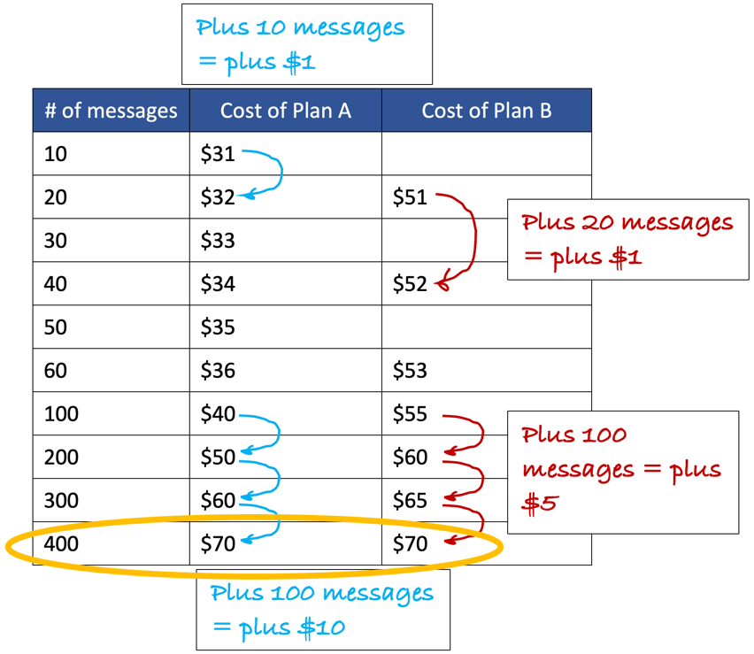 | Attending to quantities (SMP 2: Reason abstractly and quantitatively)
Example B - A student might first notice that both plans have an amount that stays the same no matter how many texts are sent and an amount that changes with the number of texts. This structure can be represented and expressed in a variety of ways—verbally (out loud or in writing), with a diagram, as a line on the Cartesian plane, or as a table showing the cost for each plan for different numbers of text messages.  In the visual representation below, we can see that the student has identified the base cost of each plan, and then how many text messages they would get for $8. They have then used that visual thinking to extrapolate out and find how many messages they would get for an additional amount of money. Isolating the changing part of the situation allowed the student to leverage what they understand about proportionality and scale up the additional messages with cost, and then add on the base cost afterward to find the total cost.  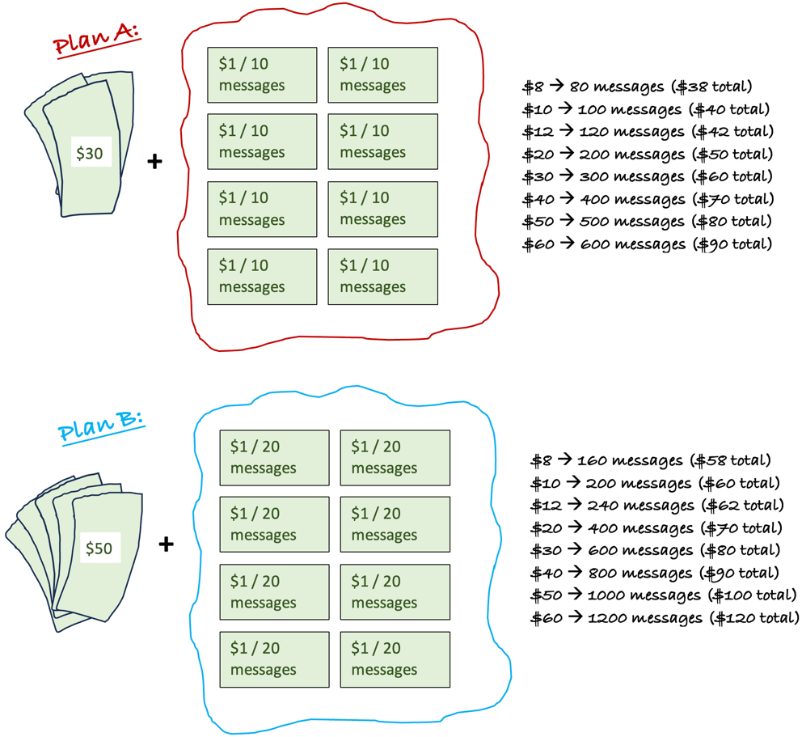  $8 80 messages ($38 total)  $10 100 messages ($40 total)  $12 120 messages ($42 total)  $20 200 messages ($50 total)  $30 300 messages ($60 total)  $40 400 messages ($70 total)  $50 500 messages ($80 total)  $60 600 messages ($90 total)  $8 160 messages ($58 total)  $10 200 messages ($60 total)  $12 240 messages ($62 total)  $20 400 messages ($70 total)  $30 600 messages ($80 total)  $40 800 messages ($90 total)  $50 1000 messages ($100 total)  $60 1200 messages ($120 total) | Attending to structure (SMP 7: Look for and make use of structure)
Example C - A student might begin by calculating how much each plan would cost for a few different numbers of text messages (5, 10, 100, 1,000) and notice that they are carrying out the same process each time (multiplying the number of text messages by the cost per text message, then adding the basic fee). They can then look for ways to represent this regularity.  “I first wanted to see how much different the cost for the different plans were depending on if you send different numbers of messages. If you don’t send any messages, the difference is $20 and Plan A is cheaper. If you send 10 text messages, I found the amount for plan A is 0.10 x 10 = $1, plus $30 = 31, and the amount for plan B is 0.05 x 10 = $0.50, plus $50 = $50.50. Then I subtracted to get 50.50 – 31 = $19.50. So, as you start sending messages, the difference is growing smaller. I did this process for a few more numbers.  20 messages (0.05 x 20 + 50) – (0.10 x 20 + 30) = $19  30 messages (0.05 x 30 + 50) – (0.10 x 30 + 30) = $18.50  40 messages (0.05 x 40 + 50) – (0.10 x 40 + 30) = $18  I noticed I was doing the same process over and over again and as # of messages increases, the difference in cost decreases and eventually it will be zero, and then after that Plan B will start being cheaper. So, I wanted to know what # of messages I could plug in to get a difference of zero. I could keep guessing and checking but instead I put in a variable to try to work backwards:  x messages (0.05 * x + 50) – (0.10 * x + 30) = $0  Then, I could just solve this equation for x: 0.05x + 50 – 0.1x + 30 = 0, and any number of messages larger than that will mean that Plan B is cheaper. | Attending to regularity (SMP 8: Look for and represent regularity in repeated reasoning)
Example D - Attending to quantities, structure, or regularity can all lead to students attempting to model the situation using mathematical representations such as expressions or equations, a table, or a graph to help them make predictions, generalize, and answer the question.  “I noticed that each of these plans has a starting cost amount, and then an amount that goes up by the same amount every time you send a text message. This made me think that I could use y = mx + b form and write an equation to go with each plan. b is the part that stays the same no matter what (so 30 for Plan A and 50 for Plan B). mx is the part that changes when x changes. In this problem the number of messages is the variable (x) because it changes. You multiply the number of messages by 0.10 in Plan A and 0.05 in Plan B. So, the equation for Plan A could be y = 0.10x + 30 and for Plan B, y = 0.05x + 50.” | Modeling with mathematics  (SMP 4: Model with mathematics)
Example E - Because Task A does not suggest a particular approach, students can select from a wide range of mathematical tools to explore the problem, from paper and pencil to graph paper and straight edge to calculators, spreadsheets, or apps on a laptop. They might also make use of color coding or manipulatives as they explore structure and regularity in the problem. In the approach below, the student has used an online graphing calculator to help them make sense of and solve the problem.  “I noticed that each of these plans has a starting cost amount, and then an amount that goes up by the same amount every time you send a text message. This made me think that these must be linear relationships and if I graph them, it will form a line. The point where the lines cross shows me that if you send more than 400 messages a month, Plan B is cheaper, but if you send less than 400 messages a month, Plan A is cheaper.”  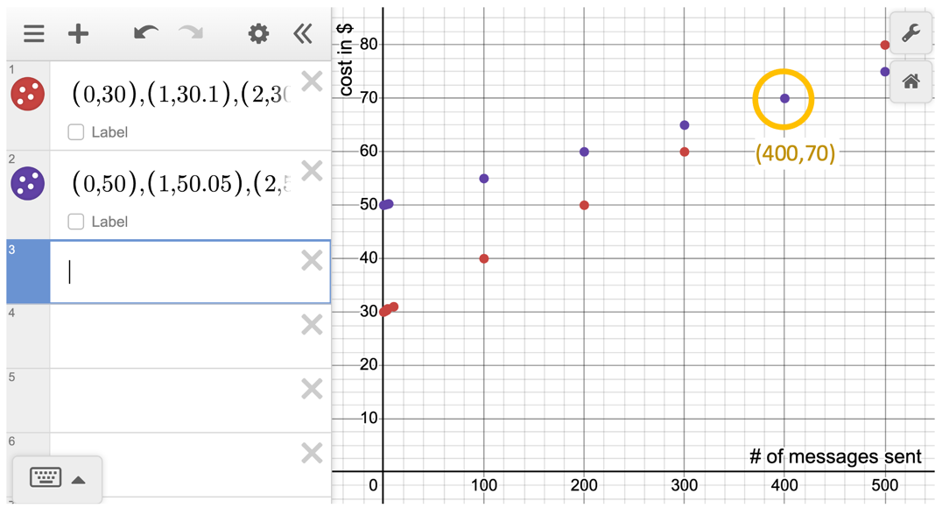 | Using mathematical tools (SMP 5: Use appropriate tools strategically)
Developing facility with the SMPs requires opportunities to solve rich, open problems that provide opportunities to engage in mathematics using a wide range of student expression types, tools, and approaches that leave room for cultural connections. These environments also cultivate rich opportunities for access for students with disabilities because they normalize choice, honoring students’ own mathematical thinking and approaches, as well as the use of a variety of tools and technology. This in turn can allow for the seamless and non-stigmatizing integration of students’ individualized education program-defined supports. By integrating the Standards for Mathematical Practice with mathematical content standards, we also provide students with opportunities to explore mathematics using a variety of means and modalities and create a more inclusive learning environment that values each student’s unique abilities.
By fostering a culturally responsive mathematics education, we provide students with a sense of belonging and relevance. Allowing students to draw upon their cultural backgrounds and personal experiences in mathematics promotes discussion, creativity, critical thinking, and collaboration. This approach empowers students to develop a deeper appreciation and understanding of mathematics, including ways that mathematical concepts can be understood through a cultural lens. By embracing this diversity, we create a math class that encourages creativity, critical thinking, and collaboration, empowering students to develop a deeper appreciation and understanding of mathematics.

Conclusion
As the how of engaging with rich mathematics, the SMPs play a crucial role in California’s mathematics classrooms alongside the Drivers of Investigation (the why) and Content Connections (the what of rich mathematics). By integrating the SMPs with mathematical content standards, educators take steps to further embed these crucial mathematical “habits of mind” while increasing the inclusivity of mathematical instruction for students with disabilities. Embracing diverse instructional methods and cultural perspectives in the math classroom fosters an inclusive environment that expands the number of learners able to apply rich mathematical concepts. This approach empowers to cultivate creativity, critical thinking, and collaboration, ultimately leading to a deeper appreciation and understanding of mathematics.

References
Bostic, Jonathan, and Gabriel T. Matney. 2014. “Role-Playing the Standards for Mathematical Practice: A Professional Development Tool.” NCSM Journal of Mathematics Education Leadership (Summer): 3–10.
California Department of Education. 2023. California Mathematics Framework Chapter 8. Sacramento, CA: California Department of Education.
Hiebert, James. 2003. Teaching Mathematics in Seven Countries: Results from the TIMSS 1999 Video Study. Washington, DC: National Center for Educational Statistics.
National Council of Teachers of Mathematics. 1989. Principles and Standards for School Mathematics. Reston, VA: National Council of Teachers of Mathematics.
National Council of Teachers of Mathematics. 2014. Principles to Actions: Ensuring Mathematical Success for All. Reston, VA: National Council of Teachers of Mathematics.
National Governors Association Center for Best Practices, Council of Chief State School Officers. 2010. Common Core State Standards for English Language Arts. Washington, DC: National Governors Association Center for Best Practices, Council of Chief State School Officers.
National Research Council and Mathematics Learning Study Committee. 2001. Adding It Up: Helping Children Learn Mathematics. Washington, DC: National Academies Press.
Stigler, James W., and James Hiebert. 2004. “Improving Mathematics Teaching.” Educational Leadership 61 (6): 12–17.

