Science: Biology

From Molecules to Organisms: Structures and Processes   
Big Idea

Option #1 Performance Task |   
Student Document

Authors: Initiative Team

August 2024

Directions

Please review the task below and answer the various questions within the task to the best of your ability. Each part of the test has entry phenomena to explore and use as a guide to complete items. Remember, there are many ways to complete a task; pay close attention to the materials provided with each item and the central ideas being requested within each item. If needed, you may have an adult or peer read the task out loud to aid your understanding. Remember, this assessment is designed to assess your understanding of these concepts and any relations they have with each other. Additionally, feel free to use the following as supports in answering each item:

* text-to-speech software
* speech-to-text software
* scratch paper
* science journals
* class word wall
* class models

PART 1. From Molecules to Organisms: Structure and Function, Sample Phenomenon: Sickle Cell Anemia

Part 1. Entry Phenomenon

The activities below should be done sequentially. They can be completed within a group or individually. Once you have completed the activity, answer each item independently.

Explore the Entry Phenomenon – Step 1

Watch a preselected phenomenon video provided by your teacher. Feel free to use the optional T-Table below to capture what you notice and wonder about the phenomenon. Record as many observations as possible as you watch.

Table 1. Optional T-Table “I notice... / I wonder ...”

|  |  |
| --- | --- |
| I notice… | I wonder... |
|  |  |

Build Further Understanding – Step 2

Once you watch the video, review the materials below to gather more background information regarding the cause, symptoms, and history of the illness described in the phenomenon. Use these materials as reference resources when completing items for this part of the task.

Table 2. Materials to Build Further Understanding

|  |  |  |
| --- | --- | --- |
| Material title | Description of resource with hyperlink | QR code digital exploration |
| Sickle cell anemia[1] | This free and publicly available web resource describes the phenomenon in greater detail.  <https://www.mayoclinic.org/diseases-conditions/sickle-cell-anemia/symptoms-causes/syc-20355876> |  |
| Sickle cell disease[2] | This free and publicly available infographic describes the phenomenon in greater detail.  <https://www.nhlbi.nih.gov/resources/sickle-cell-disease-fact-sheet> |  |

Item 1 Tasks

For Part 1, Item 1 is broken into three sub-items. Think about these questions throughout the task:

* How does the structure of DNA affect how cells look and behave?
* How does the circulatory system rely on other systems to carry oxygen to the cells of the body and what impact would this change have on a person?

Item 1a

Create a model of how a change in DNA could lead to a change in the shape of the red blood cell.

* **Remember your response must include**
  + a clear claim you making to answer this question
  + evidence gathered from your resources (for example, the cards in the task, your science notebook, any word banks you create, class models)
  + your reasoning to support the logic and connections you are making

You may use a response method that works for you if your strategy can satisfy the above requirements. Finally, you are provided cards as a resource. *You do not have to use them*.

Item 1b

After exploring the web resources below, develop a model that shows the relationship between two or more systems and how these systems interact to help maintain oxygen levels during increased exercise.

* **Remember your response must include**
  + a model showing the requested relationship and interaction

You may use a response method that works for you if your strategy can satisfy the above requirements. A word bank with key terms is provided as a resource. Additionally, cards will be provided to you as a resource, multiple cards are provided to aid in model creation. All cards do not have to be used and some cards may be used more than others. *Cards can be ignored if not relevant to your chosen expression method.*

Table 3. Materials to Build Understanding

|  |  |  |
| --- | --- | --- |
| Material title | Description of resource with hyperlink | QR code digital exploration |
| How your body controls breathing[3] | NIH resources serve as a resource for students to read about how systems collaborate to regulate breathing and maintain homeostasis.  <https://www.nhlbi.nih.gov/health/lungs/body-controls-breathing> |  |

Table 4. Item 1b Word Bank Resource

| Word bank | |
| --- | --- |
| Carbon Dioxide or pCO2  Respiratory System  Circulatory System  Nervous System  Activity or Exercise  Brain  Nerve Signals  Respiration Rate | Muscle Contractions  Heart Rate  Oxygen Levels or pO2  Cells  Chemoreceptor  Homeostasis  CO2 + H2O → H2CO3 → HCO3- + H+  H+ increase = pH decrease |

Item 1c

Based on the model you created for Item 1b, plan and carry out an investigation that illustrates the connection between your circulatory, respiratory, and nervous systems and that supports or refutes the claim, “The more I exercise, the greater the carbon dioxide levels I exhale (breathe out).” Make sure your investigation is approved by your instructor before you begin any experiments.

* **Remember your response must include**
  + a clear claim regarding whether you agree or disagree with the statement, “The more I exercise, the greater the carbon dioxide levels I exhale (breathe out).”
  + a clear investigation plan that includes the materials and procedure for your experiment
  + samples and reflections showing how your investigation went

You may use a response method that works for you if your strategy can satisfy the above requirements. Additionally, you may use your science journal, models from previous responses, word banks, and in-class resources to plan and carry out your investigation.

PART 2. From Molecules to Organisms: Growth and Development of Organisms, Sample Phenomenon: Growth and Repair

Part 2. Entry Phenomenon

The activities below should be done sequentially. They can be completed within a group or individually. Once you have completed the activity, answer each item independently.

Explore the Entry Phenomenon

Examine this image of a cut hand. Table 5 provides you with an optional T-Table for capturing your thinking. Reflect and take notes or sketch ideas related to the following questions:

* What do you think the response of the body would be when a cut occurs on the hand?
* How would the body go about repairing the injury at the cellular level?

Figure 1. Part 2 Entry Phenomena Cut Hand

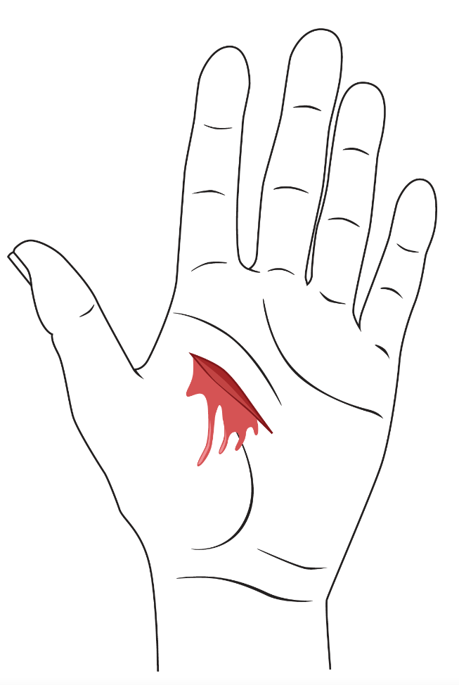

Table 5. Optional T-Table “I notice... / I wonder...”

|  |  |
| --- | --- |
| I notice… | I wonder… |
|  |  |

Item 1

For Part 2, Item 1 has no sub-items.

Item 1

Create a model showing the phases of mitosis with the correct visual representations of each phase, and numbers or notations showing the correct process order—starting with the first and ending with the final phase.

Use the model you created and the phenomenon image to illustrate and describe growth and repair.

* **Remember your response must include**
  + a model of the phases of mitosis
  + a clear claim regarding the process of growth and repair at the cellular level
  + evidence gathered from your resources to describe and support your claim (for example, the cards in the task, your science notebook, any word banks you create, class models)
  + your reasoning to show the logic and connections you are making

You may use a response method that works for you if your strategy can satisfy the above requirements. Finally, you are provided cards as a resource. *You do not have to use them*.

PART 3. From Molecules to Organisms: Organization for Matter and Energy Flow in Organisms, Sample Phenomenon: Closed Ecosystems

Part 3. Entry Phenomenon

The video phenomenon drives understanding of this task. Exploration of the phenomenon can be completed within a group or individually. Once you have completed the activity, answer each item independently.

Explore the Entry Phenomenon

Watch a preselected phenomenon video provided by your teacher. Feel free to use the optional T-Table below to capture what you notice and wonder about the phenomenon. Record as many observations as possible as you watch.

Table 6. Optional T-Table “I notice... / I wonder...”

|  |  |
| --- | --- |
| I notice... | I wonder... |
|  |  |

Additionally, as you watch the video, consider the following questions:

* How long do you think this sealed terrarium would sustain itself?
* What is happening between the organisms living in the sealed container at the molecular level?

Item 1

Item 1 is broken into two sub-items.

**Item 1a**

Create a model to illustrate how the sun’s energy is transferred to living things and is part of the carbon cycle.

* **Remember your response must include**
  + a model showing how the sun’s energy is transferred to living things and is part of the carbon cycle

You may use a response method that works for you if your strategy can satisfy the above requirements. Finally, you are provided a scene within an environment to use as a resource in your model creation. *You do not have to use this item.*

Figure 2. Photosynthesis and Cellular Respiration Model for Task 1a

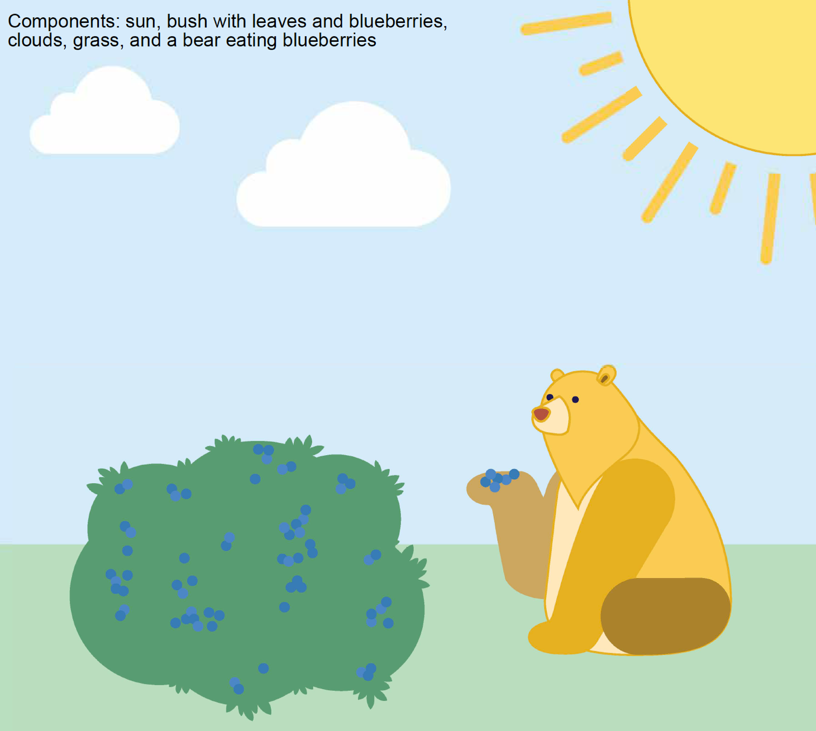

Item 1b Task

Using the same model you constructed for Item 1a, create an explanation based on evidence for how the sun drives the carbon cycle.

* **Remember your response must include**
  + references to your model from Item 1a
  + a clear claim regarding how the sun drives the carbon cycle
  + evidence gathered from your resources to describe and support your claim (for example, the cards in the task, your science notebook, any word banks you create, class models)
  + your reasoning to show the logic and connections you are making

You may use a response method that works for you if your strategy can satisfy the above requirements.

1. Mayo Clinic. December 22, 2023. “Sickle Cell Anemia.” <https://www.mayoclinic.org/diseases-conditions/sickle-cell-anemia/symptoms-causes/syc-20355876>.
2. National Heart, Lung, and Blood Institute. June 26, 2024. “Sickle Cell Disease.” <https://www.nhlbi.nih.gov/sites/default/files/publications/SickleCellDisease_FactSheet_July2022.pdf>.
3. National Heart, Lung, and Blood Institute. March 24, 2022. “How Your Body Controls Breathing.” <https://www.nhlbi.nih.gov/health/lungs/body-controls-breathing>.