Identifying and Unpacking English Language Arts/English Language Development Big Ideas
The First Step to Identifying Alternative Means of Expression

Authors: Robyn Lee-Giuseffi, Linda Palomino,
Beth Clavenna-Dean, and Zach Smith
July 31, 2024

Executive Summary
This practice brief defines the process of the Inclusive Access to a Diploma: Reimagining Proficiency for Students with Disabilities initiative English language arts/English language development (ELA/ELD) subject matter experts (SMEs) used to craft the Big Ideas that represented proficiency in ELA/ELD content. Additionally, the document details how local educational agencies (LEAs) can use unpacked ELA/ELD Big Idea courses to identify viable alternative means of expression for students with disabilities in California to meet proficiency in this content area. This brief provides educators who will be using the crafted ELA/ELD performance tasks, namely grade nine through ten ELA/ELD teachers, special education teachers, administrators, counselors, and others a better understanding of how the Big Ideas were developed and how they are aligned with coursework requirements for earning a California standard diploma.
The SMEs used the California 2014 English Language Arts/English Language Development Framework (ELA/ELD Framework) and the ELA/ELD grade nine and ten standards to define, unpack, and craft Big Ideas representing proficiency in ELA/ELD content. The ELA/ELD Big Ideas for grades nine and ten ELA courses were built on ELA/ELD-based coursework requirements for earning a standard diploma in the state of California. Creating a shared understanding of the big ideas that represent proficiency in secondary coursework without dictating to local educational agencies (LEAs) the assessment format (for example, paper, digital platform, oral interview, and so on) of these big ideas provides clarity to schools on the requirements while allowing for local control in the design and delivery of instruction and assessments. Educators need a shared understanding of the requirements while remaining nimble in delivery and assessment. This is especially important for teachers of students with disabilities, including those eligible for the California Alternate Assessment (CAA), whose individualized education program (IEP)-defined supplementary aids and services require personalized strategies tailored to these students’ strengths and needs.

Big Ideas and Alternative Means of Expression
The Inclusive Access to a Diploma: Reimagining Proficiency for Students with Disabilities initiative focuses on providing students with disabilities the alternative means to express proficiency in the coursework needed to graduate with a standard diploma based on the state minimum requirements. Alternative means of expression offer students authentic, rigorous, and nonconventional options to demonstrate their knowledge and skills of the big ideas and corresponding standards associated with graduation coursework. Big Idea statements describe a group of complementary skills that integrate a number of the standards (in this case ELA/ELD standards) required for graduation in the state of California around a central Big Idea. It is important to acknowledge that alternative means of expression do not modify the big ideas and associated standards in graduation coursework and, therefore, do not compromise the validity of assessing proficiency. Instead, alternative means of expression allow students to showcase their abilities through mediums that align with individual preferences and strengths, thereby offering greater equity and access to learning. Various assessment resources (tools, strategies, assessment types, and performance tasks) can serve as alternative means of expression that are offered to students with disabilities, giving them flexibility in how they show their learning while still meeting coursework proficiency requirements—especially those requirements tied to earning a diploma.
To design rigorous alternative means of expression, the SMEs first needed to identify the big ideas and the associated standards supporting each big idea that define the knowledge, competencies, and skills needed to be proficient in grade nine through ten ELA courses. The ELA/ELD SMEs used state curriculum frameworks and adopted standards to provide guidance on these key areas—much like educators in LEAs would use frameworks and standards—as these state-adopted resources direct schools and districts in the best practices and core focus of content within the state. Once big ideas have been established and their corresponding standards are identified, educators are free to find alternative means of expression based on the needs of students and assessment strategies, which also meet the requirements of the big idea. Similarly, the SMEs used the big ideas and corresponding standards to develop sample performance tasks that could be used as an alternative means of expression for a grade nine or ten ELA course. The resources developed through the Inclusive Access to a Diploma initiative are intended to provide flexibility. Educators may choose to apply the sample tasks with embedded alternative means of expression to their adopted materials or they might want to develop their own tasks, using the Big Idea documents and mirroring the SME’s process. Furthermore, local control is an important provision within the state of California to ensure local educators have autonomy and empowerment to craft instructional methods that are culturally responsive to the preferences, strengths, and needs of the rich assortment of student populations served in their community.

Strategies for Identifying and Unpacking Big Ideas
The SMEs engaged in regular collaboration to study the CA ELA/ELD Framework and the grades nine through ten ELA and ELD standards. Central to the ongoing work to develop the team’s common understanding of the framework goals for literacy instruction were the ELA standards for Reading Literature, Reading Informational Text, Writing, Speaking and Listening, and Language and the CA ELD standards (California Department of Education 2013). Since the “CA ELD standards are both nested within and amplify the CA CCSS for ELA/Literacy,” it is critical to consider and use both sets of standards for literacy instruction and assessment (California Department of Education 2014). The ELD standards further complement the ELA standards by defining purposes for using English, processes students use for interacting with content, and specific language that facilitates these interactions.
Based on the framework’s goals for ELA and literacy instruction and the grades nine through ten standards, the team identified five Big Idea concepts, aligned with the integrated nature of the CA ELA/ELD Framework’s vision for ELA/literacy instruction. Taken together, the five Big Ideas address all the standards and align with the grades nine through ten competencies in preparation for college, careers, and civic life.
- Big Idea 1: Collaborative Discourse - Contributing ideas in collaborative discussions about complex texts and topics
- Big Idea 2: Rhetorical Literary Analysis - Using knowledge of rhetoric to analyze literature from diverse perspectives and write narratives
- Big Idea 3: Analyzing and Writing Arguments - Using knowledge of rhetoric to analyze arguments from diverse perspectives and write arguments
- Big Idea 4: Research Across Texts - Conducting research and using findings in written informational and explanatory texts
- Big Idea 5: Informational Oral Presentations - Planning and delivering oral presentations conveying information from credible sources
After the five Big Ideas above were crafted, the team identified the ELA standards most heavily emphasized in each of the Big Ideas. Guided by the premise that the ELD standards “amplify (magnify and make clear) areas of English language development that are crucial for academic learning,” ELD standards were also identified for their support of specific big ideas (California Department of Education 2014, p. 30). The ELA and ELD standards that correspond with each Big Idea can be found in the ELA/ELD Guidance Document: Big Ideas and Standards Alignment, which shows the distribution of ELA and ELD standards across the five Big Ideas, ensuring all the standards address the five big ideas and resulting performance tasks.
The team then used the big idea statements and corresponding standards to develop Evidence Statements that synthesized how students would demonstrate proficiency and apply to each group of standards within each big idea. The performance tasks show examples of how the Big Ideas and Evidence Statements can be a lens for measuring students’ proficiency in grades nine through ten ELA and ELD standards. The CA ELA/ELD Framework is the cornerstone for the Big Ideas documents, with narrative descriptions of big ideas and their corresponding evidence statements and standards defined on the initiative website. Additionally, the ELA/ELD Guidance Document: Big Ideas and Standards Alignment provides detailed descriptions of each component and its related requirements showing their alignment with the CA ELA/ELD Framework.

Empowering Local Educational Agencies
The process of identifying big ideas and corresponding standards was an important step in developing sample performance tasks that integrate alternative means of expression. We encourage ELA/ELD teachers to use the Big Idea documents to create their own alternative means of expression using the samples as inspiration which can be molded to fit local needs. Because the framework calls for such a high degree of integration, the big ideas ultimately can be viewed as modular pieces that can stand alone as tasks; for example, Big Idea 2: Rhetorical Literary Analysis: Using knowledge of rhetoric to analyze literature from diverse perspectives and write narratives was used to develop its corresponding performance task. Each big idea has a corresponding module task that can be used to show proficiency in that singular Big Idea.
To provide a more integrated experience for students, LEAs can consider combining more than one big idea into one performance task, which organizes related singular big ideas into one multi-step larger task for a student to complete. For example, the ELA/ELD Performance Task: Rhetorical Literary Analysis, Collaborative Discourse is a pairing of Big Idea 1: Collaborative Discourse with Big Idea 2: Rhetorical Literary Analysis. Another big idea pairing could be Big Idea 2: Rhetorical Literary Analysis and Big Idea 4: Research Across Texts of students researching the background of the literature they have read or researching to write their own narratives.

Critical Role of Collaboration
Educator collaboration is a necessity to ensure the best learning experiences and outcomes for students. The framework makes this imperative clear in every chapter with the figure below and provides many examples of what professional collaboration could look like in action through each of the vignettes.
Figure 2. Sample Collaboration Statement from the CA ELA/ELD Framework
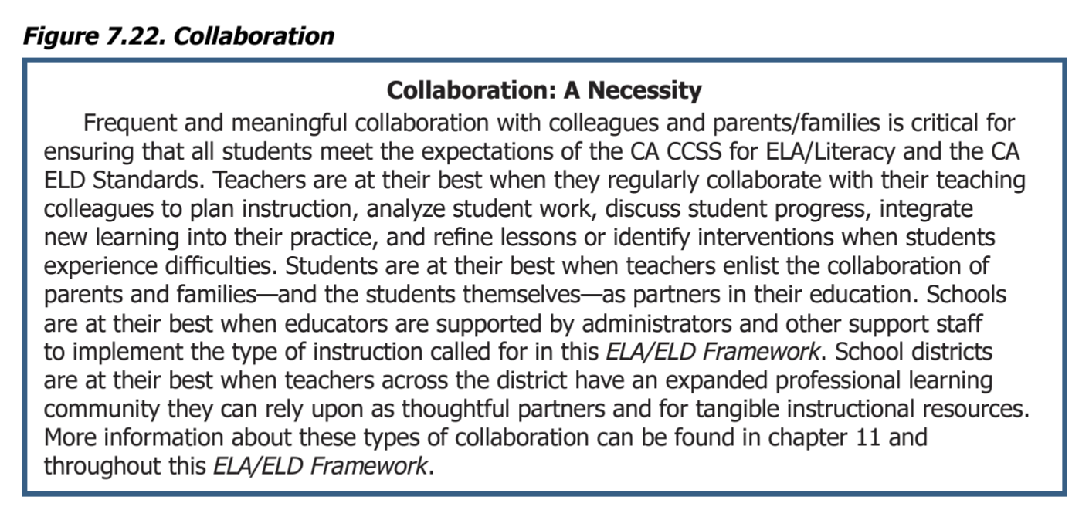
Source: California Department of Education 2014, p. 812.
While collaboration within content areas is crucial for building a common understanding of content and grade level expectations, so is collaboration between general education teachers and special education teachers to ensure all students have the access and support they need. The general education teachers who deeply understand the content expectations are best equipped to provide clarity about the non-negotiables within the standards. The special education staff in the design of alternative means of expression provide valuable expertise on the individual strengths, preferences, needs, and learning challenges of students with disabilities and they are best equipped to identify other successful ways for students to demonstrate their proficiency. Examples of this type of powerful collaboration between special education educators and general education educators can be found within each of the Performance Tasks in the section “Strategies for Supporting Students,” specifically in the lists that detail “Appropriate Resources for this task,” “Inappropriate Resources for this task,” and “Potential Alternative Means of Expression.” These details were made possible through collaboration between general education educators and special education educators with students being the biggest beneficiaries.

Conclusion
In conclusion, this practice brief explains the process by which the subject matter expert team and WestEd team grounded the resulting ELA/ELD performance tasks in the CA ELA/ELD Framework. The team developed big idea statements with embedded evidence statements for clusters of ELA and ELD standards to demonstrate the integrated nature of literacy instruction and assessment. Each of the resulting big idea statements and supporting documents can be used by teachers to develop their own customized performance tasks which add clarity to how students might demonstrate proficiency. Ultimately, meeting the needs of linguistically diverse students and students with disabilities is a shared responsibility for all the educators on campus and especially demands collaboration between general education teachers and special education teachers.

References
California Department of Education (CDE). 2012. California English Language Development Standards: Kindergarten Through Grade Twelve. Sacramento, CA: CDE Press.
California Department of Education (CDE). 2013. California Common Core State Standards: English Language Arts and Literacy in History/Social Studies, Science, and Technical Subjects. Sacramento, CA: CDE Press. https://www.cde.ca.gov/be/st/ss/documents/finalelaccssstandards.pdf.
California Department of Education (CDE). 2014. California English Language Arts/English Language Development Framework for California Public Schools: Kindergarten Through Grade Twelve. Sacramento, CA: CDE Press. https://www.cde.ca.gov/ci/rl/cf/documents/elaeldfw.pdf.

