Physical Education

Course 1 Big Idea 1

Demonstrate Proficient Movement Skills
Performance Task | Teacher Document
Authors: Project Team
November 2024

Table of Contents
Overview of the Performance Task 1
Administering the Performance Task and Embedding
Supports for Students 2
Key Vocabulary Terms 3
Strategies for Supporting Students 4
Potential Alternative Means of Expression 6
PART 1. Demonstrate Proficient Movement Skills Needed to Perform a Variety of Physical Activities Big Idea 8
Task Alignment to Key Elements of Big Ideas and Standards 8
Part 1. Item 10
Part 1. Sample Student Responses 21
Resources 31

Overview of the Performance Task
This performance task addresses the learning students need to demonstrate proficient movement knowledge and skills, aligned with the California 2009 Physical Education Framework, the content standards, and the mandated content for physical education. The goal of the physical education standards is to equip students with the knowledge, skills, and dispositions necessary to successfully participate in physical activity as high school students and into adulthood. Movement skills demand a multi-dimensional approach to the learning including movement skill development and accompanying knowledge, and the ability to learn movement skills independently. This performance task gives attention to these dimensions: combining and applying movement skills already learned in Transitional Kindergarten (TK) through grade eight; demonstration of independent learning of movement skills; knowledge related to movement skills; and demonstration of proficient movement skills.
This performance task evaluates students’ learning of key concepts within high school Physical Education Course 1 Big Idea: Students demonstrate proficient movement skills. The Big Idea aligns with Overarching Standard 1 in the high school physical education content standards. Proficient students demonstrate knowledge of and competency in motor skills, movement patterns, and strategies needed to perform various physical activities. They learn movement skills independently and combine and apply movement patterns, demonstrating proficient movement skills in aquatic, rhythms and dance, and individual and dual activities.
The performance task provides a four-part process that includes activities and tasks by which students can demonstrate proficiency for the standards associated with mature movement skills. The process provided for teachers allows them to customize the performance task based on the content area, as well as the unique needs, cultures, interests, and abilities of students to create a relevant, meaningful, and inclusive learning experience.
When preparing to administer this performance task, the teacher needs to determine both flexible and fixed elements to ensure students have multiple ways to demonstrate their knowledge and skills without compromising the depth and rigor of the standards. In addition to understanding the requirements, educators must also consult students’ Individualized Education Program (IEP) to ensure that all required accommodations and supplementary supports are provided during instruction and assessment.
Additional information on providing alternative means of expression can be found in the Best Practice Guides and the Assessing Movement Skills and Movement Knowledge and Identifying Alternative Means of Expression created as part of the California Inclusive Access to a Diploma: Reimagining Proficiency for Students with Disabilities initiative.

Administering the Performance Task and Embedding Supports for Students
This section provides guidance to the educator on how to administer the task and how to support the student in demonstrating their learning of the Big Idea and should be reviewed before the task is introduced to students. It outlines key vocabulary, appropriate and inappropriate supports, and potential methods and means of expression for each part of the task.

Key Vocabulary Terms
The terms provided below support the performance task, teachers will need to review them with students before beginning the performance task. Note: the vocabulary cannot be taught during the completion of the task.
- Movement skills: Skills that require voluntary body and/or limb movement to achieve its goal
- Movement knowledge: Elements of knowledge associated with movement
- Movement patterns: An organized series of related movements
- Independent learning: Learning on one’s own
- Critical elements: Those elements of performing a skill deemed necessary for its correct execution
- Mature form: The critical elements of a skill, performed in a smooth and continuous motion
- Closed skills: Movement skills that are performed in an environment that is stable and predictable
- Open skills: Movement skills that are performed in a changing environment
Because Physical Education Course 1 includes four content areas (aquatics, rhythms and dance, individual activities, and dual activities), teachers must identify additional vocabulary associated with specific physical activities which include equipment and skill components. In the student exemplar, the vocabulary is related to an overhead tennis serve. The following words would be important for the student to understand when showing proficiency in this skill:
- equipment: racquet
- activity-specific skill components: underhand toss, racquet grip, body orientation to net, step in opposition, and overhand serve

Strategies for Supporting Students
The following sections describe appropriate and inappropriate supports to provide students as they complete the items in this task.

Appropriate Resources
When determining the appropriate resources for this task, the teacher must identify the student’s communication modes and physical abilities to move and support their body. The goal is to maintain the rigor of the standards while also accommodating student needs by providing a material resource the student could use to complete the task without compromising the standard or Big Idea.
- reading written assessment directions or test items to the student
- answering clarifying questions related to the key vocabulary (for example, scaffolding movement skills vocabulary with visual supports, demonstrating vocabulary associated with movements)
- helping the student make sense of the item by asking questions such as, “What important information does the question or picture give you? Are there any words you want to ask about or look up?” or by providing indirect verbal prompting “Think about how you can make the ball go higher.”
- allowing tools, assistive devices, and equipment necessary to support knowledge expression and movement proficiency (Students who are unable to move their arms and/or legs to the extent needed for a proficient skill and students who cannot access certain environments may communicate knowledge of the proficient movement by physically manipulating the limbs and joints of a human-like figure (doll). Some students may need an assistive device or equipment, such as a modified wheelchair, to putt or hit a golf ball from a seated position. Others may require a flotation device such as a kickboard that permits them to perform certain parts of a swimming stroke. Some may need adaptive equipment such as a brace to ensure an appropriate grip of a racquet or a beeper ball so they can hear a ball’s location. Others may need different court sizes, serving lines, or net and basket heights. Still others may need switches and levers to activate communication assistive technology.
- providing larger print or larger images
- ensuring the student is close enough to hear or read instructions
- allowing a sighted partner to be used for mobility in the environment, such as body orientation to a target (for example, positioning the student toward the flag on a golf green and providing visual information)
- allowing students to complete different parts or items of a knowledge assessment over an extended period versus completing an entire task or part in one sitting
- allowing students with attention difficulties or emotional anxiety, when performing in a large group or space, to perform in a small group or space
- allowing students, who lack language, to receive full visual cues (visual demonstration) only to communicate the skill being assessed
- allowing students with severe sensory impairments in vision and hearing to receive tactile and proprioceptive cues from full physical or hand-over-hand prompts

Inappropriate Resources
The inappropriate resources identify what assistance should be avoided as it may alter the rigor of the learning and negatively impact the student’s ability to independently demonstrate proficiency as well as be objectively scored on that task.
- explaining to students how to use resources and specialized or assistive devices and equipment (Students should know how to use the equipment after receiving instructions during initial use. Some examples include the skills to maneuver the wheels on the wheelchair to change their body orientation and how to use switches or levers to release an object or activate computer-assisted communication.)
- reteaching skills and associated skill concepts such as the intended direction of an object affects the angle of the implement at the time of contact
- communicating by providing direct verbal prompts, Picture Exchange Communication (PEC), sign language of the critical elements of the concepts and skills being assessed
- providing modeled cues (visual demonstration) for the entire skill by performing the skill with the student during the assessment
- extending the time for a specific movement skill to be assessed as the movement performance must be captured in a single time frame

Potential Alternative Means of Expression
The following options provide various ways students might demonstrate their learning of the standards being assessed. This performance task is assessed through four means: the independent learning journal or reflection, performance or knowledge of a skill component by combining and applying movement skills previously learned, performance of a movement skill, and demonstration of knowledge to proficiently perform a movement skill.
Students can complete knowledge-based elements of this task by:
- using digital software to type the content
- using text-to-speech or speech-to-text to complete the content
- annotating a paper or digital copy of the answer
- verbally expressing the response
- dictating to a scribe
- using physical education realia to demonstrate knowledge related to skills
- drawing a picture or diagram
Students can complete movement-based elements of this task by:
- performing the skill to the extent that the student’s arms, legs, and body can move to demonstrate movement proficiency (for example, a flutter kick with hip, knee, and ankle movement versus a straight-legged kick only from the hip; a one-handed golf putt versus a two-handed putt; and running independently versus using crutches)
- manipulating a human-like figure (doll) to demonstrate the components of a proficient skill when the student cannot move or use their arms, legs, and body to demonstrate proficiency (can be used to complement the assessment adaptations described above)
- performing an adaptive skill such as a seated golf swing or wheelchair basketball dribble when pushing the chair while the ball is in the student’s lap
- space and environmental accommodations such as standing closer to the net to serve, performing the skill indoors, or performing in a small group setting

PART 1. Demonstrate Proficient Movement Skills Needed to Perform a Variety of Physical Activities Big Idea
Part 1 of this performance task outlines the following:
- associated standards that will be assessed
- student task descriptions and requirements
- rubrics
- sample student responses
Teachers should familiarize themselves with the related standards, review the student task, explore each item’s rubric, and view the sample student responses to prepare for students to use this performance task to show proficiency in this task. Additionally, teachers must be careful to incorporate any IEP-defined supports specific to individual students with disabilities taking this performance task.

Task Alignment to Key Elements of Big Ideas and Standards
Big Ideas in Physical Education coursework clusters physical education standards, concepts, and key understandings into coherent statements summarizing important movement knowledge and skills needed for proficiency. The assessment categories provide the teacher with the key concepts being evaluated in each big idea (the associated content standards centered within the big idea of this task), come from the California State Board of Education adopted Physical Education Framework for California Public Schools: K–12 and are aligned with the Physical Education Model Content Standards for California Public Schools: K–12.

Related Standards – Demonstrate Proficient Movement Skills Big Idea
The standards included in this Big Idea build on motor skill proficiency developed in kindergarten through grade eight. Proficiency in this Big Idea gives the student the capacity for success leading to advanced levels of performance, thereby increasing the likelihood of continued participation well into adulthood. By the end of Course 1, students demonstrate proficiency in aquatics, rhythms and dance, and individual and dual activities skills. On their path to becoming independent learners of movement skills, students improve their understanding of motor learning concepts, biomechanics, and skill-related fitness concepts addressed in Big Idea 2.

Related Standards – Physical Education Course 1
Overarching Standard 1: Students demonstrate knowledge of and competency in motor skills, movement patterns, and strategies needed to perform a variety of physical activities.
- Standard 1.1 Combine and apply movement patterns, from simple to complex, in aquatic, rhythms and dance, and individual and dual activities. (Item 3)
- Standard 1.2 Demonstrate proficient movement skills in aquatic, rhythms and dance, and individual and dual activities. (Items 1 and 2)
- Standard 1.12 Demonstrate independent learning of movement skills. (Item 4)

Part 1. Item

Task Preparation
Items 1, 2, 3, and 4 form a four-part, integrated learning and performance experience for students in high school Physical Education Course 1. In all instances, pre- and post-assessment measures are used to collect evidence of learning. The four assessment items were designed to be addressed in a specific order included in the step-by-step directions. The order differs in the pre-assessment phase versus the post-assessment. Students will have the opportunity to self-select the movement skill they are independently learning and may need support thinking about and identifying movement skills to combine and apply. As an important note, this performance task is designed as a formal assessment, and therefore, it is assumed this assessment was preceded with high-quality instruction that included practice and feedback on the knowledge and skills being assessed within this task.

Directions – Setting Up the Task
The following steps are designed to guide teachers in how to plan, set up, carry out, and assess the task successfully. These items are designed and assessed over time; students target movement knowledge and skills from the dual activities content area, practice becoming proficient in this content, and are assessed (Items 1, 2, 3, and 4) in their learning of this content to meet the requirements of this Big Idea. In addition to this teacher guide, the Physical Education Course 1 Performance Task Movement Skills: Student Materials resource provides students with an overview and directions for this performance task. When setting up this task, educators should follow the steps below with steps 3 and 4 being separated by some time for instruction, practice, and feedback on movement knowledge and skills.
- Step 1 – Gather movement skills from the dual activities content area that include opportunities to combine and apply movement skills that students have learned in TK through grade eight. Make a list of these movement skills that align with students’ interests and needs as well as the scope of your physical education curriculum for students to choose from when completing this performance task.
- Step 2 – Collect and prepare resources for students to refer to when learning their self-selected skills. These may include descriptions and images (photos or videos) of skills being performed which include critical elements and mature form. Care should be taken to ensure descriptions and images are of proficient performance of the skill, rather than advanced performances often associated with competitive situations.
- Step 3 – Define the core elements needed for proficiency. The framing below offers how a teacher might communicate these required elements for this Big Idea:
  - Independent learning – Learning movement skills independently (on your own) is very important for your learning now and in the many years ahead. With the ability to learn on your own, you can explore and choose new physical activities to attempt and experience high levels of success and confidence with your new learning. You can adapt the choices you make for your physical activities as conditions change (for example, less opportunity to move with others, changing abilities and interests as you get older, and time constraints due to work and family responsibilities). Learning movement skills on your own is key to participating in enjoyable physical activities throughout your life.
  - Combine and apply movement skills learned previously – In your physical education experiences at school (grades K through eight) and your movement experiences outside of school, you have learned many movement skills. These skills are small-scale, important building components of the new skills you learn now in high school and become more comprehensive skills as you grow. For example, before you can shoot a layup with a basketball, you need to be able to skip and before you can serve a volleyball or tennis ball, you need to be able to throw overhand.
  - Proficient movement skill – When we perform movement skills correctly (proficiently), we are more successful, enjoy the activity, and usually want to continue participating in the activity. The proficient performance of every movement skill is defined by the critical elements (see Key Vocabulary Terms, do not share with the student) and is characterized by mature form. Both the critical elements and mature form are shared with us by researchers who study human movement and define proficient movement. We use the critical elements and mature form to guide your learning of the movement skill you select from the dual activities category.
  - Cognitive learning associated with the proficient movement skill – We also use knowledge about the skill we are learning to guide our work. We already know there are important things we need to know to be able to do something (movement skills). The relationship of knowledge and skills working together is always a vital part of learning and improving movement skills.
- Step 4 – Assess student knowledge and skills. This step is designed to be completed at the end of a unit when students have had a chance to (1) identify, practice, and develop proficiency in new movement skills and knowledge that tie to dual activities and (2) tie the new movement knowledge and skills with an existing skill they already understand and can do in physical education. (Teachers should not assess students in step 4 until they have experienced adequate instruction and feedback in the movement knowledge and skills they have selected as the focus of this performance task.)
  - Proficient movement skills performance (Item 1)
    - The student performs their chosen skill.
    - The teacher scores the student’s performance using the critical elements and mature form.
  - Knowledge associated with proficient movement skills (Item 2)
    - The student expresses the knowledge they have of the skill they learned independently.
  - Combine and apply movement skills learned previously (Item 3)
    - The student performs their chosen skill.
    - The teacher scores the performance of the movement skills learned previously along with the application of the new skill using the critical elements and mature form.
  - Independent learning (Item 4)
    - The student reviews the independent learning they have done. They use their daily learning journal pages to provide evidence of learning and inform their new responses (post-instruction) to the guiding questions about their individual learning.

Item 1
Movement skill proficiency is assessed in Item 1 and answers the question “How proficient is the learner at a specific (self-selected) skill from the dual physical activities content area?” The rubric for Item 1 provides two categories for assessing a student’s proficiency. First, the rubric defines how to measure a student’s form and the critical elements tied to a specific skill. Second, the rubric lays out the level of independence needed to be assessed as proficient in this item.

Item 1 Task (Student Document, p. 1)
Demonstrate the movement skill you selected as your new skill of focus for this unit. Remember to include the critical elements tied to this movement skill in your demonstration.

A Rubric for Assessing a Response to Item 1
The rubric below aligns with the following overarching standard for physical education.
Overarching Standard 1: Students demonstrate knowledge of and competency in motor skills, movement patterns, and strategies needed to perform a variety of physical activities.
- Standard 1.2 Demonstrate proficient movement skills in aquatic, rhythms and dance, and individual and dual activities. (Items 1 and 2)
Rubric for Item 1
Success criteria | Attempted | Approaching | Proficient
Proficiency in the response related to mature form and related critical elements | The student attempts to display mature form and display the critical elements for the movement skill.  The student demonstrates difficulty repeating the movement skill with a consistent display of the critical elements.  The student demonstrates intense concentration on performing the skill. | The student approaches mature form for the movement skill usually displaying most of the critical elements.  The student repeats the movement skill yet does not consistently include each of the critical elements.  The student occasionally can shift attention to other factors while performing the skill. | The student displays mature form for the movement skill displaying all the critical elements on each attempt.  The student repeatedly performs the skill, consistently displaying each of the critical elements.  The student adjusts to different situations and uses the skill at an appropriate time.
Proficiency in the response related to the student’s level of independence | The student allows the teacher to provide full physical or hand-over-hand prompting for the skill and attempts to move or permits movement with this prompting.  The student performs the skill when receiving fully modeled cues from a person or computer-generated image (such as a video) by copying the movement.  The student performs the skill when receiving direct verbal, written, pictured, or signed cues that identify each component of the skill.  The student uses adaptive equipment and manipulative resources when receiving full physical or hand-over-hand, fully modeled, and direct verbal, written, pictured, or signed cues. | The student performs the skill when receiving partial physical prompts. These prompts may be as minimal as a tap on a limb or joint and address a critical component of the skill.  The student performs the skill when receiving partially modeled cues (demonstrations or pictures). These modeled cues target a critical component of the skill.  The student performs the skill when receiving indirect verbal, written, pictured, or signed cues in the form of a question or a suggestion to think about certain components of the skill.  The student uses adaptive equipment and manipulative resources when receiving partial physical, partially modeled, and indirect verbal, written, pictured, or signed cues. | The student independently performs the movement skill.  The student performs the movement skill to the maximum extent possible based on their abilities to move and support their body and limbs.  The student uses supportive or modified equipment to allow them to perform the movement skill.  The student performs a different form of the skill for an adaptive sport or activity.  The student without sufficient body control and movement uses a manipulative such as a human-like figure (doll) to demonstrate knowledge of proficient movement skills.

Item 2
In Item 2, students need to be able to clearly communicate the cognitive learning associated with a proficient movement skill they displayed in Item 1 and include knowledge of “how” to perform the movement skill as well as the critical elements and characteristics of mature form for the movement skill.

Item 2 Task (Student Document, p. 2)
Please answer the questions below about the new skill you have selected to learn and record the results of your thinking.
- What are the steps to a proficient performance of the skill?
- What are the critical elements of the skill?
- What characteristics would you see in a mature form performance of the skill?

A Rubric for Assessing a Response to Item 2
The rubric below aligns with the following overarching standard for physical education.
Overarching Standard 1: Students demonstrate knowledge of and competency in motor skills, movement patterns, and strategies needed to perform a variety of physical activities.
- Standard 1.2 Demonstrate proficient movement skills in aquatic, rhythms and dance, and individual and dual activities. (Items 1 and 2)
Rubric for Item 2
Attempted | Approaching | Proficient
The student describes limited critical elements in an incorrect order.  The student describes limited characteristics of mature form without attention to the correct order.  The student describes a few process and product results of the proficient movement. | The student describes the critical elements with uneven accuracy and/or order.  The student describes the characteristics of mature form with uneven accuracy and/or order.  The student describes some process and product results of the proficient movement. | The student describes each of the critical elements in the correct order.  The student describes each of the characteristics of mature form with accuracy and in the correct order.  The student describes the process and product results of the proficient movement.

Item 3
The task in Item 2 captures evidence of student learning related to combining movement skills learned previously in TK through grade eight. Students should be encouraged to identify movement skills that comprise the new movement skill they have selected for this performance task.

Item 3 Task (Student Document, p. 3)
Many movement skills combine two or more simple movements to make another movement. For example, a step and a hop combined make another movement, the skip. For this item, you will combine the movement skills you’ve already learned in earlier physical education classes with the new movement skills you identified for Items 1 and 2.

Step 1
Determine a movement skill you have already learned to apply to the new movement skill you displayed in Items 1 and 2.

Step 2
Next, perform the two skills together to show how you’ve learned to combine new and old movement skills to demonstrate your ability to combine and apply simple skills to form new movements that comprise the movements needed to complete physical activity. Your teacher will score your performance and give you feedback on the critical elements of the simple skills, how well you transition from one to another skill, and how well you apply simple skills to your new skill.

A Rubric for Assessing a Response to Item 3
The rubric below aligns with the following overarching standard for physical education.
Overarching Standard 1: Students demonstrate knowledge of and competency in motor skills, movement patterns, and strategies needed to perform a variety of physical activities.
- Standard 1.1 Combine and apply movement patterns, from simple to complex in aquatic, rhythms and dance, and individual and dual activities. (Item 3)
Rubric for Item 3
Success criteria | Attempted | Approaching | Proficient
Proficiency in the response related to mature form and related critical elements | The student attempts to combine movement patterns learned earlier with limited success at displaying the critical elements and effective transitions.  The student attempts to apply movement patterns learned earlier to new movements with limited success at displaying the critical elements and effective transitions. | The student approaches combining movement patterns with an inconsistent display of the critical elements and effective transitions.  The student approaches applying movement patterns to new movements with an uneven or inconsistent display of the critical elements and effective transitions. | The student combines movement patterns learned earlier by displaying each of the critical elements combined with effective transitions.  The student applies movement patterns learned earlier by displaying each of the critical elements and combined with effective transitions.
Proficiency in the response related to the student’s level of independence | The student allows the teacher to provide full physical or hand-over-hand prompting for the skill.  The student performs the skill when receiving fully modeled cues from a person or a computer-generated image (such as a video) by copying the movement.  The student performs the skill when receiving direct cues that identify each component of the skill.  The student uses adaptive equipment and manipulative resources when receiving full physical or hand-over-hand, fully modeled, and direct verbal, written, pictured, or signed cues. | The student performs the skill when receiving partial physical prompts. These prompts may be as minimal as a tap on a limb or joint and address a critical component of the skill.  The student performs the skill when receiving partially modeled cues targeting a critical component of the skill.  The student performs the skill when receiving indirect cues in the form of a question or a suggestion to think about certain components of the skill.  The student uses adaptive equipment and manipulative resources when receiving partial physical, partially modeled, and indirect verbal, written, pictured, or signed cues. | The student independently performs the movement skill.  The student performs the movement skill to the maximum extent possible based on their abilities.  The student uses supportive or modified equipment to allow them to perform the movement skill.  The student performs a different form of the skill for an adaptive sport or activity.  The student, without sufficient body control and movement, uses a manipulative, such as a human-like figure (doll) to demonstrate knowledge of the proficient movement skill.

Item 4
This task focuses on assessing the student’s ability to be independent in their learning of new movement skills. In this item, the teacher uses the student’s reflections to assess a student’s ability to be an independent learner. This assessment includes measuring the processes, strategies, and supports they use to learn successfully. When completing Item 4, students can access and refer to notes, drawings, and videos they used as tools within their learning processes, strategies, and plans as evidence of their learning.

Item 4 Task (Student Document, p. 4)
This item focuses on assessing the degree to which you understand yourself as a learner, including what you learned about strategies and tools that work best for you when learning new movement knowledge and skills, including applying that knowledge and skills with movements you are already proficient in.
Answer the questions below to the best of your ability. Please feel free to reference tools such as diagrams, notes, videos, and anything else when establishing evidence for your claims.
- How do you learn new movements and skills best?
- What strategies do you use to handle setbacks and challenges when learning new things?
- How do you transfer learning skills you already have to new skills you have identified as important to learn related to movement skills or physical activities?
- How do you evaluate your progress in learning using evidence and what strategies do you use to adjust when experiencing setbacks?

A Rubric for Assessing a Response to Item 4
The rubric below aligns with the following overarching standard for physical education.
Overarching Standard 1: Students demonstrate knowledge of and competency in motor skills, movement patterns, and strategies needed to perform a variety of physical activities.
- Standard 1.12 Demonstrate independent learning of movement skills. (Item 4)
Rubric for Item 4
Attempted | Approaching | Proficient
The student begins to understand how they learn and what they need to learn.  The student starts to analyze and solve problems and may reflect on their thoughts and actions and adjust with significant reminders from others.  The student is beginning to apply strategies to widen and deepen their learning through the independent learning process and often needs support and guidance.  The student attempts to transfer critical and discipline-based thinking skills when proposing an answer to their question or proposing a course of action. | The student demonstrates a good but incomplete understanding of how they learn and what they need to learn.  The student analyzes and solves problems and can reflect on their thoughts and actions and adjust with reminders from others.  The student frequently applies strategies to widen and deepen their learning through the independent learning process.  The student successfully transfers critical and discipline-based thinking skills when proposing an answer to their question or proposing a course of action. The student evaluates evidence to draw some conclusions. | The student shows a deep understanding of how they learn and what they need to learn.  The student analyzes and solves problems and can reflect on their thoughts and actions and make needed adjustments.  The student independently applies strategies to widen and deepen their learning through the independent learning process.  The student effectively transfers critical and discipline-based thinking skills when proposing an answer to their questions or proposing a course of action. The student effectively evaluates evidence to draw valid conclusions and determine the next steps.

Part 1. Sample Student Responses
The content below provides a sample of proficient responses from a student for Items 1 through 4 in this performance task. This sample response should only serve as a model—different students will arrive at solutions in different ways. The “Student Voice” sections below provide a sample of how a student would communicate proficiency for each item.

Context to Student Sample – Overhead Serve in Tennis
The sample student response for this task was focused on a student selecting the overhead serve as the new movement skill they targeted in their learning. All sample items will therefore reference this focus in the student voice elements. As stated above, different students will apply different strategies based on the new movement skills they are targeting in learning.

Item 1 Task (Student Document, p. 1)
Demonstrate the movement skill you selected as your new skill of focus for this unit. Remember to include the critical elements tied to this movement skill in your demonstration.
Student Voice: Here is a snapshot of the various stages of the overhead serve movement skill I selected as my area of focus for this task.
Table 1. Steps to a Proficient Overhead Serve Movement Skill
Step | Screenshot of step | Description of step
1 | 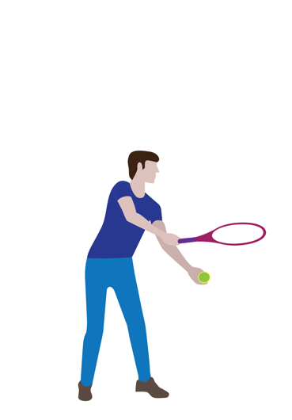 | Preferred hand and wrist  Fingers curled around the grip  Wrist firm  Nonpreferred hand and wrist  The nonpreferred hand is held out in front of the body  The ball is held in front of the body  Elbows and arms  The nonpreferred elbow is straight as the arm is extended  The preferred arm is brought down and fully extended at the elbow  Eyes and head  Eyes looking slightly forward  Trunk  Slight lean forward  Knees  Slightly bent
2 | 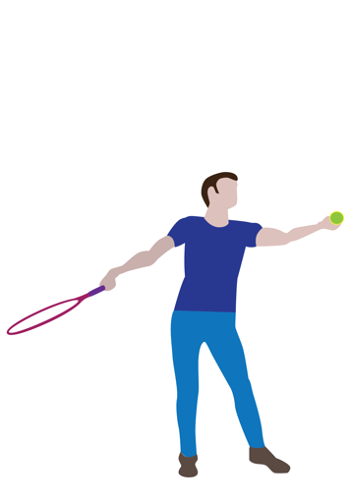 | Preferred hand and wrist  Wrist firm continued grip  Nonpreferred hand and wrist  Hand positioned to release the ball upward  Elbows and arms  Preferred arm fully extended at the elbow  Eyes and head  Head slightly tilted up  Trunk  Slight lean forward  The trunk begins to rotate toward the net  Knees  Knees extend
3 | 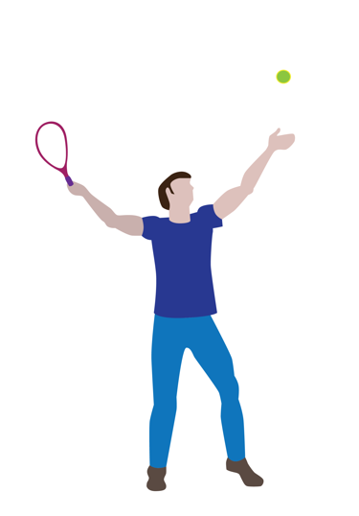 | Preferred hand and wrist  Wrist firm  Racket head up  Nonpreferred hand and wrist  Hand releases ball at least racket height above head  Elbows and arms  Preferred arm fully extended at the elbow  Eyes and head  Head slightly tilted up  Eyes looking at the ball  Trunk  The trunk continues to rotate toward the net  Knees  Knees extend
4 | 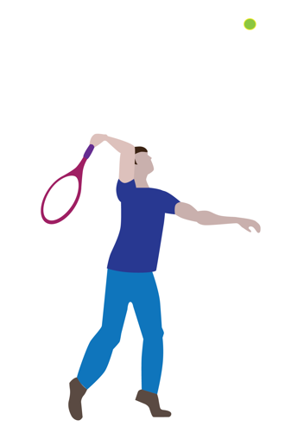 | Preferred hand and wrist  Wrist firm  Racket head up and transitioning toward the ball  Nonpreferred hand and wrist  Extended toward target  Elbows and arms  Preferred arm bends in preparation to extend  The nonpreferred elbow is slightly bent  Eyes and head  Head tilted up  Eyes looking at the ball  Trunk  Slight lean forward at the waist  The trunk rotates toward the net  Knees  Knees extend
5 | 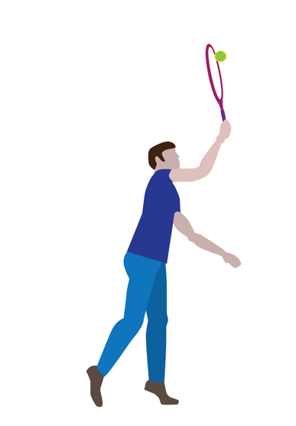 | Preferred hand and wrist  Wrist firm  Racket head up vertically to the ground  Nonpreferred hand and wrist  Wrist firm  Hand stays open  Elbows and arms  The preferred elbow begins to straighten with the contact of the ball  The nonpreferred elbow is slightly bent contributing to the balance  Eyes and head  Head facing intended target  Eyes looking at the ball  Trunk  Slight lean forward at the waist  The trunk rotates toward the nonpreferred side  Knees  Knees slightly bent
6 | 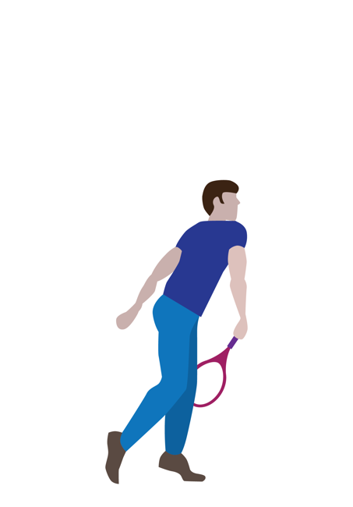 | Preferred hand and wrist  Wrist flexed down  Nonpreferred hand and wrist  Wrist firm  Elbows and arms  Preferred elbow straight as the arm comes out, across, and down toward the hip on the nonpreferred side  Nonpreferred elbow straight  Eyes and head  Head facing intended target  Eyes looking at the ball  Trunk  Slight lean forward at the waist  The trunk rotates toward the nonpreferred side  Knees  Knees slightly bent

Item 2 Task (Student Document, p. 2)
Please answer the questions below about the new skill you have selected to learn and record the results of your thinking.
- What are the steps to a proficient performance of the skill?
- What are the critical elements of the skill?
- What characteristics would you see in a mature form performance of the skill?
Student Voice: The answers below show my understanding of the overhead serve movement skill.
My answers for questions 1 and 2: The steps to an overhead serve can be broken down into six fluid movements done with my body. These steps include the critical elements needed for this skill.
- Starting Stance: I grip the racket firmly in my dominant hand, my fingers curling comfortably around the handle, while my other hand holds the ball steady in front of me. My elbows are positioned just right—my non-dominant arm extended and my racket arm relaxed at my side. I keep my knees slightly bent and lean forward a little, eyes focused straight ahead, ready to begin.
- Toss: I bring the ball upward with a steady motion, releasing it high enough to meet my racket above my head. My non-dominant arm stays fully extended, guiding the toss as I tilt my head upward to track the ball’s path. My knees remain bent, ready to push upward into the next phase.
- Backswing: As the ball rises, I draw my racket back with a smooth and deliberate motion, my wrist firm and controlled. My dominant arm begins to extend, while my body naturally starts to rotate slightly toward the net. My focus stays locked on the ball, and I feel the tension building as I prepare to strike.
- Contact Phase: My wrist stays firm as the racket head transitions to meet the ball at the right angle. My non-dominant hand stretches out toward the target for balance while my dominant arm bends, preparing to strike. I keep my eyes fixed on the ball, my body leaning forward and rotating naturally, and my knees pushing upward with purpose.
- Impact and Follow-Through: The moment of impact feels powerful—my wrist holds steady as the racket connects perfectly with the ball vertically. My non-dominant hand remains extended to keep me balanced while my racket arm follows through across my body toward my opposite hip. My trunk twists smoothly toward the net, my knees slightly bent to reduce the motion.
- Completion of the Serve: I finish the serve with my racket arm completing its arc, the racket ending near my hip on the opposite side. My non-dominant hand helps stabilize me and my head stays turned toward the target, watching the ball travel. My body finishes the motion smoothly, my knees bend slightly, and I’m already prepared for what comes next.
My answer for question 3: A mature form is one where my serve is one continuous movement. It feels and looks smooth with a nice flow. I’m able to do this while showing all the critical elements. My serve is smooth and controlled—it feels like a comfortable movement now. I think about what I’m doing much less than when I first learned this movement skill. Now, when I serve, the ball lands inside the court boundary lines almost every time I serve it. I can control (within a few feet) where the ball lands.

Item 3 Task (Student Document, p. 3)
Many movement skills combine two or more simple movements to make another movement. For example, a step and a hop combined make another movement, the skip. For this item, you will combine the movement skills you’ve already learned in earlier physical education classes with the new movement skills you identified for Items 1 and 2.

Step 1
Determine a movement skill you have already learned to apply to the new movement skill you displayed in Items 1 and 2.

Step 2
Next, perform the new skill, showing how you’ve learned to combine skills you’ve learned previously. Your teacher will score your performance and give you feedback on the critical elements of the simple skills, how well you transition from one skill to another, and how well you apply simple skills to your new skill.
Student Voice: My new skill, the overhead tennis serve, includes an important series of simple movements I learned earlier—I step with my nonpreferred foot and then throw overhand. Both of these simple movements are very important to the overhand serve.
Critical elements combining  step and overhand throw | Applying the combined step and  overhand throw to the overhead serve
Verified by observation—Critical Elements for Overhand Throw  - Step with non-dominant foot  - Weight transfer to forward foot  - Hips and spine rotate bringing the throwing arm back fully behind the body  - The throwing arm moves forward  - Follow-through across the body with the throwing arm after releasing the ball | Verified by observation—Application of Combined Movement Patterns to Overhead Serve  - Movement patterns (step and overhand throw) were combined and applied to the overhead tennis serve and performed with the serve.

Item 4 Task (Student Document, p. 4)
This item focuses on assessing the degree to which you understand yourself as a learner, including what you learned about strategies and tools that work best for you when learning new movement knowledge and skills, including applying that knowledge and skills with movements you are already proficient in.
Answer the questions below to the best of your ability. Please feel free to reference tools such as diagrams, notes, videos, and anything else when establishing evidence for your claims.
- How do you learn new movements and skills best?
- What strategies do you use to handle setbacks and challenges when learning new things?
- How do you transfer skills you have already learned to new skills you have identified as important to learn related to movement skills?
- How do you evaluate your progress in learning using evidence and what strategies do you use to adjust when experiencing setbacks?
Student Voice: The following responses represent my best thinking related to the strategies I deployed to learn the overhead tennis serve.
- Question 1: I learn new movement skills best when the learning is a step-by-step process, and I can see or know that I’m getting better at what I’m learning. Pictures helped me learn more about my movement skills and the words with the pictures helped to answer my questions. I also had to think about how the movement felt as I was learning.
- Question 2: I start by thinking about “why” a setback happened. For example, when the ball didn’t go where I expected it to go during a serve, I reflected on what may have caused the difference. I also took note of these areas and studied pictures of the overhead serve (frame by frame because it was easier to see little differences). I made small changes and noted the results. Once I had the steps to my serve in place, I tried to only make small changes to my serve based on trial and error and what I was learning from my notes and pictures.
- Question 3: In the case of the overhead serve, I never had thought about the overhand throw being a part of the serve, and now I see how really important it is to think about and use this new learning. As I was practicing the serve, I found out that thinking about the overhand throw helped me to remember to bring my elbow back (like a throw) and also use my left arm for balance—just like I've done when throwing. This enabled me to learn the serve faster and focus on the new parts of the skill I hadn’t done much of before—like hitting the ball above my head.
- Question 4: I keep asking myself questions and measuring my progress. For example, I asked, “How successful was I when I tried something new?” and “Did the new thing matter?” Also, setting small goals helped build my skills to be more proficient at serving.

Resources
California Department of Education (CDE). 2024. California Preschool/Transitional Kindergarten Learning Foundations, Volume 2. CDE Press.
California Department of Education (CDE). 2009. Physical Education Framework for California Public Schools: Kindergarten Through Grade Twelve. CDE Press.
California Department of Education (CDE). 2005. Physical Education Model Content Standards for California Public Schools: Kindergarten Through Grade Twelve. CDE Press.
Vetter, P. F. 2021. Test of Secondary Basic Sports Skills. Champaign, IL: Human Kinetics.
Wickstrom, R. L. 1983. Fundamental Motor Patterns. Philadelphia, PA: Lea & Febiger.

If a student dictates to a scribe, it is important for the scribe to be careful to record only what the student explicitly communicates, rather than making interpretations and “filling in the blanks.”
California Physical Education Framework 2009, p. 117
California Physical Education Framework 2009, p. 118
Students are free to respond to the task using words (for example, lists, sentences, and so on) and images (for example, drawings, stick figures, and so on).
Students are free to respond to the task using words (for example, lists, sentences, and so on) and images (for example, drawings, stick figures, and so on).
Teachers and students will find a need to assess open movement skills and attend to the student’s ability to adjust for different situations as well as use the skill at appropriate times. For example, a backhand stroke in tennis and the overhead smash in badminton both include adjusting the use of when to use the skill and what adaptations might be needed depending on the location of an opponent.

